Clune Park – Structural Survey
Summary Report

Cause

The cause of the principal defect is corrosion swelling of the precast concrete slabs forming the roof deck. Moisture penetrates the concrete, causing reinforcement to corrode. This corrosion leads to swelling of the steel and cracks then develop in the concrete. The cracks allow water to penetrate the slab more easily and the process accelerates until, ultimately, the steel is no longer able to sustain the tensile forces and the units collapse.

Given that all properties are equally exposed to wind and rain and are of the same construction and age, it is reasonable to assume that the defect will apply to all buildings to varying degrees.

Defining Disrepair

Serious Disrepair has been defined by the Scottish Government and Inverclyde Council have adopted this definition.

The defect affects greater than 20% of the individual roof areas and is therefore a failure of a primary building element and by definition the property is deemed to be in serious disrepair.

The corrosion also has a secondary impact on other building elements which in turn lead to further elemental failures, typically;

- Cracking of Stonework / Brickwork Gables: This cracking increases in width with height towards the roof and affects two or three storeys of the building height.

- Horizontal Cracking above Third Floor Window Level: This takes the form of a horizontal line of cracking which represents horizontal movement of the top two or three courses of brickwork immediately below the concrete roof slab. This appears to be the result of horizontal pressure from swelling of the concrete roof slabs, causing the top two or three courses of brickwork and lintels to be pushed outwards.

- Disturbance to Ceiling over Closes and Flats: Where we obtained access to vacant flats (where the ceiling had collapsed through water penetration), it was clear that cracks were developing along the joints between adjacent precast concrete units.

Impact & Lifespan
It is difficult to predict the lifespan of the buildings if no work was done but, as a guide, we believe that section of the roof and upper walls would become unsafe in 5 – 10 years. Water penetration would also render timber floors unsafe in a similar timescale.

In the short to medium term, if no action was taken, localised spalling of concrete and damaged brickwork would become a significant hazard.

Tackling Disrepair

The defect would only be repaired in the long term by removal of the concrete slab units and construction of new dual-pitched tiled roofs on trussed rafters. This would also require works to the wall head to secure the top courses of stonework/brickwork which have been moved by the horizontal pressure of corrosion.

Repair works to the roughcast gables and the rear elevations of the properties would also be required. To isolate the new surface from existing cracked brickwork, and provide a secure fixing, a K-Lath type system would be required.

Current estimates for these common works indicate costs ranging from £60,000-£140,000 per tenemental property depending upon whether it is mid-terrace or gable ended.

Photographs of the defect and its impact on the buildings are noted below.

Photographic Evidence

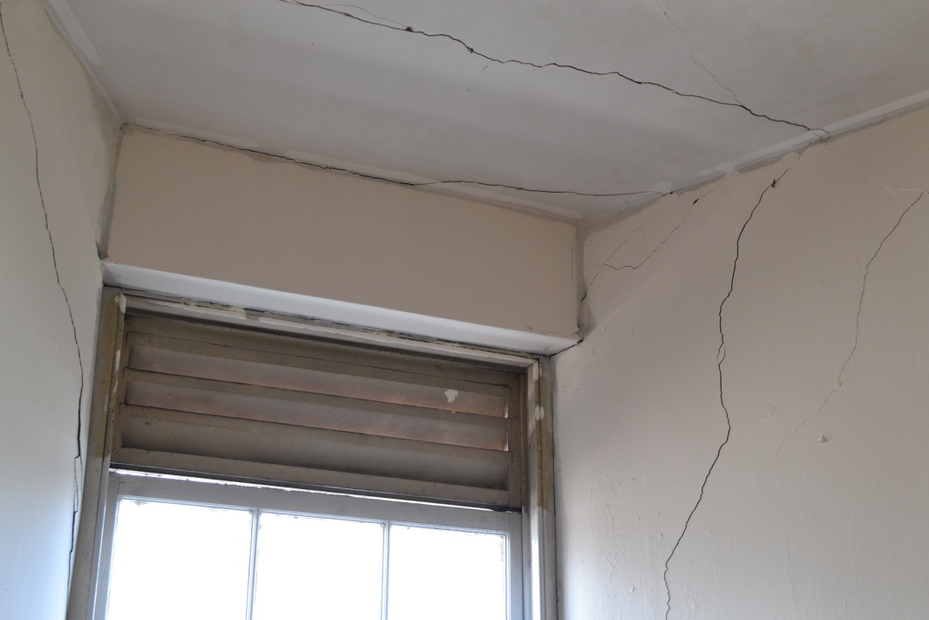
Horizontal pressure from roof slab corrosion causing outward movement of walls at top floor

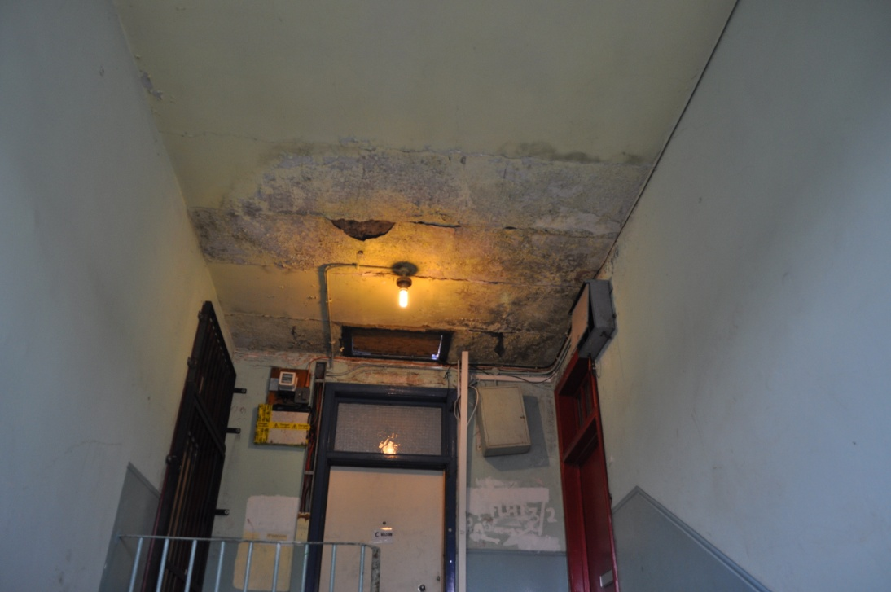
Corrosion causing movement or roof slab and ingress of water, thereby accelerating corrosion
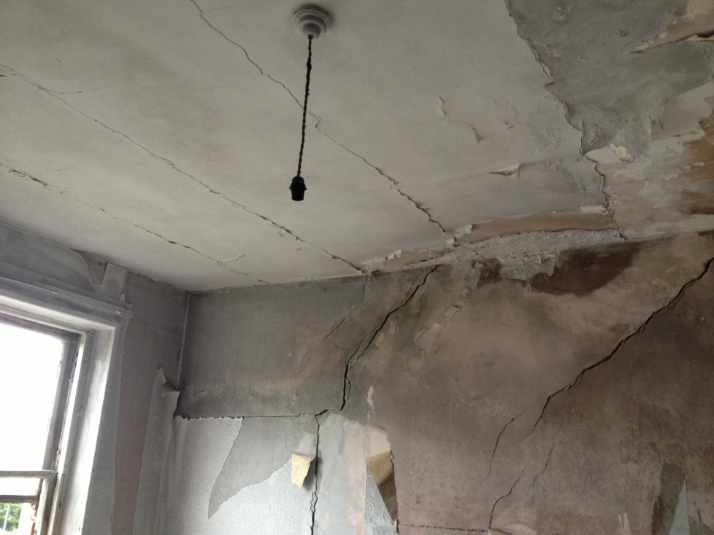
Corrosion swelling of the concrete roof slabs, causing outward movement of external walls, presenting as internal cracks

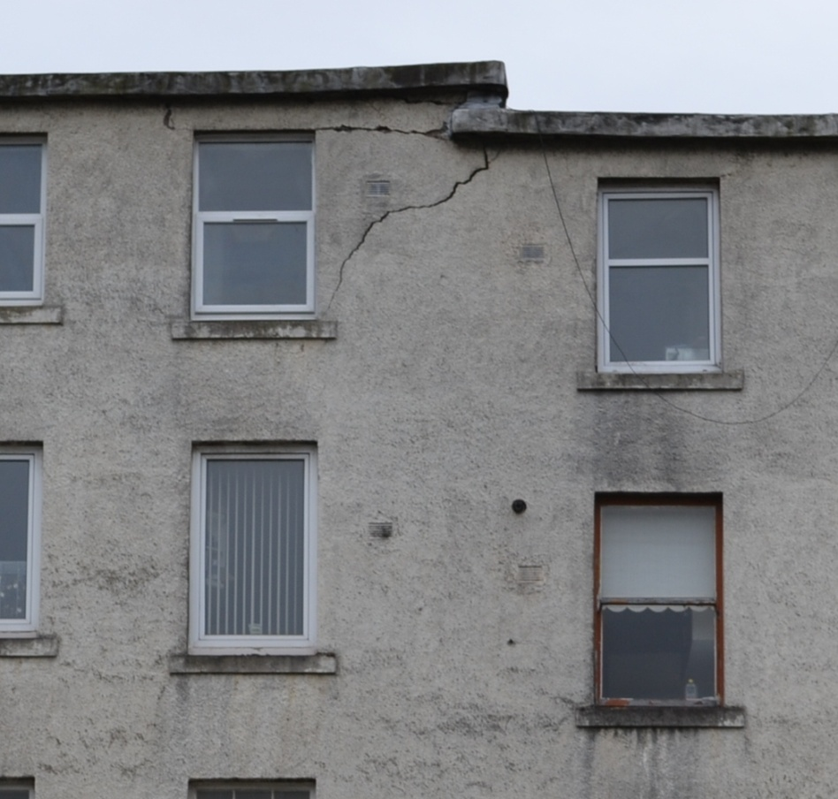
Structural cracking caused by horizontal pressure from corrosion swelling of concrete roof slabs

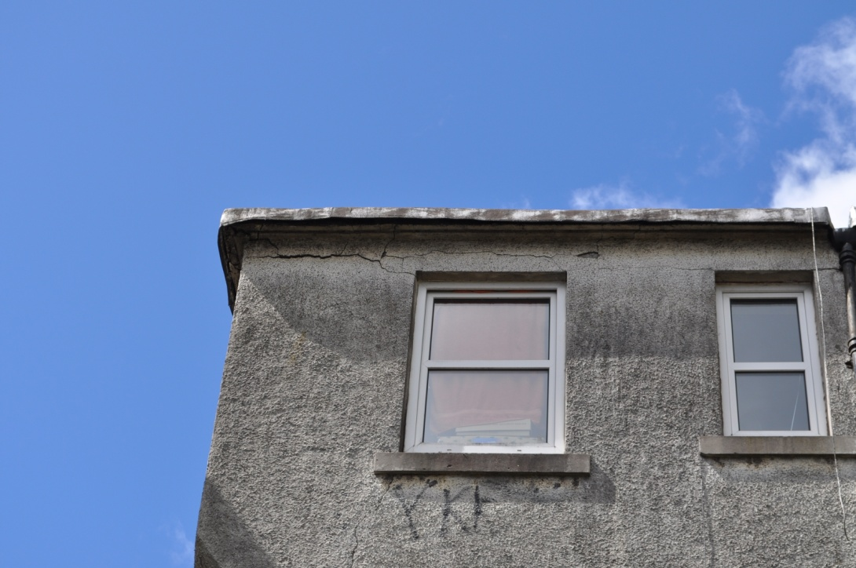
Horizontal pressure from swelling of the concrete roof slabs, causing movement of the top courses of brickwork and lintels

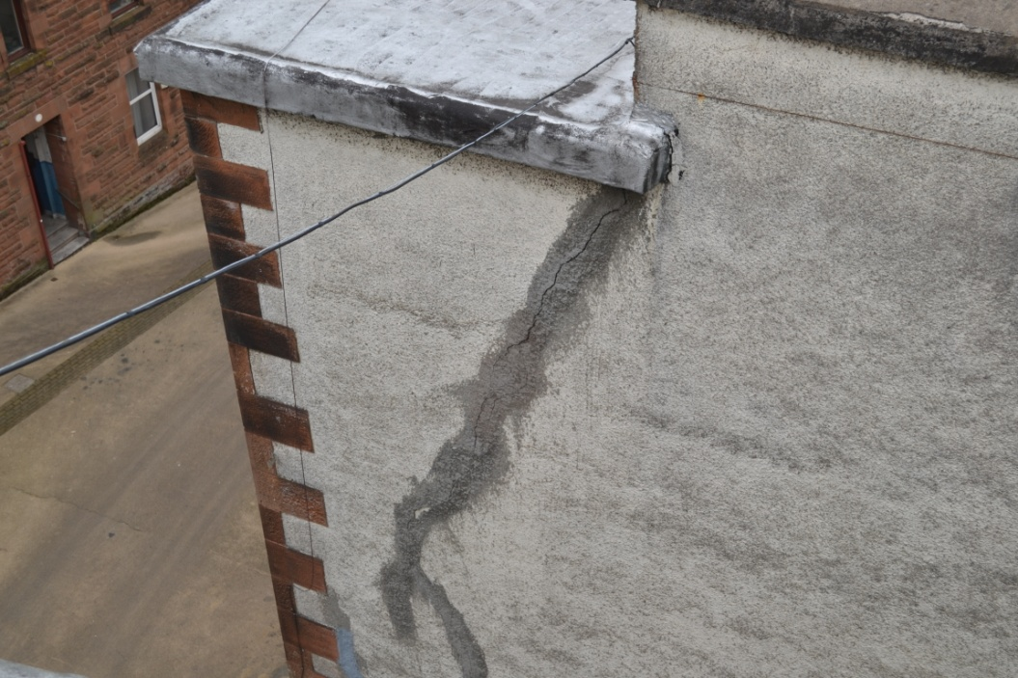
Horizontal pressure from corrosion swelling of the concrete roof slabs causing outward movement of front elevation wall. Cracking increases in width with height towards the roof
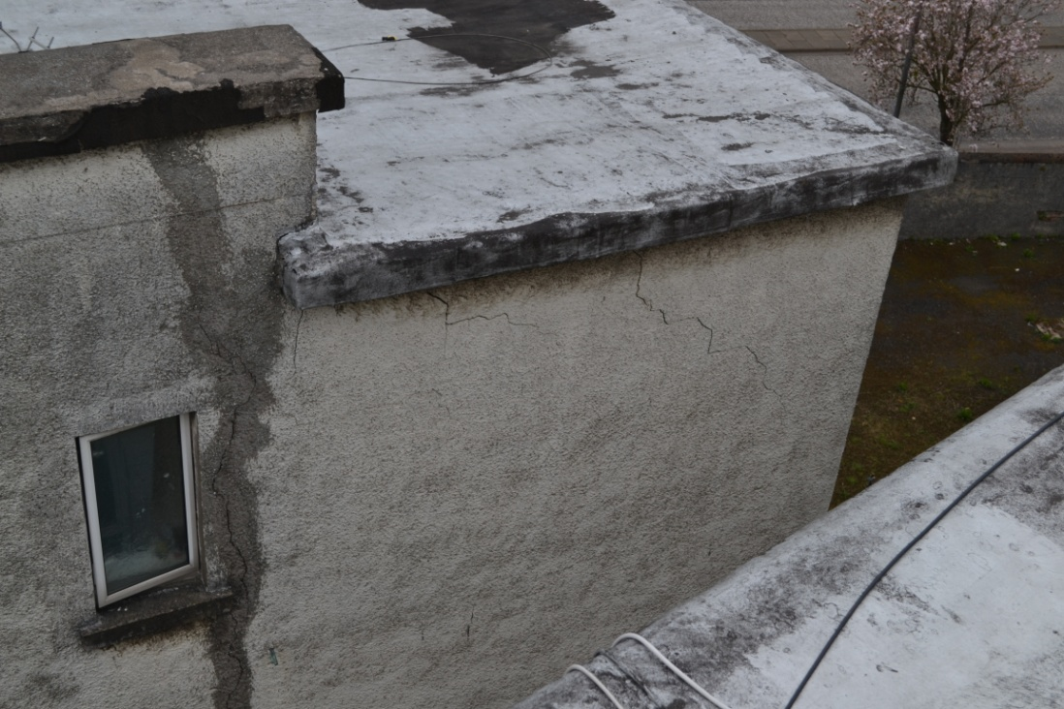
Horizontal pressure from corrosion swelling of the concrete roof slabs causing outward movement of rear elevation wall

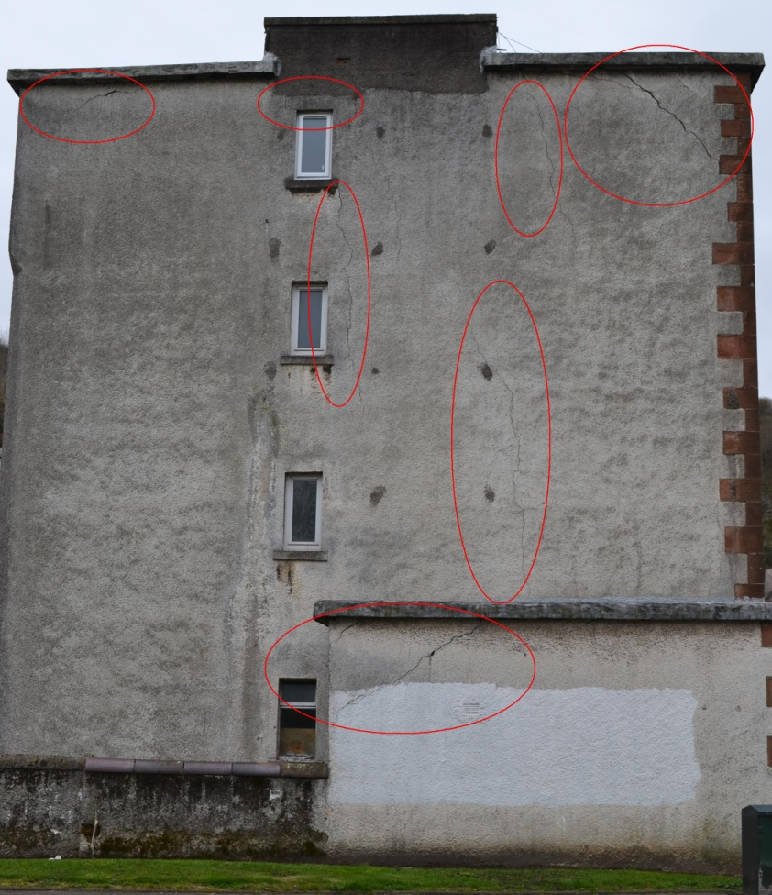
Horizontal pressure from corrosion swelling of the concrete roof slabs causing outward movement of front and rear elevation walls. Cracking increases in width with height towards the roof and affects 2-3 storeys of the buildings height.

