

Property Services

FOR SALE

**Former Garvel Deaf Centre, York Road, Greenock**

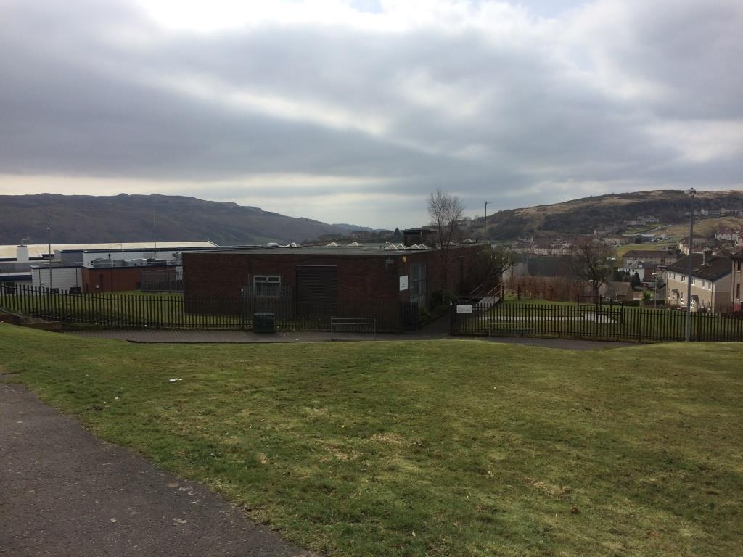

* RESIDENTIAL LOCATION
* SUITABLE FOR RESIDENTIAL/COMMUNITY FACILITY USE
* SUBJECT TO DETAILED PLANNING APPROVALS
* OFFERS FOR SALE INVITED

|  |
| --- |
| The above Particulars are believed to be correct, but are supplied for information only and no reliance should be placed thereon. They are not deemed to form any contract or part of contract which may be entered into. Inverclyde Council does not bind itself to accept the highest rent or offer and in supplying these Particulars is not issuing instructions and will not therefore, bear liability for Agent’s or other fees. |
|  |
| Property Asset Team  Inverclyde Council, Municipal Buildings Greenock PA15 1LY  Telephone 01475 712102 Email: property@inverclyde.gov.uk |

**LOCATION**

The property is situated at the junction of York Road and Chester Road, Greenock within a residential location of local Housing Authority housing and directly adjacent to St. Andrew’s Primary School. There are good road and nearby public transport links with Greenock Town Centre situated approximately 3 miles to the east.

**DESCRIPTION**

The subject site extends to 0.14 Hectares or thereby and comprises a former Local Authority School for the Deaf. The building is on one level with a former play area to the rear. It is up to potential developers to satisfy themselves as to the suitability of this building/site for any potential development.

It is the responsibility of prospective purchasers to satisfy themselves as to the availability, condition and capacity of all service provisions.

**PLANNING**

The site lies within the administration of Inverclyde Council in a predominately residential area, but any specific proposals should be referred to the Planning Services utilising the contact details on the contacts page.

**ROADS GUIDANCE**

All development proposals would be required to comply with the Council’s Roads Development Guidelines, including the requirement to provide off street car parking. Prospective developers are advised to contact the Council’s Roads Service on telephone number 01475 714800 to discuss all proposals.

**RATING**

The subjects are currently assessed as a ‘Store’ and will require to be re-assessed on occupation and completion of any developments.

**ENTRY**

Immediate entry on completion of legal formalities can be offered.

**VIEWING**

Viewing may be arranged by contacting the Property Asset Team at 01475 712102 or online [property@inverclyde.gov.uk](mailto:property@inverclyde.gov.uk)

**INTEREST**

All interested parties must register their interest with the Property Asset Team either by telephone to 01475 712102, via the Inverclyde Council website, or online at [property@inverclyde.gov.uk](mailto:property@inverclyde.gov.uk) in order to receive the offer package which is required prior to submitting an offer once a closing date has been announced.

**OFFERS**

Offers are invited for a purchase. The offer should include full details of any proposed development.

**CLOSING DATE**

Please note **a closing date** **for offers** will be set in due course. It is essential to register interest as only all parties who have recorded their interest will be notified of the date and time.

All offers should be submitted by the notified time to:

Head of Legal, Democratic, Digital, & Customer Services

Inverclyde Council

Municipal Buildings

Greenock PA15 1LY

All offers must strictly comply with the terms and conditions as set out in the attached Standard Conditions of Sale. These will be forwarded to all parties who register an interest, and will include an address label which must be affixed to the front of all envelopes containing offers.