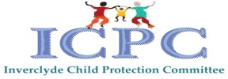

Inverclyde Practitioners Guidance Female Genital Mutilation (FGM)

With thanks to colleagues at Barnardos
Created 2017
Updated June 2024
Review June 2026

Definition

The World Health Organization describes Female Genital Mutilation (FGM) as: "procedures that involve partial or total removal of the external female genitalia, or other injury to the female genital organs for non-medical reasons" (WHO, 2013). FGM comprises all procedures that involve partial or total removal of the external female genitalia, or other injury to the female genital organs for non-medical reasons. Prior to the adoption of the term FGM, the practices were referred to as “female circumcision.” Some communities refer to FGM as ‘circumcision’, ‘cutting’ or ‘sunnah’, rather than ‘FGM’.

Types of FGM

There are many variations of FGM that broadly come under four types:

Type 1: Partial or total removal of the clitoris and/or the prepuce (clitoridectomy)

Type 2: Partial or total removal of the clitoris and the labia minora with or without
excision of the labia majora (excision)

Type 3: Narrowing of the vaginal orifice with creation of a covering seal by cutting
and bringing together (sewing) the labia minora and/or the labia majora, with or
without excision of the clitoris (infibulation)

Type 4: All other types of harmful traditional practices that mutilate the female
genitalia, including pricking, cutting, piercing, incising, scraping and cauterisation

The practice is mostly carried out by traditional circumcisers, who often play other central roles in communities, such as attending childbirths. However, more than 18% of all FGM is performed by health care providers, and this trend is increasing.

Cultural justifications given for FGM

Many affected communities believe that FGM is a necessary custom to ensure that a girl is accepted within the community and eligible for marriage. Families who practice FGM on girls usually see it as a way of safeguarding their future.
Other reasons include:
• perceived health benefits
• preservation of the girl’s virginity
• cleanliness
• rite of passage into woman-hood
• status in the community
• protection of family honour
• perceived religious justifications

There are no religions that advocate for FGM.

FGM is recognized internationally as a violation of the human rights of girls and women. It reflects deep-rooted inequality between the sexes, and constitutes an extreme form of discrimination against women. It is nearly always carried out on minors and is a violation of the rights of children. The practice also violates a person's rights to health, security and physical integrity, the right to be free from torture and cruel, inhuman or degrading treatment, and the right to life when the procedure results in death.

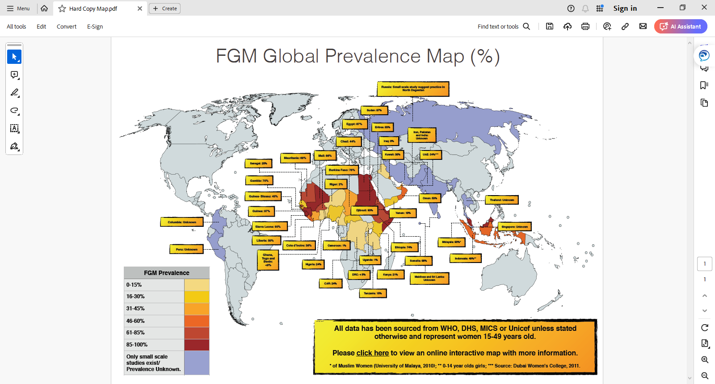
Who is at risk?

FGM is usually practised on girls between infancy and 15 years old, but can also be
performed on older girls. More than 125 million girls and women alive today have been cut globally and in the UK, it is estimated that there are over 130,000 women living with FGM.

Health implications

FGM has no health benefits, and it harms girls and women in many ways. It involves removing and damaging healthy and normal female genital tissue, and interferes with the natural functions of girls' and women's bodies.

Short term health implications include:
• death
• severe pain and shock
• broken limbs from being held down
• injury to adjacent tissues
• urine retention
• increased risk of HIV and AIDS

Long term health implications include:
• uterus, vaginal and pelvic infections
• cysts and neuromas
• infertility
• increased risk of fistula
• complications in childbirth
• depression and post-natal depression
• psychosexual problems
• pregnancy and child birth
• sexual dysfunction
• difficulties in menstruation
• trauma and flashbacks

The Legal Position

The Prohibition of Female Genital Mutilation (Scotland) Act 2005 made it a criminal offence to have female genital mutilation carried out in Scotland or abroad, and increased the maximum penalty from five to 14 years imprisonment. The Female Genital Mutilation (Protection and Guidance) (Scotland) Bill which is currently progressing through parliament aims to strengthen the 2005 Act.

Signs that a girl could be at risk of FGM

• One or both of a girl’s parents come from a community affected by FGM
• A girl is born to a woman who has undergone FGM
• Mother has requested re-infibulation following childbirth
• A girl has an older sibling or cousin who has undergone FGM
• One or both parents or elder family members consider FGM integral to their
cultural or religious identity
• The family indicate that there are strong levels of influence held by elders and/
or elders who are involved in bringing up female children
• A girl/family has limited level of integration within UK community
• A girl from a practising community is withdrawn from PSHE and/or Sex and
Relationship Education or its equivalent may be at risk as a result of her
parents wishing to keep her uninformed about her body, FGM and her rights

Signs that a girl could be at immediate risk of FGM

• If a female family elder is present, particularly when she is visiting from a
country of origin, and taking a more active / influential role in the family
• If there are references to FGM in conversation, for example a girl may tell other
children about it
• A girl may confide that she is to have a ‘special procedure’ or to attend a
special occasion to ‘become a woman’
• A girl may request help from a teacher or another adult if she is aware or
suspects that she is at immediate risk
• Parents state that they or a relative will take the child out of the country for a
prolonged period
• A girl may talk about a long holiday to her country of origin or another country
where the practice is prevalent
• A girl is taken abroad to a country with high prevalence of FGM, especially
during the summer holidays which is known as the ‘cutting season’

Signs that FGM has occurred

• prolonged absence from schools
• frequent need to go to the toilet
• long break to urinate
• urinary tract infections

Issues for Inverclyde

Some people living in the area may have come from cultures where FGM is practiced. Some women may have already undergone FGM or could be under pressure to have it performed. It is therefore relevant for all professionals including teachers, health and social care staff and police officers, who work with girls and young women throughout Inverclyde to have an awareness about FGM.

Child Protection Issues

FGM can happen within loving families who do not see it as abuse. However, FGM is a criminal act which causes severe physical and mental harm to victims both in the short and long term and for this reason it cannot be condoned or excused. The safety and welfare of the child at risk is paramount

If a professional is concerned that FGM is going to be, or has been performed, on a child or young woman they should follow the processes in their agency Child Protection Procedures to make a child protection referral. In such a situation, professionals should be mindful of other female siblings in the family. Professionals should recognise the importance of a quick response to such concerns when they arise given the potential for FGM to be performed at short notice. Female genital mutilation should always be seen as a cause of significant harm and normal child protection procedures should be invoked. Where a child or young person within a family has already been subjected to female genital mutilation, consideration must be given to other female siblings or close relatives who may also be at risk

Good Practice Guidance

Professionals should work in a sensitive manner with families to explain the legal position around FGM. Interpretation services should be available if English is not spoken or well understood. It is important that language used to describe FGM should be respectful and is not insulting to individuals, their culture or tradition.

A female doctor should be used if physical examination is required in such circumstances. Questioning should be kept to a minimum and properly informed consent should be obtained when necessary. Consent should always be sought from the victim prior to medical examination. In cases where the child is unable to understand or provide their consent this should be given by the parent or adult carer who has responsibility for the care and protection of the child. As in all child protection situations, where such consent is not forthcoming consideration must then be given to appropriate legal options to facilitate the medical examination.

Medical Examination
A medical examination should be considered in all children where FGM has been undertaken. This would include both acute and non-recent presentations and would ensure children have appropriate on-going care if required.
In all cases the need for a medical should be discussed with the Level 4 Child Protection Paediatrician via the Child Protection Service (0141 451 6605) or included within the IRD.
Pregnant Women
All women are asked at routine sensitive enquiry about FGM and when FGM disclosed referred to SNIPs and when appropriate to SW.

When a mother or one woman from a family has undergone FGM, consideration should be given to whether any daughters/ siblings may also have FGM performed on them.

Further Resources

Scotland’s National Action Plan to Prevent and Eradicate Female Genital Mutilation (FGM) outlines its purpose as fostering an environment of prevention in Scotland whilst supporting those who are FGM survivors.
Equally Safe, Scotland’s strategy to tackle all forms of violence against women and girls.
PDF file: Factsheet - Female Genital Mutilation (Protection And Guidance) (Scotland) Bill (220 KB)
In 2017, the Scottish Government published FGM: Responding to Female Genital Mutilation in Scotland: Multi-Agency Guidance. This framework supports agencies and practitioners to develop and agree processes for working collaboratively and individually to promote the safety and wellbeing of women and girls.
NSPCC FGM Factsheet 2020. www.nspcc.org.uk/female genital mutilation

Barnardos Female genital mutilation (FGM) | Barnardo's (barnardos.org.uk)

National FGM Centre – Developing excellence in response to FGM and other Harmful Practices

National Child Protection Guidance
Getting it right for every child (GIRFEC)

