

Property Services

FOR SALE:

**Former Community Hall, 80 Leven Road, Greenock**

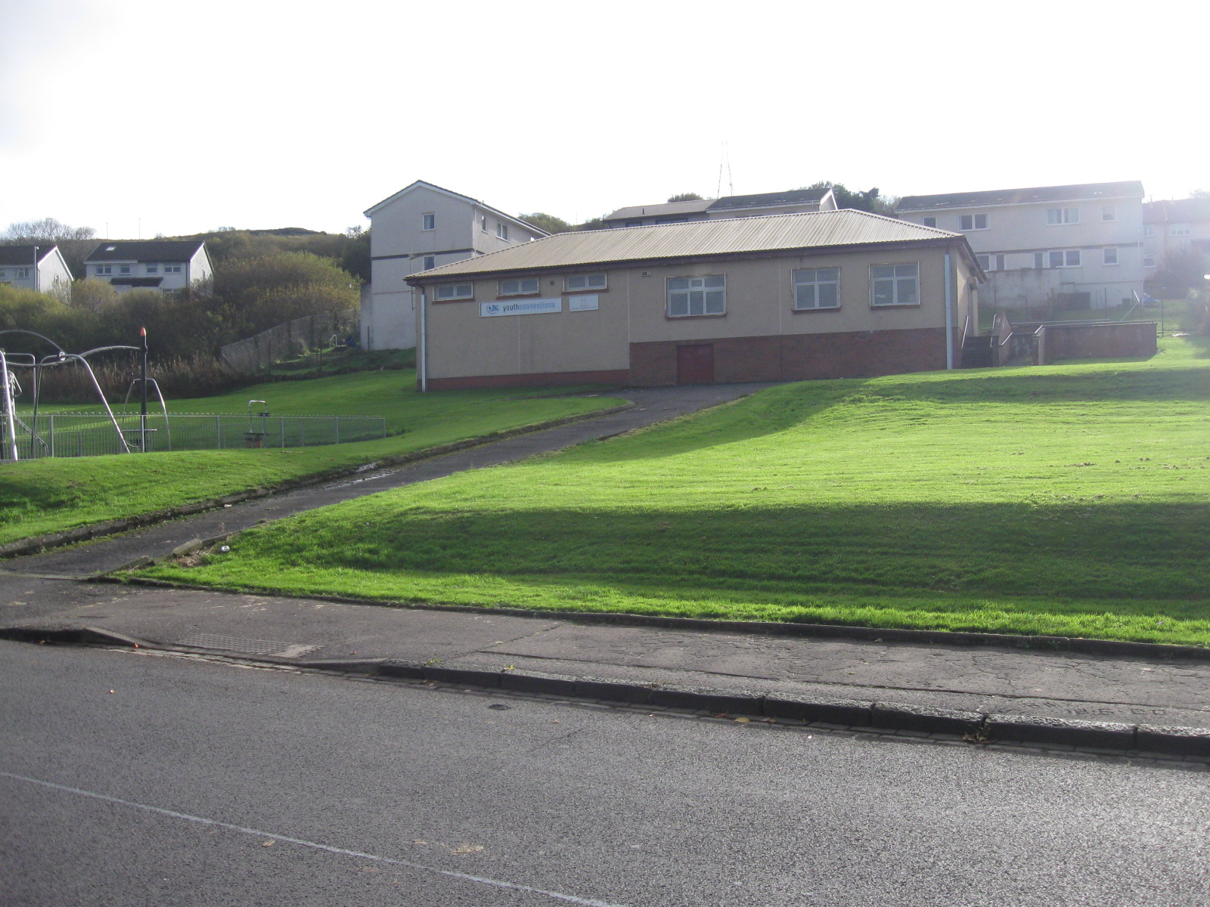

* WITHIN RESIDENTIAL LOCATION
* EXCELLENT RIVER VIEWS
* SITE EXTENDING TO 0.051 HECTARES OR THEREBY
* SUITABLE FOR COMMUNITY/OFFICE USE SUBJECT TO STATUTORY CONSENTS
* OFFERS TO PURCHASE INVITED

|  |
| --- |
| The above Particulars are believed to be correct, but are supplied for information only and no reliance should be placed thereon. They are not deemed to form any contract or part of contract which may be entered into. Inverclyde Council does not bind itself to accept the highest rent or offer and in supplying these Particulars is not issuing instructions and will not therefore, bear liability for Agent’s or other fees. |
|  |
| Property Asset Team  Inverclyde Council, Municipal Buildings, Greenock PA15 1LY  Telephone 01475 712102 Email: property@inverclyde.gov.uk |

**LOCATION**

The property is situated within a Housing Association residential location in the south eastern outskirts of Greenock, lying approximately 1.6 miles from Greenock town centre and some 25 miles from Glasgow city centre to which there are good road and rail links.

**DESCRIPTION**

The subjects comprise a purpose built community hall with parking, which is accessed off Leven Road. The site extends to 0.051 Hectares or thereby and has good views across the River Clyde.

It is up to potential developers to satisfy themselves as to the suitability of the subjects for any potential development.

It is the responsibility of prospective purchasers to satisfy themselves as to the availability, condition and capacity of all service provisions.

**PLANNING**

The site lies within the administration of Inverclyde Council and is situated in a predominately residential area, but any specific proposals should be referred to the Planning Services utilising the contact details on the contacts page.

**ROADS GUIDANCE**

All development proposals require to comply with the Council’s Roads Development Guidelines, including any requirement to provide off street car parking. Prospective developers are advised to contact the Council’s Roads Service on telephone number 01475 714800 to discuss all proposals.

**RATING**

The subjects are currently assessed as a ‘Community Centre’ and may require to be re-assessed on completion and occupation of any development.

**ENTRY**

Immediate entry on completion of legal formalities can be offered.

**VIEWING**

Please contact the Property Asset Team either by telephone on 01475 712102, or online [property@inverclyde.gov.uk](mailto:property@inverclyde.gov.uk)

**INTEREST**

All interested parties must register their interest with the Property Asset Team either by telephone on 01475 712102, or via the Inverclyde Council website or online at [property@inverclyde.gov.uk](mailto:property@inverclyde.gov.uk) in order to receive the offer package which is required prior to submitting an offer once a closing date has been announced.

**OFFERS**

Offers are invited for a purchase. The offer should include full details of any proposed development.

**CLOSING DATE**

Please note a **closing date for offers** has been set at 12 Noon, Friday 19th July 2024.

All offers should be submitted by the notified time to:-

Head of Legal, Democratic, Digital & Customer Services

Inverclyde Council

Municipal Buildings

Greenock PA15 1LY

Any offer submitted must strictly comply with the terms and conditions as set out in the attached conditions of sale. These will be forwarded to all parties who register an interest, and will include an address label which must be affixed to the front of all envelopes containing offers.