

Property Services

FOR SALE:

DEVELOPMENT OPPORTUNITY

**Site, Mearns Street, Greenock**

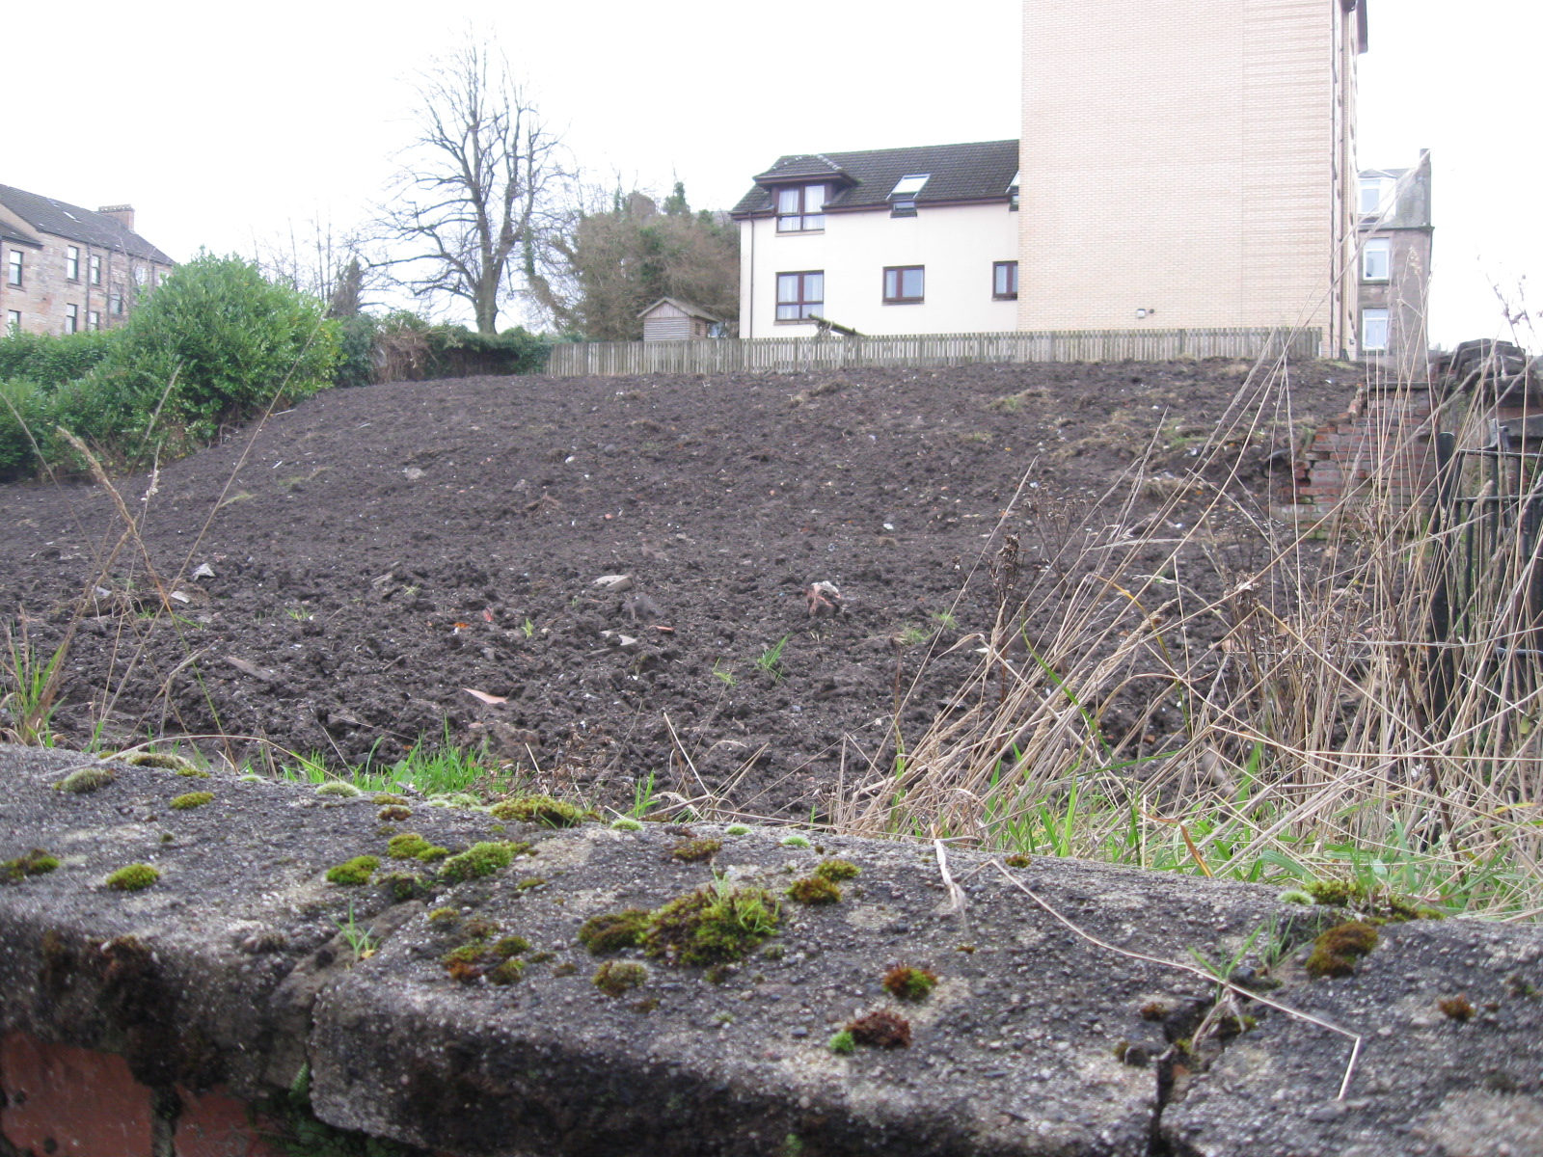

* DESIRABLE RESIDENTIAL LOCATION
* CLOSE TO TOWN CENTRE AND TRANSPORT LINKS
* SUITABLE FOR RESIDENTIAL USE SUBJECT TO PLANNING APPROVAL
* SITE EXTENDING TO 0.104 HECTARES OR THEREBY
* OFFERS TO PURCHASE INVITED

|  |
| --- |
| The above Particulars are believed to be correct, but are supplied for information only and no reliance should be placed thereon. They are not deemed to form any contract or part of contract which may be entered into. Inverclyde Council does not bind itself to accept the highest rent or offer and in supplying these Particulars is not issuing instructions and will not therefore, bear liability for Agent’s or other fees. |
|  |
| Property Asset Team  Inverclyde Council, Municipal Buildings, Greenock PA15 1LY  Telephone 01475 712102 E-mail: property@inverclyde.gov.uk |

**LOCATION**

The site enjoys a prominent position at the junction of Mearns Street and Armadale Place, Greenock and lies within a predominately private residential area in the Well Park area of Greenock.

The site is within walking distance of Greenock town centre and associated local amenities.

There are also good road and rail links to the Greater Glasgow area.

**DESCRIPTION**

The subjects comprise a sloping, broadly rectangular site extending to 0.104 Hectares or thereby, formerly occupied by a Scout Hall and several lock-up garages, all now demolished.

It is up to potential developers to satisfy themselves as to the suitability of this site for any potential development.

It is the responsibility of prospective purchasers to satisfy themselves as to the availability, condition and capacity of all service provisions.

**PLANNING**

The site lies within the administration of Inverclyde Council in a predominately residential area, but any specific proposals should be referred to the Planning Services utilising the contact details on the contacts page.

**ROADS GUIDANCE**

All development proposals require to comply with the Council’s Roads Development Guidelines, including the requirement to provide off street car parking. Prospective developers are therefore advised to contact the Council’s Roads Department on telephone number 01475 714800 to discuss all proposals.

**RATING**

The property is currently assessed as ‘Ground’. The subjects will require to be re-assessed on completion and occupation of any development.

**ENTRY**

Immediate entry on completion of legal formalities can be offered.

**VIEWING**

The site is open for viewing at any time.

**INTEREST**

All interested parties must register their interest with the Property Asset Team either by telephone on 01475 712102, via the Inverclyde Council website, or online at [property@inverclyde.gov.uk](mailto:property@inverclyde.gov.uk) in order to receive the offer package which is required prior to submitting an offer.

**OFFERS**

Offers are invited for a purchase. The offer should include full details of any proposed development.

**CLOSING DATE**

Please note a **closing date for offers** has been set at 12 Noon, Friday 19th July 2024.

All offers should be submitted by the notified time to:-

Head of Legal, Democratic Digital & Customer Services

Inverclyde Council

Municipal Buildings

Greenock PA15 1LY

Any offer submitted must strictly comply with the terms and conditions as set out in the attached conditions of sale. These will be forwarded to all parties who register an interest, and will include an address label which must be affixed to the front of all envelopes containing offers.