Inverclyde Council

Local Housing Strategy

2023-2028

08

**Fall**

Table of Contents

1 Introduction to the Inverclyde Local Housing Strategy 3

1.1 Local Housing Strategy Purpose 4

1.2 Local Housing Strategy 2017-22: Outcomes and Achievements 4

1.3 Local Housing Strategy Consultation and Engagement 4

1.4 Local Housing Strategy Vision, Outcomes and Priorities 9

2 Local Housing Strategy Context 11

2.1 Strategic Context for Housing in Scotland 11

2.2 Strategic Context for Housing in Inverclyde 13

3 Equalities Impact and other Assessments 18

4 The Housing System in Inverclyde 20

5 Outcome 1: People in Inverclyde live in quality homes in connected communities 28

5.1 LHS Priority 1: What’s our Starting Point? 28

5.2 LHS Priority 1: What do Residents, Partners and Stakeholders Think? 32

5.3 LHS Priority 1: Our Actions 33

5.4 Setting Housing Supply Targets 35

6 Priority 2: People in Inverclyde find it easier to access and sustain a home 37

6.1 LHS Priority 2: What’s our Starting Point? 38

6.2 LHS Priority 2: What do Residents, Partners and Stakeholders Think? 43

6.3 LHS Priority 2: Our Actions 44

7 Priority 3: People in Inverclyde are supported to live independently and well at home 46

8. Priority 4: People in Inverclyde live in good quality, carbon friendly homes and energy efficient homes which reduce fuel poverty 52

9. Delivering Local Housing Strategy Outcomes 60

10. Local Housing Strategy Action Plan 65

Appendix A: LHS Conference Outcomes Report

Appendix B: Housing Supply Targets Briefing paper

Arneil Johnston

50 Scott Street

Motherwell

ML1 1PN

# Introduction to the Inverclyde Local Housing Strategy

Inverclyde Council is pleased to present the new five year Local Housing Strategy for Inverclyde, covering the period 2023-2028.

The Local Housing Strategy (LHS) sets out the strategic direction, policies and plans that will enable Inverclyde Council and partners to deliver high quality housing and housing services to meet the needs of local people across all housing tenures. The LHS also sets out the important contribution that housing makes to enabling economic growth and regeneration, improving health and wellbeing, creating connected and sustainable places, reducing climate change and tackling poverty across Inverclyde.

This Local Housing Strategy builds on the progress of the 2017-22 Inverclyde LHS and sits at the heart of all housing planning arrangements and partnership activities in Inverclyde. It is an ambitious strategy, setting out what homes and communities should look and feel like over the next five years. The LHS vision ensures that housing successfully contributes towards the area’s repopulation, regeneration and economic growth objectives, to make Inverclyde a place where people want to live through the provision of quality and affordable housing. It also aims to ensure that people live in quality homes which are well connected to jobs and to thriving local communities which support positive health and wellbeing.

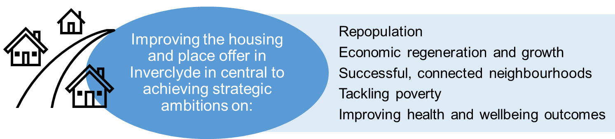

To maximise housing’s contribution to Inverclyde’s strategic objectives, Local Housing Strategy outcomes must be elevated and firmly embedded into the corporate, community planning, health and economic development strategies of the area. To achieve this, the new Local Housing Strategy has been co-produced with strategic partners and stakeholders who will continue to be accountable for implementation and delivery, making the case for housing investment, regeneration and transformation over the next 5 years.

It is acknowledged that the extent and nature of housing challenges faced by Inverclyde are in many ways unique. As a result, some national policy and funding mechanisms won’t work in the Inverclyde context. To address this, the LHS sets out a range of ambitious and tailored solutions within an outcome delivery framework that enables ongoing collaboration across local and national government, public bodies and third sector agencies.

The LHS has been developed with the backdrop of Covid-19 recovery, the UK exit from the European Union, war in Ukraine, as well as rising inflation, interest rates and cost of living pressures. All these factors have and will continue to have significant impacts on the Inverclyde economy and local communities. The LHS therefore comes at a crucial time and by aiming to support inclusive growth which tackles inequalities, will be instrumental to improving housing outcomes for everyone in Inverclyde.

## Local Housing Strategy Purpose

The LHS sets out the vision of Inverclyde Council and local partners for the supply of housing across all tenures and types of housing provision. The strategy aligns with national and local housing priorities, including key objectives within Inverclyde’s economic regeneration strategy. The main purpose of the local housing strategy is to:

* set out a shared understanding of need and demand for all types of housing, and for housing services now and in future
* provide clear strategic direction for housing investment including the development of new homes as well as investment in existing housing
* set out actions and targets to improve the quality, condition and energy efficiency of homes
* provide a strong contribution to the integration of housing, health and social care services to enable independent living and improved wellbeing outcomes
* set the framework to prevent homelessness wherever possible and to resolve homelessness quickly and effectively when it does occur
* focus on the priorities and outcomes required to achieve the LHS vision.

In meeting the requirements of the LHS Guidance (Scottish Government, 2019), the strategy must be:

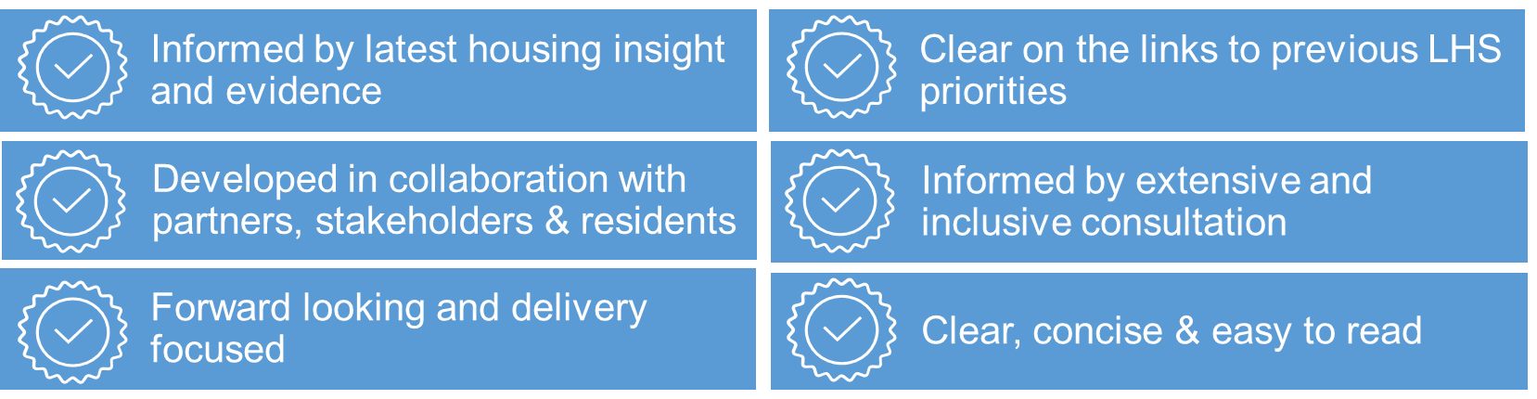

## Local Housing Strategy 2017-22: Outcomes and Achievements

This Local Housing Strategy builds on a strong foundation of positive housing outcomes delivered by the 2017-2022 LHS. Key outcomes achieved over the last 5 years are as follows:

**Housing Supply & Placemaking**

Delivery of 740 house completions between 2017-22 against the LHS 2017-222 Housing Supply Target of 1,300 over 5 years

Delivery of 390 new affordable homes through the delivery of the Strategic Housing Investment Programme 2017-22

£2M of Scottish Government funding secured from the Affordable Housing Supply Programme to support the development of the Open Market Acquisition Scheme enabling RSLs to purchase 21 homes for affordable housing between 2017-22

191 properties acquired in the Clune Park regeneration area to be held for demolition and housing-led regeneration between 2017-22

16% reduction in long term empty properties with 49 empty properties brought back into use since the establishment of the Inverclyde Empty Homes service in 2017.

**Supporting Independent Living**

Delivery of 51 new affordable homes specifically designed for wheelchair users

Delivery of 24 dementia friendly housing units (St Stephen’s development, River Clyde Homes)

Delivery of 49 homes supporting independent living through the use of technology in RCH ‘wellbeing at home’ developments

Up to 2,000 households provided with care and support to remain independent at home in 2021/22

Up to 2,000 households each quarter provided with telecare services to remain independent at home

Delivery of new core and cluster housing models for key client groups in Auchendarroch Street, Station Road and Lyle Street increasing the total number of spaces to 112

Annual average investment of £1.25M on aids and adaptations by Registered Social Landlords homes supporting up to 670 households per year

Investment of £2.8M on 672 aids and adaptations in homes in the private housing sector since 2017.

**Housing Choice and Homelessness**

Investment of £5.2M in homelessness services from 2017-22 with an increase in annual investment by 28% from £967k in 2017 to £1.2M in 2021/22

Relaunch of Inverclyde Homelessness Service as a Housing Options and Homelessness Advice Service more strongly focused on the prevention of homelessness

£307k invested in short term housing support services supporting over 45 households to sustain housing

Delivery of a Rapid Rehousing Support Team with eight support workers providing intensive wrap around support for homeless households with complex needs

Growth and development of Housing First for homeless households with complex needs, with 41 clients receiving support at 31st March 2023

Improved collaboration and new processes established with Criminal Justice and Health services

30% reduction in the number of households experiencing homelessness after leaving an institutional setting (from 2021/22 to 2022/23) as a result of new joint prevention approaches

Decommissioning of the Inverclyde Centre underway including the closure of 7 rooms and an increase in the number of community based dispersed tenancies

Provision of 49 units of community based dispersed temporary accommodation by Registered Social Landlords with a target of 60 tenancies established for 20

23 temporary tenancies ‘flipped’ or converted to permanent accommodation in 2022/23

Enhanced service user engagement indicating that 88% were either satisfied or very satisfied with the service received from staff

New Landlord Forum to be launched in June 2023 to improve collaboration with private landlords and enhance access to the private rented sector.

**House Condition, Fuel Poverty and Climate Change**

Investment of £7.3M in energy improvement works via Home Energy Efficiency Programmes for Scotland (HEEPS), enabling over 160 private homes per year to improve energy performance

Over 2,000 households provided with non-financial advice and assistance on energy usage and property condition by iHEAT, including 1,000 home visits per annum

742 renewable energy installations by households in Inverclyde including photovoltaics, onshore wind and hydro

1,340 households (on average) assisted through the Care & Repair service per annum

Support, advice and assistance on property condition provided to over 2,174 residents in private housing per annum via the Scheme of Assistance.

## Local Housing Strategy Consultation and Engagement

Local authorities are required by The Housing (Scotland) Act 2001 and The Equality Act 2010 to consult on their Local Housing Strategy, with a duty placed on public bodies to involve, consult and engage with as many local residents, tenants and communities of interest as possible.

An extensive consultation and engagement programme was delivered to support development of the new LHS, offering a range of opportunities for local people, communities and wider stakeholders to share their views on the most pressing housing challenges facing Inverclyde, as potential ideas for change and improvement.

As a result, a diverse network of partners, stakeholders and subject matter experts participated in developing the new Local Housing Strategy. Consultation processes successfully assembled a range of views, enabling feedback to systematically inform the LHS development. These processes included the following opportunities:

* LHS early engagement survey: A survey to inform the priorities of the new Local Housing Strategy was made available to communities and residents across Inverclyde, enabling them to express their views on which local housing issues ‘matter most’. The survey was open for 8 weeks from September to November 2022 and was completed by 475 local residents and community representatives. The early engagement survey was heavily promoted across Inverclyde Council’s digital and social media channels. It was also promoted via the local press, by Steering Group partners and marketed to employees in Inverclyde Council and the HSCP. The survey was made available online with alternative survey formats on including telephone and freepost options. The survey was also shared via partner agencies of the Inverclyde Council for Voluntary Services, with support available to encourage the participation of hard to reach groups
* Stakeholder conference: To encourage and enable widespread participation, a full day LHS development conference was held in November 2022 via Microsoft Teams. Over 50 partners and stakeholders attended the event, including representatives from public, private, third and community sectors. The purpose of the conference was to co-produce an LHS vision, agree the main housing issues that should form the basis of LHS outcomes and generate ideas and innovation as a basis for LHS actions. A conference report summarising the outcomes from the day can be accessed in Appendix A
* Option identification workshops: Four half-day workshop sessions were held, to inform the definition of key LHS priorities, together with a range of viable options for addressing them. Workshop participants were specialist stakeholders and subject matter experts from across the Council and partner organisations
* Option appraisal workshops: Four half-day workshop sessions were held to systematically appraise LHS options against pre-determined criteria. The outputs from these sessions form the basis of the LHS Action Plan detailed in Chapter 10, with completed option appraisal matrices available in Appendices B-D
* Strategic engagement: Mechanisms were put in place, as part of the LHS consultation plan to ensure the LHS is fully aligned with local strategies, policies and plans. These include partnership working with representatives from Inverclyde Health and Social Care Partnership, the Inverclyde Alliance and local housing developers
* Strategic governance: The Inverclyde LHS development process has been led by the LHS Steering Group which provides a multi-agency governance framework for the development and implementation of the LHS. Representatives include partners from Inverclyde Council, (Safer Communities, Planning, Housing Strategy, Regeneration and Planning and Performance, Alcohol and Drug and Homelessness Services), Registered Social Landlords and the Voluntary Sector.

To maximise participation in the LHS Consultation Plan, a creative approach was deployed, offering a range of engagement and consultation opportunities. Where possible, digital platforms and channels were utilised to enable partners and stakeholders to take part, whilst offering alternative options for stakeholders who required person-led options. The advancement of virtual consultation methods has been effective in providing new ways to engage with partners and to expand the digital audience of the LHS. The extent and nature of the LHS Consultation Plan can be summarised as follows:

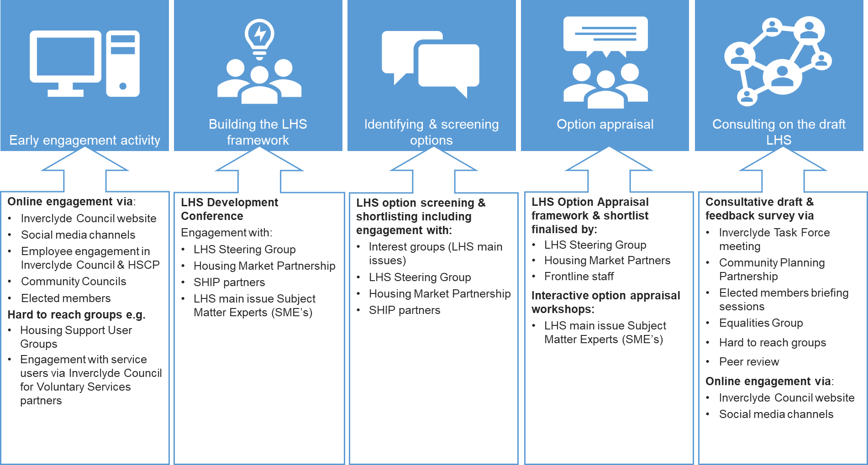

## Local Housing Strategy Vision, Outcomes and Priorities

Housing to 2040 sets out the national vision for housing in Scotland and places housing firmly at the centre of other national objectives including tackling poverty and inequality, creating and supporting jobs, meeting energy efficiency and fuel poverty targets, tackling the climate emergency and creating connected, successful communities.

For the Inverclyde area, there are a unique set of challenges when compared to the rest of Scotland including depopulation, a rapidly declining working age population, high levels of empty properties and areas of low housing demand. These are interlinked with the need for physical regeneration aligned to economic growth strategies and improvements in health and wellbeing. It is therefore vital that the vision and priorities within the LHS contribute towards delivering some of the major strategic objectives of Inverclyde.

The LHS vision therefore places housing at the centre of strategic ambitions for Inverclyde including the objectives of the Inverclyde Alliance to grow the economy and population, regenerate communities and reduce inequalities. The LHS vision includes:

* a focus on housing led regeneration and place making to assist with repopulation and to ensure a holistic and collaborative approach to placemaking
* a commitment to enhance the quality of housing choices by improving low demand housing stock
* improving the range of housing options, making it easier for households to access affordable housing that meets their needs, particularly working age households
* pursuing a collaborative approach to implementing preventative housing solutions that contribute positively to health and well-being
* addressing housing disrepair and fuel poverty in Inverclyde to improve affordability and housing quality.

Co-produced with LHS delivery partners, stakeholders, local residents and communities, the 2023-2028 Local Housing Strategy vision for Inverclyde is that:

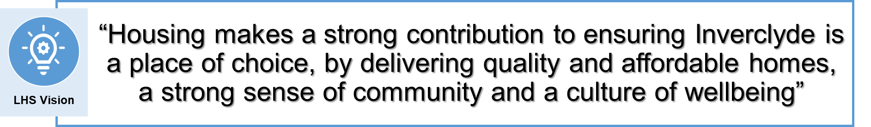

To achieve this vision and realise the strategic ambitions of the Inverclyde Alliance Local Outcomes Improvement Plan (LOIP) and Inverclyde Economic Regeneration Strategy, the following four LHS priorities have been defined:

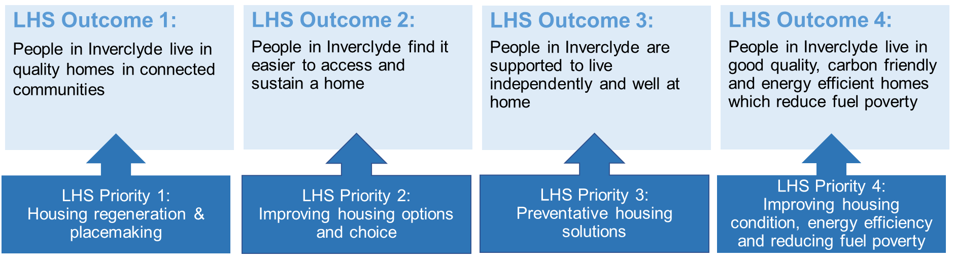

Each LHS outcomes will be delivered by focusing on the priority activities identified.

The evidence, key issues and actions for each LHS outcome are set out in Chapters 5 to 8 of the new Local Housing Strategy. Guiding the delivery of the LHS are the principles set out by the Christie Commission on the Delivery of Public Services in Scotland. These include commitments to collaboration, efficiency, innovation, prevention, and tackling inequality.

The LHS Steering Group will build on the strong partnerships already in place in Inverclyde, recognising that achieving LHS outcomes will require a collective effort from delivery partners, stakeholders, communities, and the people of Inverclyde.

# Local Housing Strategy Context

It is important that the LHS supports and helps deliver national housing outcomes and targets, whilst also reflecting the local needs and priorities set out in the Inverclyde Alliance Local Outcomes Improvement Plan (2017-22).

The LHS is therefore set within the wider Community Planning framework for the Council and its partners. On this basis, the LHS defines the housing contribution to local strategic priorities and provides a framework for meeting the targets set out in Scotland’s first national Housing Strategy: ‘Housing to 2040’. The national and local strategic framework that will support and enable LHS delivery is set out in more detail below.

## Strategic Context for Housing in Scotland

**Housing to 2040**

Housing to 2040 is Scotland’s first ever long-term national housing strategy providing a vision for what housing should look like and how it will be provided to the people of Scotland, no matter where they live and what point in their life they are in.

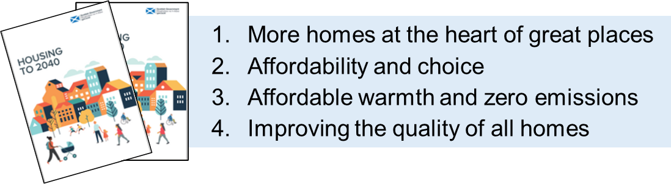The strategy is developed around four themes which focus on increasing supply, enabling affordability and choice, decarbonising homes and enhancing housing quality.

Housing to 2040 makes a commitment to increase housing supply by setting an ambitious target to deliver 100,000 affordable homes over the next ten years up to 2031/32, with at least 70% of these for social rent. The strategy sets out a specific vision for achieving:

* A well-functioning housing system
* High quality, sustainable homes
* Sustainable communities
* Homes that meet people’s needs

**National Performance Framework**

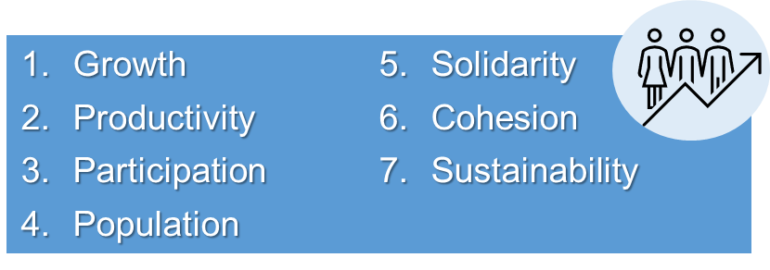The Scottish Government’s National Performance Framework provides a vision for ‘A Scotland that *is ‘wealthier and fairer, smarter, healthier, safer and stronger and greener’*.

It provides a framework which includes seven high level targets for public services to work towards including:

LHS outcomes in Inverclyde align well to the National Performance Framework Vision and make strong contributions to the targets set under the growth, participation, population, cohesion and sustainability elements of the framework.

**Fourth National Planning Framework (NPF4)**

In January 2023, the Scottish Government approved a new spatial plan for Scotland that will look ahead to 2050. The fourth National Planning Framework (NPF4) sets out a vision for what Scotland, as a place, could and should look like in 2050. This includes national planning policies and provides a plan for future development in Scotland.

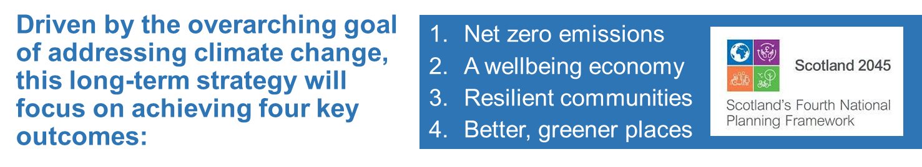

The LHS has been informed by the themes and aims set out in NPF4. Concepts such as 20 minute neighbourhoods, the Place Principle, prioritising brownfield development and a fabric first approach to decarbonising homes and communities; all feature within action points to deliver Inverclyde LHS outcomes.

Furthermore, the LHS has been informed by evidence from the draft 2022 Glasgow City Region Housing Need and Demand Assessment (HNDA). HNDA3 provides housing estimates for each of the eight local authorities that make up the GCR area (including Inverclyde) as the basis for setting Housing Supply Targets in the LHS and Housing Land Requirements in the LDP.

In developing the new National Planning Framework for Scotland, Glasgow City Region partners set a ‘minimum all tenure housing land requirement’ (MATHLR) in June 2021, following Scottish Government consultation on the spatial strategy for NPF4. The MATHLR took into consideration:

* housing system evidence including emerging HNDA housing estimates
* historic housing completions
* housing delivery targets aligned to Strategic Housing Investment Plans
* local strategic drivers for housing delivery, including the delivery of the Glasgow City Region Deal and local economic development strategies.

MATLHR targets set a minimum threshold for housing land allocations within the next Inverclyde Local Development Plan.

The proposed Minimum All Tenure Housing Land Requirement set for Inverclyde for the next 10 years is 1,500 units.

Setting the MATLHR does not impact on the requirement to develop Housing Supply Targets within the LHS using the housing estimates produced by the HNDA as a starting point. In preparing this LHS there has been close partnership working between housing and planning colleagues to ensure that housing delivery and land use planning principles are informed and well aligned.

## Strategic Context for Housing in Inverclyde

It is important that the LHS should be closely aligned with the Inverclyde Alliance Local Outcomes Improvement Plan (2017-27), as well as supporting a range of other local plans and strategies which set ambitions for the people of Inverclyde. Key strategic plans and documents which align to LHS priorities are set out below.

**The Inverclyde Local Outcomes Improvement Plan**

Inverclyde’s Local Outcome Improvement Plan (LOIP) 2017/22 sets out the outcomes that the community planning partners in Inverclyde, known as the Inverclyde Alliance, seek to deliver. Improving the wellbeing and quality of life for every resident is the aim of the Inverclyde Alliance who want to ‘create a confident, inclusive Inverclyde with safe and sustainable, healthy communities and a thriving economy’. Tackling the challenges of depopulation, a declining working age population, low household incomes and worklessness is a major priority of the Inverclyde Alliance to enable economic development. The vision of the Inverclyde’s Local Outcome Improvement Plan (LOIP) is:

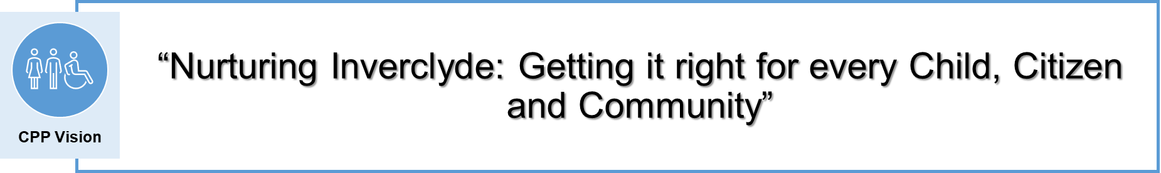

Housing has a key role to play in the delivery of the vision of the Inverclyde LOIP and the economic regeneration of the area. A key element of the LOIP vision is that:

*‘Inverclyde will be a more attractive place to live and work with excellent education provision, leisure facilities, transport links, good quality housing and employment opportunities’*

The new LHS has therefore been developed in close collaboration with partners from the Inverclyde Alliance to ensure housing makes a strong contribution to wellbeing and quality of life outcomes for all individuals and communities across the area.

The Inverclyde Alliance Outcomes Improvement Plan has three strategic priorities:

* **Population**: Inverclyde’s population will be stable and sustainable with an appropriate balance of socio-economic groups that is conducive to local economic prosperity and longer-term population growth.
* **Inequalities:** There will be low levels of poverty and deprivation and the gap in income and health between the richest and poorest members of our communities will be reduced
* **Environment, Culture and Heritage**: Inverclyde’s environment, culture and heritage will be protected for all Inverclyde residents as an attractive place in which to live, work and visit.

Inverclyde Alliance also recognises that there are communities that require targeted interventions in a range of areas, including housing, health, community safety and environmental protection. In response, Locality Plans have been developed with communities experiencing the greatest levels of inequality and deprivation. Housing led regeneration master plans are also being developed by Inverclyde Council in a number of ‘Priority Place Areas’ including Eastern Gateway, Central Port Glasgow and Greenock Town Centre. In each area, masterplans will be informed by an updated private sector house condition survey (reporting in 2023), a review of specialist housing provision and the development of an acquisition and refurbishment strategy by local Registered Social Landlords (RSLs).

The LHS therefore sets the delivery framework for contributing to community planning ambitions by delivering housing and housing services which:

* support business growth and repopulation through the provision of accessible and affordable housing options which meet housing need
* lead on the regeneration of areas through investment in maintenance and repair, addressing low demand stock and bringing empty stock back into use
* provide a range of housing options and housing related services that enable people to live independently at home in the community
* identify and address barriers to digital, social and economic inclusion.

**Glasgow City Regional Economic Strategy 2021**

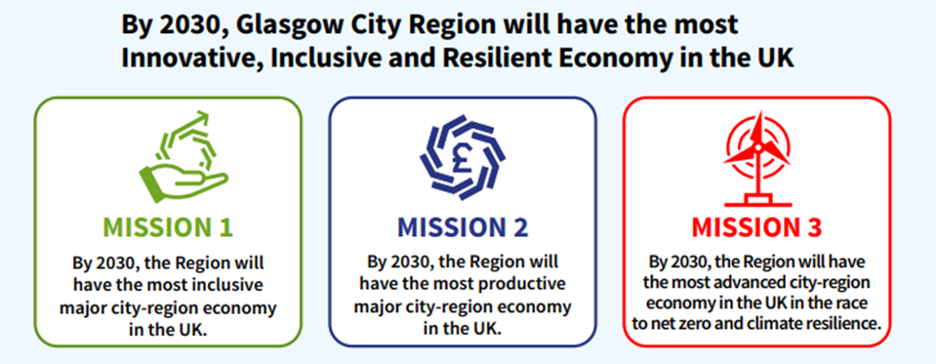A new regional economic strategy was launched in December 2021 setting out how the Glasgow City Region will address current and future key challenges including the impact of Covid-19, the climate emergency and unprecedented technology advances. The approach has been endorsed by the eight local authorities in the GCR, including Inverclyde Council, as well as the UK/Scottish Governments and public sector bodies.

A new vision has been developed with three interlinked regional missions woven through the strategy to address the challenges facing the region.

The strategy provides a transformational economic development framework for the region, which follows the £1.1B Glasgow City Region Growth Deal announced by the UK and Scottish Government in 2014.

The City Region Growth Deal has the potential to generate significant economic opportunities and benefits for the residents of Inverclyde including investment in infrastructure to unlock the potential of key strategic sites, employability programmes to support young and vulnerable people, a unique opportunity to grow the maritime sector on the Clyde coast along, the growth of other business sectors such as finance, engineering, manufacturing, life sciences, creative industries and media.

**Inverclyde Economic Regeneration Strategy**

Inverclyde’s economic ambitions and actions are outlined in the Economic Regeneration Strategy 2021-25. Actions are led by Inverclyde Council and recognise the importance of integrated partnership working with the private sector, the Scottish Government, Scottish Enterprise and Skills Development Scotland in the delivery of the economic regeneration ambitions. The vision of the Inverclyde Economic Regeneration Strategy is:



The vision is underpinned by four main themes of **People, Business, Place** and **Partnership.** The five key priorities of the Inverclyde Economic Regeneration Strategy are:

**Priority 1:** To boost skill levels and reduce worklessness

**Priority 2:** To accelerate the regeneration of strategic employment sites and town centres

**Priority 3**: To progress the renewal and economic regeneration of the most disadvantaged areas of Inverclyde

**Priority 4**: To increase Inverclyde’s capacity to accommodate jobs particularly in the private sector

**Priority 5**: To grow and diversify the business base

Since the economic crash in 2007/08, Inverclyde has shown gradual economic improvement with a notable fall in unemployment from 12.2% in 2012 to 4.4% in 2020. Despite some positive indicators, there remain significant challenges for delivery of economic recovery in the area such as reduced levels of public sector funding, low pay growth, poor productivity, significant unemployment and wages and skills levels below the national average. Strengthening the business base, creating jobs and boosting skills along with addressing population decline and regenerating disadvantaged areas are key issues to be addressed.

It is important that housing investment is maximised as part of Inverclyde’s economic strategy and that good quality housing options are made available for working age households. Housing and economic growth are fundamentally linked, and a lack of suitable, affordable housing can be a barrier to the economy being able to recruit and retain staff to grow their businesses and in turn grow the local economy. Housing has an important contribution to make to the growth of the local economy, ensuring that the working age population can be recruited and retained by connecting jobs to quality, affordable homes.

**Inverclyde Health and Social Care Partnership Strategic Plan 2019 -2024**

The vision of the Inverclyde Health and Social Care Partnership was created by the Inverclyde people and was developed within the ‘Nurturing Inverclyde’ vision of the Council and the Inverclyde Alliance as follows:

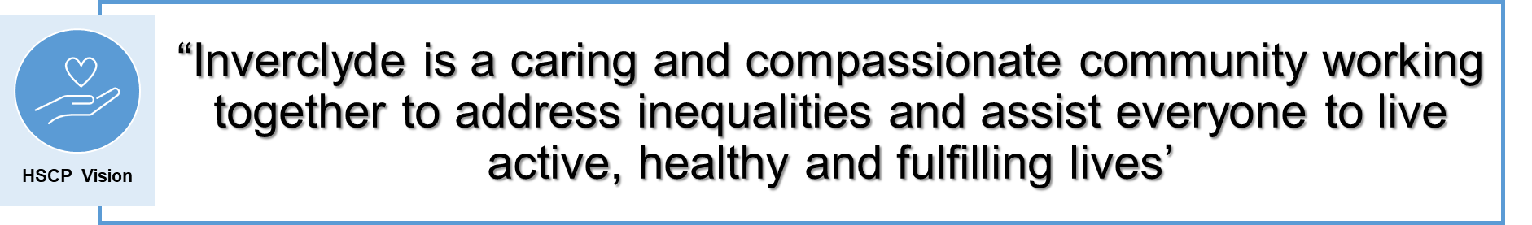

The vision is underpinned by six strategic outcomes called ‘Big Actions’ which align well to the delivery of LHS outcomes.

**Big Action 1**: Reducing health inequalities by building stronger communities and improving physical and mental health

**Big Action 2**: A nurturing Inverclyde will give our children and young people the best start in life

**Big Action 3:** Together we will protect our population

**Big Action 4**: We will support more people to fulfil their right to live at home or within a homely setting and promote independent living

**Big Action 5**: Together we will reduce the use of, and the harm from alcohol, tobacco and drugs

**Big Action 6:** We will build on the strengths of our people and our community.

The Inverclyde Health and Social Care Partnership’s Housing Contribution Statement (HCS) (2019-2024) sets out the role of housing services in meeting health and social care outcomes and is a key element of the new Strategic Commissioning Plan in Inverclyde. The Housing Contribution Statement serves as key link between the Strategic Commissioning Plan and the Local Housing Strategy.

Aligned to the Big Actions and outcomes identified within the Strategic Commissioning Plan, the HCS is underpinned by 3 outcomes which the Health and Planning Group will aim to realise.

**Outcome 1**: Increase the provision of quality, affordable homes across all tenures which meet the needs of the people of Inverclyde

**Outcome 2**: Provide suitable provision of housing adaptations and housing related support to ensure that our people live in homes which meet their physical and wellbeing needs

**Outcome 3**: Ensure easy access to relevant housing information and advice on housing and support services to improve housing outcomes for all Inverclyde residents.

The HCS identifies a number of strategic barriers which may impact on the ability of the outcomes to be delivered in Inverclyde such as demographic change and a rapidly aging population, the inequalities which exist in Inverclyde and the fiscal and economic issues currently being faced by communities.

**Inverclyde Net Zero Strategy 2021-2024**

Inverclyde Council has committed to delivering on the goal of achieving net zero emissions by 2045. To achieve this, specific carbon reduction actions have been identified as well as a change management and improvement process. The Net Zero Strategy has two ambitious targets which are underlined by a number of actions as follows:

**Target 1**: **Delivery of carbon footprint reductions of 73% from 2021 to 2030/31** (on a 2012/13 baseline) through four specific actions including (i) energy use in buildings, (ii) transport, (iii) street lighting, and (iv) waste and water. The scale of each action relates to the extent of emissions on the Council’s carbon footprint. The Net Zero Strategy also has a number of actions in relation to public awareness and behaviour change with energy use in buildings and transport being the priority areas of focus

**Target 2**: **Improvement to Net Zero by 2045**. Using the improvement process of ‘Plan-Do-Check-Act’, Inverclyde Council will continue to identify opportunities, partnerships, collaborations and actions to reduce or use certified carbon sinks to offset remaining emissions to zero by 2045.

# Equalities Impact and other Assessments

The Council has a statutory obligation to ensure that all its functions and activities are exercised in full compliance with the requirements of the Equalities Act 2010 and the Fairer Scotland Duty (2018). Equality is at the heart of the Inverclyde Local Housing Strategy, with a commitment to understanding diversity, central to the achievement of LHS priorities and outcomes. The Council aims to ensure that strategies and services deliver positive outcomes for everyone in Inverclyde by prioritising preventive approaches and tackling persistent inequalities where they exist.

The LHS is firmly aligned to strategic objectives of the Local Outcomes Improvement Plan and its mission to get it right for every child, citizen and community in Inverclyde.

A key part of the option appraisal process to finalise the LHS Action Plan was to assess all potential actions from an equalities perspective, specifically checking whether each option could ‘***support sustainable economic growth, tackle inequality and offer placemaking potential’***. The LHS Outcome Action Plan therefore prioritises actions which tackle inequalities including limited housing choice, poor housing affordability, fuel poverty and housing unsuitability for people with health conditions and disabilities.

The LHS Equalities Impact Assessment (EqIA) is available online at: <https://www.inverclyde.gov.uk/housing/policy-and-strategy/local-housing-strategy> setting out how the Council has addressed and seeks to mainstream equality issues in delivering the LHS. This assessment confirms that the LHS has been developed in full accordance with the principles of equality and diversity and actively promotes inclusion.

We will continue to monitor and report on the equalities impact of the LHS over the next five years, with a focus on the nine protected characteristics of the Equality Act. If any negative impacts on a particular section of the Inverclyde community are identified, appropriate action will be implemented to redress disadvantage within the LHS Action Plan.

**Children’s Rights & Wellbeing Assessment**

The UN Convention on the Rights of the Child (UNCRC) sets out 54 articles that cover all aspects of a child’s life and set out the civil, political, economic, social and cultural rights that all children everywhere are entitled to. A Children’s Rights & Wellbeing Assessment sets out a framework to assess the extent to which public policy and strategy impacts on the rights and wellbeing of children. The LHS has been assessed against these principles in a Children’s Rights & Wellbeing Assessment for the 2023-28 LHS, which is available online at: <https://www.inverclyde.gov.uk/housing/policy-and-strategy/local-housing-strategy>.

The Children Right’s & Wellbeing Assessment concludes that the development of the new Local Housing Strategy is likely to have a positive impact on children and young people in Inverclyde irrespective of any protected characteristic. The assessment acknowledges the key role of housing in safeguarding, supporting and promoting the wellbeing of children through the delivery of:

* a range of housing options and choices for young people and families with children
* safe homes and neighbourhoods
* affordable and suitable homes
* warm and energy efficient homes
* connected places with support services.

**Strategic Environmental Assessment**

The LHS is a broad policy document which sits within the framework of the Inverclyde Proposed Local Development Plan 2019. The LDP defines the spatial strategy for Inverclyde and allocates specific development sites to meet identified demand. A Strategic Environmental Assessment (post Adoption Statement) has been carried out in respect of the Local Development Plan, which covers the land use aspects of the Local Housing Strategy. The Strategic Environmental Assessment is available online and can be accessed online at: <https://www.inverclyde.gov.uk/housing/policy-and-strategy/local-housing-strategy>.

# The Housing System in Inverclyde

Inverclyde Council is located in the West Central Lowlands of Scotland bordering the Council areas of North Ayrshire and Renfrewshire as well as the coast of the Firth of Clyde. It’s coast is one of the most attractive places in Scotland to live, work and visit with excellent transport links to Glasgow and a wide range of local amenities. In terms of land area and population, Inverclyde Council is one of the smallest local authorities in Scotland ranking 29th smallest for land mass and 28th smallest for population.

Inverclyde is facing a number of unique challenges when compared with other areas in Scotland, such as major decreases in the working age population, high unemployment, significant health inequalities and areas of low housing demand. These factors create a complex mix of issues that influence the operation of the Inverclyde housing system. Informed by evidence and analysis of housing system operation, the LHS develops a framework for improving housing outcomes for everyone in Inverclyde by tackling areas where the housing system is not working effectively for local people and communities.

Key drivers which influence how the housing system is operating, such as population change, household projections and the performance of the Inverclyde economy are set out in more detail below.

* 1. **Population and Households**

**The Declining Population of Inverclyde**

Between 2001 and 2011, there was a sustained decline in the Inverclyde population of 4% from 84,660 people in 2001 to 81,220 in 2011.

**Chart 1: Inverclyde Population 2001-2021**

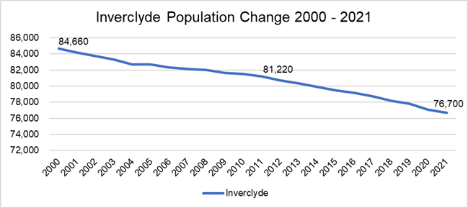Population growth has continued to decline since 2011 (at a higher rate of 5%) to 76,700 people in 2021. The declining population over the last 20 years has equalled 10% in Inverclyde, in stark contrast to an increase in the population for Scotland at 7% over the same period.

Between 2022 and 2032, the population of Inverclyde is projected to continue to decline by 6% from 76,313 to 71,413 people, compared to an increase in Scotland’s population of 1% over the same period.

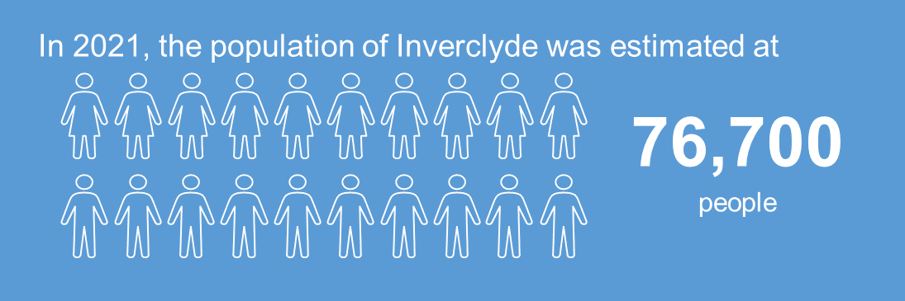

Alongside challenging demographic trends in Inverclyde, the LHS analyses the potential housing impacts of changes in the number and types of households living in the area aligned to future household projections. **In 2021, there were an estimated 37,958 households living in Inverclyde, an increase of 3% since 2001.** This growth is significantly lower than the national rate with households increasing by 15% across Scotland over the same period.

In September 2020, National Registers of Scotland (NRS) published household projections for every local authority, based on 2018 population estimates. The projections include a principal scenario and variants based on alternative assumptions about migration trends (both high and low).

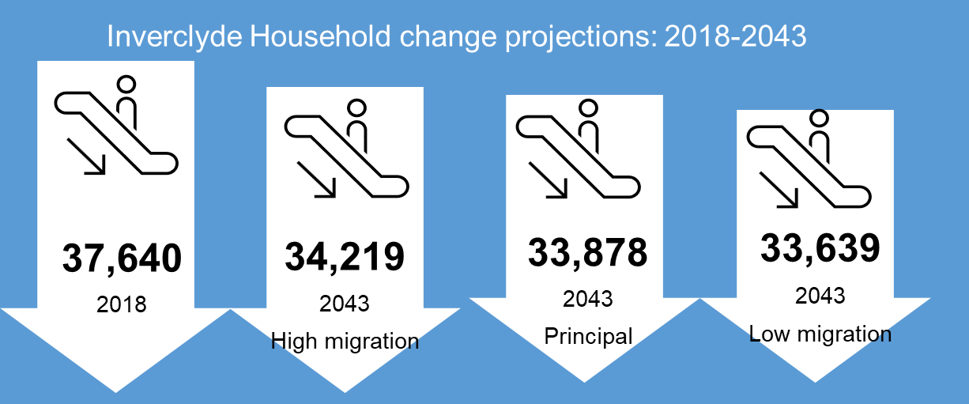All three scenarios show a projected decrease in the number of households in Inverclyde between 2018 and 2043 ranging from a decline of 9% under a high migration scenario (37,640 to 34,219 households), to 10% under the principal scenario (37,640 to 33,878 households) and 11% under a low migration scenario (37,640 to 33,639 households).

Under the principal scenario, over the life of the LHS (2023 -2028), the number of households in Inverclyde is projected to increase by 2% from 37,340 to 36,607. Over the next decade (2022-2032) household numbers will decrease by 3% from 37,340 to 36,433.

**The Ageing Population in Inverclyde**

Although the population of Inverclyde is expected to decline over the next ten years, this is against the backdrop of an ageing population. Between 2022 to 2032 the older population is expected to grow substantially as people live longer, whilst younger and working age populations are expected to decline. The working age population is projected to decrease by 15% between 2022 -2032 whilst the 65+ age cohorts will increase by 18% overall.

**Table 1: Inverclyde Population Change 2022 – 2032 by Age**



**Source: Population projections (NRS) 2018 Based**

The declining working age population will have a major impact on the sustainability of local communities in Inverclyde. Undoubtedly, the reversal of economic decline and depopulation will depend on Inverclyde’s ability to attract and retain a working population.

Although Inverclyde has a slightly lower life expectancy than the rest of Scotland, it is projected that the rate of increase in the older population will continue with the 85 and over age group expected to increase by 43% between 2022 and 2042. The aging population of Inverclyde will require housing, health and social care interventions that enable the growing older population to live independently.

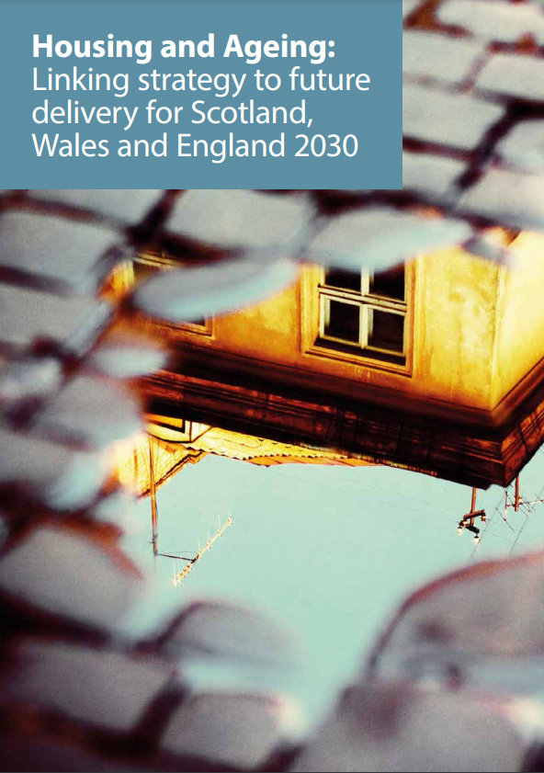**Innovative solutions will be required to enable older households to ‘Age in Place’.** The report “Housing and Ageing: Linking Strategy to future delivery for Scotland, Wales and England 2030”, recommends that housing should play a central role in the provision of services for older people. It also calls for new adaptable and affordable housing to be built; investment in early intervention; and meaningful consultation with older people to ensure there is suitable housing and services for individuals to continue living independently at home, whilst maintaining their connections with people and place.

There is increasing recognition that planning for housing in later life is about ageing in place and staying in the home of your choice for as long as possible. Increasing the supply of accessible housing in Inverclyde will be a fundamental part of promoting independence, flexibility and social inclusion. This can only be achieved by building accessible dwellings or by adapting the existing housing stock to meet the needs of Inverclyde’s older people as they age.

* 1. **The Inverclyde Economy**

The Inverclyde economy is characterised by lower employment rates than Scotland (68.2% compared to 73.4% in Scotland in 2020), and higher unemployment rates (5.1% in 2020 compared to 4.3%). Lower numbers of the workforce in Inverclyde are in full time employment (63%), when compared with Scotland (66%).

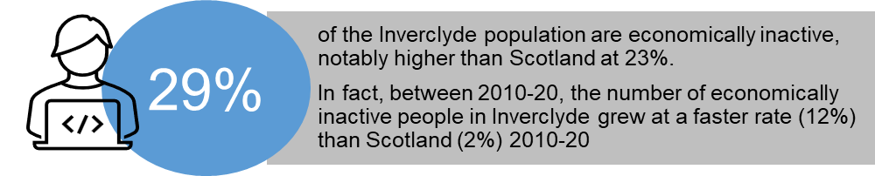

The Inverclyde economy relies predominately on micro and small business. Small and medium sized enterprises represent over 97% of local business, with 88% micro businesses. Only 3% of local business have more than 50 employees.

The largest employment sector in Inverclyde by FTE jobs is ‘Human, Health and Social Work Activity’ (19%) followed by ‘Accommodation and Food’ (13%), then ‘Wholesale and Retail’ (15%), ‘Education’ (9%) and ‘Administrative and Support Services’ (7%). Inverclyde’s employment profile therefore remains heavily reliant on the public sector. With decreasing public sector budgets resulting in reduced workforces in this sector it is likely that this will put additional pressures on the Inverclyde local employment market.

Economic output in Inverclyde has historically been significantly lower that the wider Scottish economy. In 2020 Gross Added Value (GAV) in Inverclyde was £42,484 per head, 6% lower than the Scottish average of £44,860. There is evidence that economic output is improving in Inverclyde with GVA growing by 7% between 2010 and 2020 in contrast to an 8% decline in Scotland. However, despite recent growth in productivity, Brexit, Covid 19 and the current inflationary context are putting unprecedented challenges on the Inverclyde economy and will slow economic growth and productivity in the short to medium term.

Furthermore, average annual incomes in Inverclyde are significantly lower that the Scottish average and declining when compared to the wider Glasgow City Region.

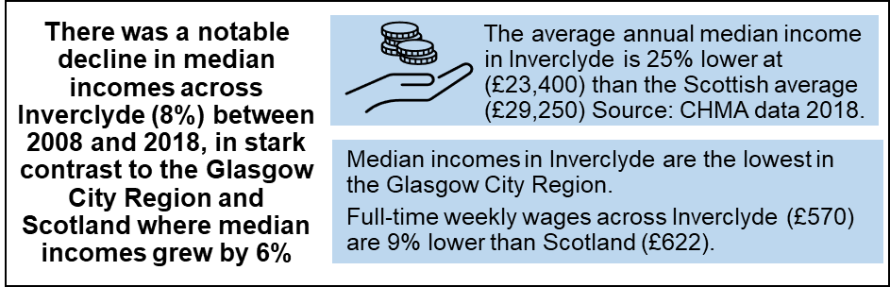

To address income inequalities, the Inverclyde LOIP and Economic Regeneration Strategy supports the growth and development of the Inverclyde economy as well as addressing urban decline and depopulation. A key element of the vision of The Inverclyde Alliance is that: ***“Inverclyde will be a more attractive place to live and work with excellent education provision, leisure facilities, transport links, good quality housing and employment opportunities”.***

To achieve this vision, it will be important that future housing planning is informed by Inverclyde’s economic growth strategy and vision for the future. Current demographic projections predict continued depopulation in Inverclyde at a scale unprecedented in Scotland. Future housing estimates which drive investment in housing reflect this population decline. Connecting housing to economic development strategies through regeneration masterplans is a key strategy for the new Local Housing Strategy.

**The Inverclyde Housing Market**

Inverclyde has experienced an increase in the rate of housing market activity following recovery from the housing market crash in 2009, with the volume of sales increasing by 27% over the last 10 years. However, there are more recent signs that the market has slowed with sales volumes dropping by 8% over the last 5 years.

**Chart 2: Average House Sale Values in Inverclyde**

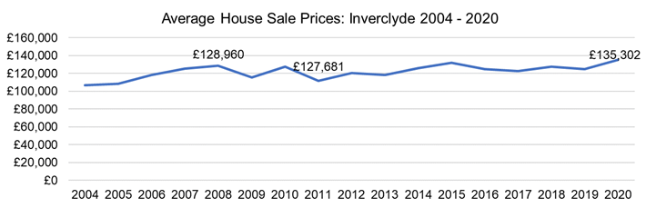In 2020, the average house price in Inverclyde was £135,302 which is 40% lower than the Scottish average house price at £188,902. House prices have grown steadily in Inverclyde over the last decade (by 28% overall) with growth slowing over the last 5 years at 17%.

Analysis of housing market affordability in Inverclyde reveals that homeownership is firmly out of reach to low income households primarily driven by the income poverty experienced in the area. The average income in Inverclyde is £31,165 per annum which is 21% below the Scottish average of £37,767. In fact, more than half of the Inverclyde population (53%) earn less than £25,000 per annum with lower quartile incomes of £12,827.

Households must spend up to 4.7 times the average local income to afford the average house price. This is well in excess of the typical 3.9 X’s multiplier used for mortgage purposes.

**Table 2: Inverclyde Mortgage Affordability Ratio 2021**

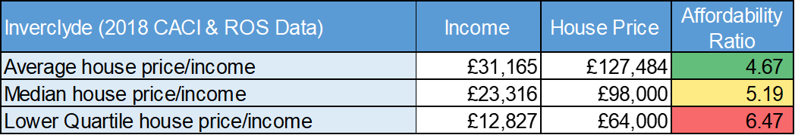

For households on lower incomes, housing affordability is particularly challenging with analysis revealing they must spend almost 6.5 times their income to purchase a home at the lower quartile price.

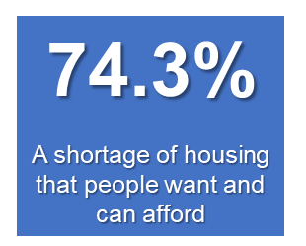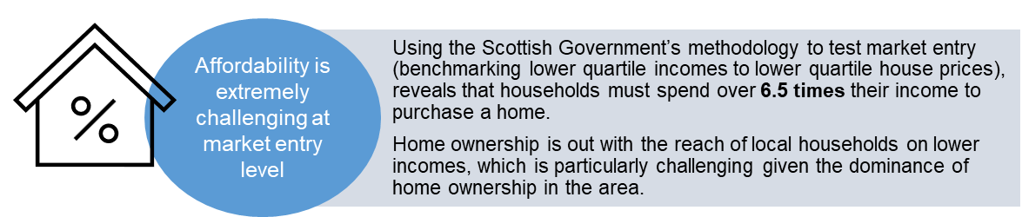

The evidence of challenging housing market access in Inverclyde are echoed by local residents. As part of the LHS early engagement survey, residents were asked to rank the top 5 housing challenges currently facing households in the Inverclyde area. The second ranking issue in the top five housing challenges ‘was a shortage of housing that people want and can afford’ at 74.3%. The top housing challenge facing residents in Inverclyde was defined as the energy efficiency of homes in the area.

* 1. **Inverclyde Housing Stock**

There are approximately 39,466 residential homes in Inverclyde to meet the needs of the local population.

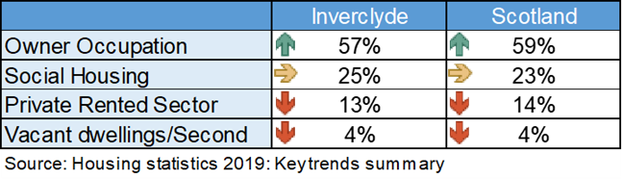

Owner occupation is the most dominant tenure in Inverclyde’s housing system representing 57% of homes, with the social housing sector accommodating 25% of local households (slightly higher than the Scottish average of 23%).

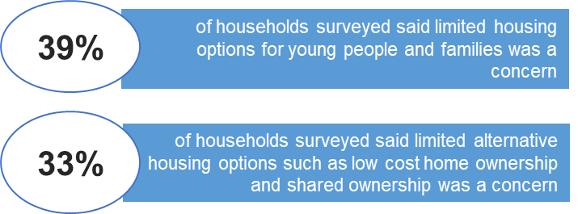The value of household incomes in Inverclyde makes affordable housing options central to meeting housing need, particularly for working age households who have no eligibility for social housing. Demographic projections show a decline in the population of working age households making it increasingly important that a wide range of quality housing options are available for working people to realise Inverclyde’s economic regeneration and growth strategy.

The early engagement survey held to inform the Local Housing Strategy development reveals that limited housing options are a concern for many households in Inverclyde. Almost 40% identified ‘limited housing options for young people and families’ as a concern, with a third highlighting a lack of intermediate housing options such as low cost home ownership as a problem.

The private rented sector (PRS) accounts for 13% of the housing stock in Inverclyde which is slightly lower than Scotland at 14%. The PRS in Inverclyde has almost doubled in size over the past decade and is an important transitional and flexible tenure option to those who are not eligible for social housing or cannot afford to access the housing market. Having said this, there is evidence that the cost of private renting is out of reach for low-income households in Inverclyde. A household requires to earn up to £25,000 to be able to afford the average market rent if they devote 30% of their income to housing costs. This is significantly above lower quartile incomes in Inverclyde (£12,827).

**Inverclyde Dwelling Profile**

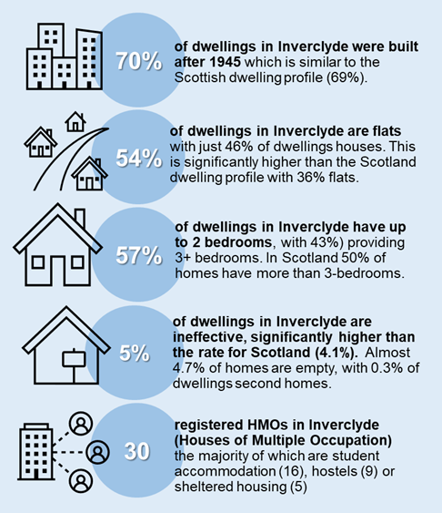**There are approximately 39,466 residential homes across Inverclyde**

The dwelling profile in Inverclyde is characterised by properties that are flatted, more dense and smaller in size than elsewhere in Scotland. The age profile of the current housing stock is relatively new with 70% of dwellings in Inverclyde built after 1945, which is similar to the Scottish profile at 69%.

54% of all dwellings inn Inverclyde are flats, with just 46% houses. This is a significantly higher proportion of flats than is the case in Scotland where 36% of dwellings are flatted.

Furthermore, 57% of dwellings in Inverclyde have up to 2 bedrooms which again is higher than Scotland (50%).

There is a major mismatch between the needs and aspirations of local households and the profile of homes available in Inverclyde. There is evidence of an oversupply of 2 and 3-bedroom homes, with low demand housing concentrated in tenemental stock. Low demand homes are also concentrated in the most disadvantaged communities in Inverclyde, with limited quality options for households in employment or who require larger family homes.

**Empty Homes**

As a well as a challenging property type profile, Inverclyde also has challenges regarding long term empty homes. Properties that are considered to be long-term empty are homes which are recorded as empty on Council tax records for 6 months or more. Scottish Government statistics suggest that 1.4% of all homes in Inverclyde are classified as long term empty.

Empty homes area a wasted resource and can often cause blight on local communities and places. In Inverclyde, empty homes create a risk of exacerbating problems with low demand housing, further declining the value of place and community. In some cases, empty homes can prolong the efforts of social landlords to carry out improvement works to mixed tenure housing assets.

Tackling empty homes can be part of a holistic approach to increasing the availability of housing and helping to regenerate communities. To deal with such challenges, the Inverclyde Empty Homes Service was set up in 2017 as a partnership between Inverclyde Council, River Clyde Homes and the Scottish Empty Homes Partnership. When an Empty Homes Officer was appointed in 2017 there were 647 long term empty properties (properties empty for 6 months or more). The number of long-term empty properties in Inverclyde now stands at 541, a decrease of 16%.

The new Local Housing Strategy will programme further action to bring more long-term empty properties back into residential use, ensuring that there is a continued reduction in the number of long-term empty homes. As low demand housing stock is often located in areas of deprivation, it further limits the housing choices of the most disadvantaged communities. Maximising the use of existing stock will not only increase supply of local housing but support improvement in the condition of homes, helping to regenerate communities. This means that tackling long term empty homes will support wider LHS objectives.

# LHS Outcome 1: People in Inverclyde live in quality homes in connected communities

The LHS is an all-tenure strategy which considers current and future housing need, setting a strategic vision for housing across both public and private sectors. Providing a better profile of housing by size, type and tenure, in sustainable, well-connected places is a fundamental aim of the Local Housing Strategy and crucial to the delivery of the Local Outcomes Improvement Plan and ambitious economic development agenda.

Aligned to providing quality homes in connected places, the LHS is required to provide evidence and policy direction in relation to:

* the extent and nature of housing need and demand across Inverclyde
* defining a generous supply of effective housing land to enable the delivery of Housing Supply Targets
* the strategic direction for housing investment in Inverclyde, including the Strategic Housing Investment Plan and wider regeneration activity
* powers and mechanisms to help households and landlords make best use of existing homes
* efficient and innovative ways of financing the development of new homes and transforming existing homes.

Informed by analysis of the main issues and housing system drivers, LHS Priority 1 focuses on ‘***Delivering quality homes in connected places’*** in Inverclyde by:

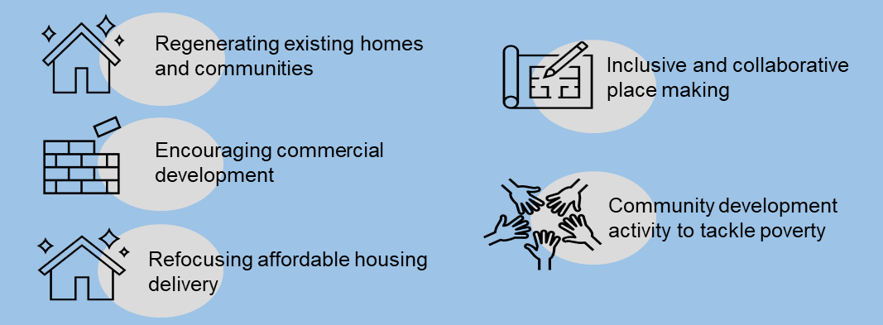

Chapter 5 sets out the evidence base and outlines what Inverclyde Council and partners will do to address the main challenges to housing regeneration and placemaking. It concludes with LHS priority actions for partnership, investment and delivery activity.

## LHS Priority 1: What’s our Starting Point?

A detailed briefing which sets out the housing system evidence underpinning LHS Outcome 1 can be accessed here: <https://youtu.be/AvQgxxvuYfA>

LHS analysis suggests that the key issues which drive the need for action, investment and partnership to enable housing led regeneration and promote placemaking in Inverclyde are as follows.

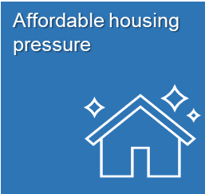There are 9,964 units of affordable housing across Inverclyde with around 10% which become available for letting in each year.

Inverclyde Common Housing Register (ICHR) is a partnership between Cloch HA, Oak Tree HA, Larkfield HA, Link HA and Sanctuary Scotland Housing. Partners operate a Choice Based Lettings system. There are just under 3,000 registrations on the Inverclyde CHR. There is clear evidence of affordable housing pressure, with roughly 7 registered applicants for every available partner let. Furthermore, 43 applications are made for every property advertised by partners. Whilst demand is strong, 25% of offers made to applicants are declined, suggesting that the quality and profile of homes available do not meet the needs and aspiration of housing applicants in Inverclyde.

Over and above this, River Clyde Homes operate Home Connections, a separate choice based lettings system. Just over 6,000 applicants are currently registered with 2/3 of applicants demonstrating a general or aspirational need for affordable housing. This means that most applicants have limited prioirty under the legislation guiding the allocation of social housing.

There is clear demand for affordable housing from working age households in Inverclyde, with at least 2/3 of housing applicants aged between 25-64. Most applicants (2/3) have a general housing need suggesting that housing affordability is the key issue for many, NOT housing unsuitability. Given the key role of housing in supporting the growth and retention of the working age population in Inverclyde, finding new and creative ways to target quality affordable housing to working households will be a crucial aspect of supporting the ambitious economic regeneration strategy for the area.

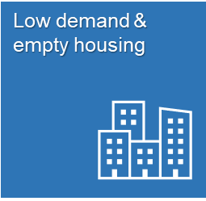Despite up to 7,000 households registered on housing waiting lists across Inverclyde, there is evidence of low demand housing stock in the area. Annual Charter Returns from Inverclyde social landlords to the Scottish Housing Regulator in 2021/22 show that 1,858 homes are identified as ‘low demand’ assets. This accounts for 20% of all social housing units in Inverclyde. 25% of the dwellings held by River Clyde Homes are classified as low demand homes and are located in the most disadvantaged communities in Scotland

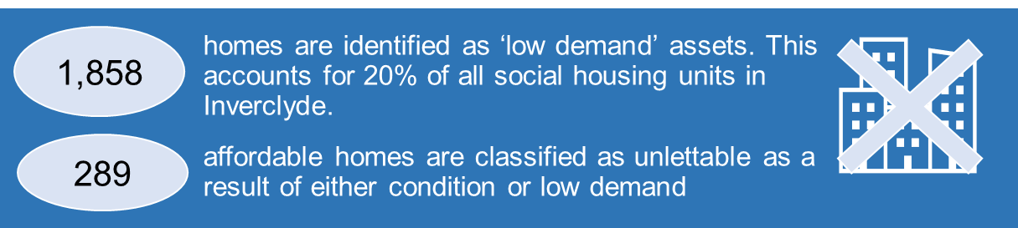

Concentrations of low demand housing stock is often located in areas experiencing deprivation, further limiting the housing choices of the most disadvantaged local people. A key focus of the new Local Housing Strategy is to target available resources from the Strategic Housing Investment Programme towards the housing led regeneration of vulnerable stock, with a lower priority given to new build housing delivery

Research commissioned by Inverclyde social landlords in 2019 explores the impact of new housing in further reducing demand for stock at risk. The research identified the profile of housing stock held by each social landlord which is vulnerable to low demand given programmed new build development. The research concluded: *“While the SHIP has an ambitious development programme, it should be recognised that new development is likely to have a negative impact on the demand for ‘at risk properties’ within the existing stock. Overall the effect of the new development may be for RSLs to modernise their stock through new build but older lower demand stock will become less popular and may in time be surplus to requirements”.*

Finding sustainable ways of transforming exisitng low demand housing assets to provide housing options that local people apsire to is a clear objective of the new Local Housing Strategy.

To provide the evidence required to calculate local housing and land requirements over the next 20 years, in 2022 Inverclyde Council supported the delivery of a Housing Need & Demand Assessment (HNDA) in partnership with the eight local authorities across the Glasgow City region.

The HNDA calculation works by projecting forward the number of new households who will require housing in Inverclyde. This is based on household projections produced by the National Records of Scotland (NRS). The number of existing households who need to move to more suitable housing is also included.

As NRS projections for Inverclyde, suggest a decline in the number of households forming or moving into the area over the next 20 years, the HNDA calculation suggests there is NO need for additional housing in the area. This ‘policy off’ approach does not reflect the impact of local strategic ambitions which seek to regenerate Inverclyde’s communities through investment in housing-led regeneration and placemaking activity.

Future housing estimates for Inverclyde suggest a requirement for just 180 new homes over the next 20 years. All of this requirement is for social housing, with no requirement for market or intermediate housing tenures

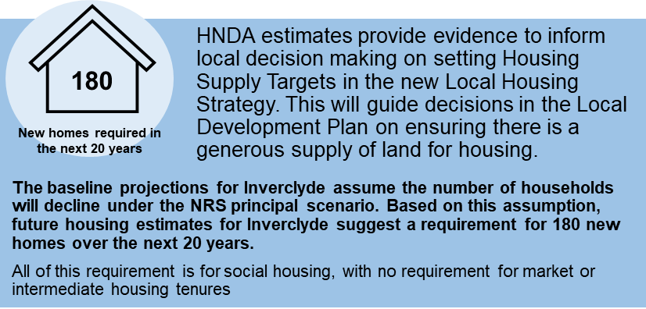In terms of market housing, HNDA3 suggests there is NO demand for new owner-occupied homes in Inverclyde. Whilst the market has not recovered enough to provide homes at scale since the 2008 recession, the subsequent effect of this means that households with aspirations to own a new build home have limited choices in Inverclyde and in some instances may leave to meet their demands elsewhere, further contributing to depopulation.

Continued investment in social housing to tackle stock which is no longer for fit for purpose through housing regeneration, selective demolition and placemaking; is therefore a key priority for the new LHS.

The Strategic Housing Investment Plan is the delivery plan for meeting affordable housing supply targets across Inverclyde. Over the next 5 years, the Strategic Housing Investment Programme in Inverclyde could deliver 710 affordable homes supported by roughly £38M of funding from the Scottish Government.

The delivery of the SHIP over the life of the new LHS will takes place against an ambitious national policy agenda to transform building and design standards. The Housing to 2040 Strategy sets a target that all new affordable homes will be zero emission by 2026. Furthermore, new provisions within The Building Scotland (Amendment) Regulations 2022 on energy performance came into force on 1st February 2023. This change to standards includes improved performance targets which will reduce emissions from new homes by a third, a focus on reducing energy demand including improved fabric insulation, and changes to make connection to low-carbon heating solutions easier.

However, to achieve national targets that all homes in Scotland should be net zero by 2045, investment in decarbonising existing homes through housing led regeneration and retrofitting projects will be essential. The national policy mechanism for affordable housing which prioirtises funding for new build housing activity over housing regeneration activity is a problem for Inverclyde. The new Local Housing Strategy sets out compelling housing system evidence and partner commitment to make the case that a different approach to affordable housing Investment in Inverclyde must be taken in the next 5 years.

The Housing Supply Target for Inverclyde set in the previous Local Housing Strategy was for 1,300 units over 5 years. Within this target, an affordable housing target of 450 homes (90 homes per annum) was set, with a private housing target of 850 homes (170 per annum). Analysis of housing completions in Inverclyde over the last 5 years (2016/17-2020/21), shows that housing delivery has NOT kept abreast of Housing Supply Targets. On average, 148 housing completions have been delivered against an annual target of 260 units. Whilst average annual affordable completions (78) have just fallen short of their target (90), market completion have fallen short by about 100 units every year.

The 2021 Inverclyde Housing Land Audit reveals that there is an effective land supply of 1,489 units across the Inverclyde area (2021-26), with a further 3,284 units of potentially effective supply available in the period from 2026 onwards. Current and effective land supply therefore offers generous capacity to meet Housing Supply Targets in Inverclyde.

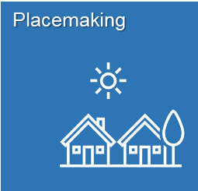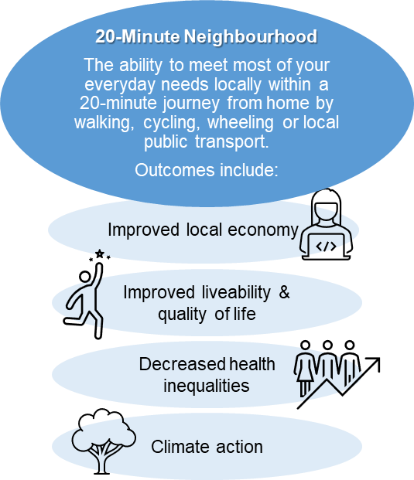A key concept in the Inverclyde Economic Regeneration Strategy is a place based approach to regeneration, tackling multiple issues (e.g. employment, entrepreneurship, social enterprise, business growth, housing, crime, and environment) in a co-ordinated way, through community engagement and partnership working. The aim is to strengthen communities, transform places and address issues of deprivation.

The Programme for Government 2020 commits the Scottish Government to working with local government and other partners to take forward a national ambition to create 20-minute neighbourhoods. A 20-minute neighbourhood offers the ability to meet most of your everyday needs locally within a 20-minute journey from home by walking, cycling, riding or by local public transport. The outcomes of creating 20-minute communities include an improved local economy, improved quality of life for residents, decreased health inequalities and action to tackle climate change.

Housing led regeneration activity will be a crucial aspect of making sure that a holistic and collaborative approach to transforming places is achieved. Placemaking, environmental improvements and developing sustainable communities will be essential components of the process to build regeneration masterplans across Inverclyde. A master planning approach will ensure a joined up vision for the area is articulated, taking a holistic view of a range of ‘priority places’ in Inverclyde. Consultation and engagement with local communities will be a key aspect of a successful regeneration master planning approach. Current priority place areas for developing regeneration strategies include: (i) Eastern Gateway; (ii) Central Port Glasgow and (iii) Greenock Town Centre

In each priority area, regeneration strategies will be informed by the condition of existing housing and evidence of housing need. To this end, the process will be informed by the outcomes of a new Private Sector House Condition Survey, a review of specialist housing provision and the development of an acquisition and refurbishment strategy in partnership with local Registered Social Landlords (RSLs). Furthermore, Inverclyde Council continues to acquire properties to be held empty in the Clune Park regeneration area with a future aspiration for the demolition of tenement properties, which are no longer fit for purpose. This housing led approach will be the main catalyst for the regeneration of the area. To date, over half of the properties in Clune Park, 269, have been acquired by Inverclyde Council.

## LHS Priority 1: What do Residents, Partners and Stakeholders Think?

Informed by resident feedback and housing system analysis, partners and stakeholders came together to define the major barriers that should be overcome in the Inverclyde LHS to enable housing-led regeneration and promote placemaking. Key local challenges which drive the need for future partnership, investment and delivery activity include the following:

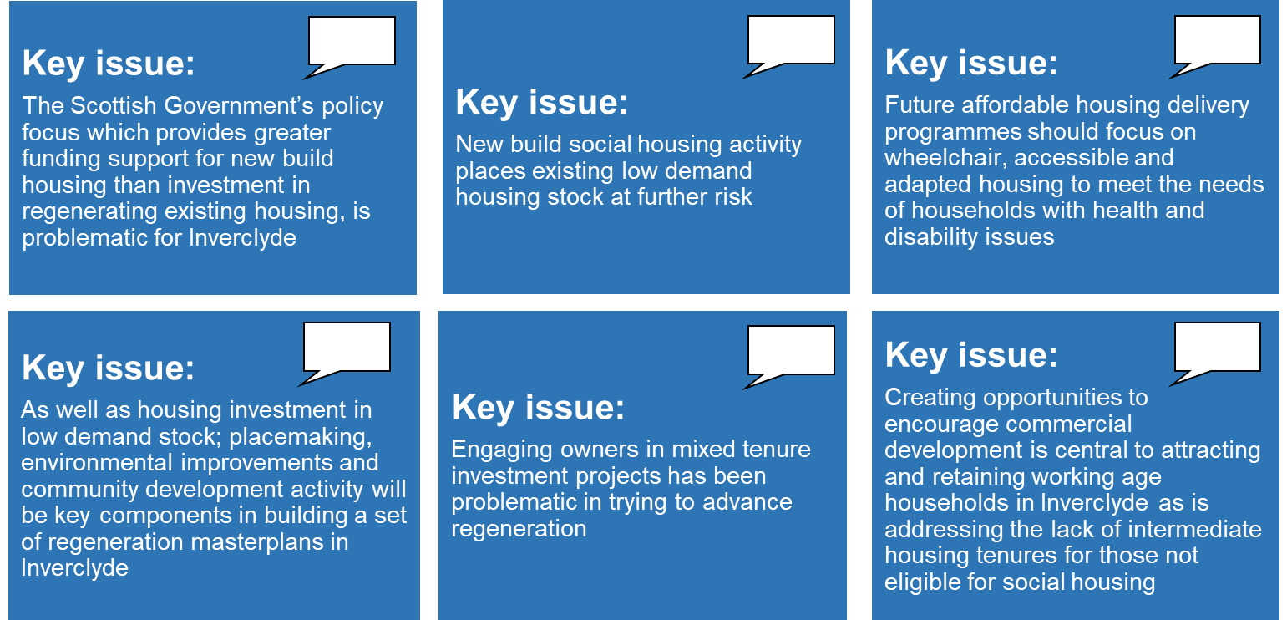

## LHS Priority 1: Our Actions

Partners and stakeholders co-produced a range of options and ideas to proactively address the challenges associated with providing quality homes in connected places across Inverclyde. The following priority actions have been identified to enable the Council and partners to deliver LHS Priority 1 Outcomes over the next 5 years:

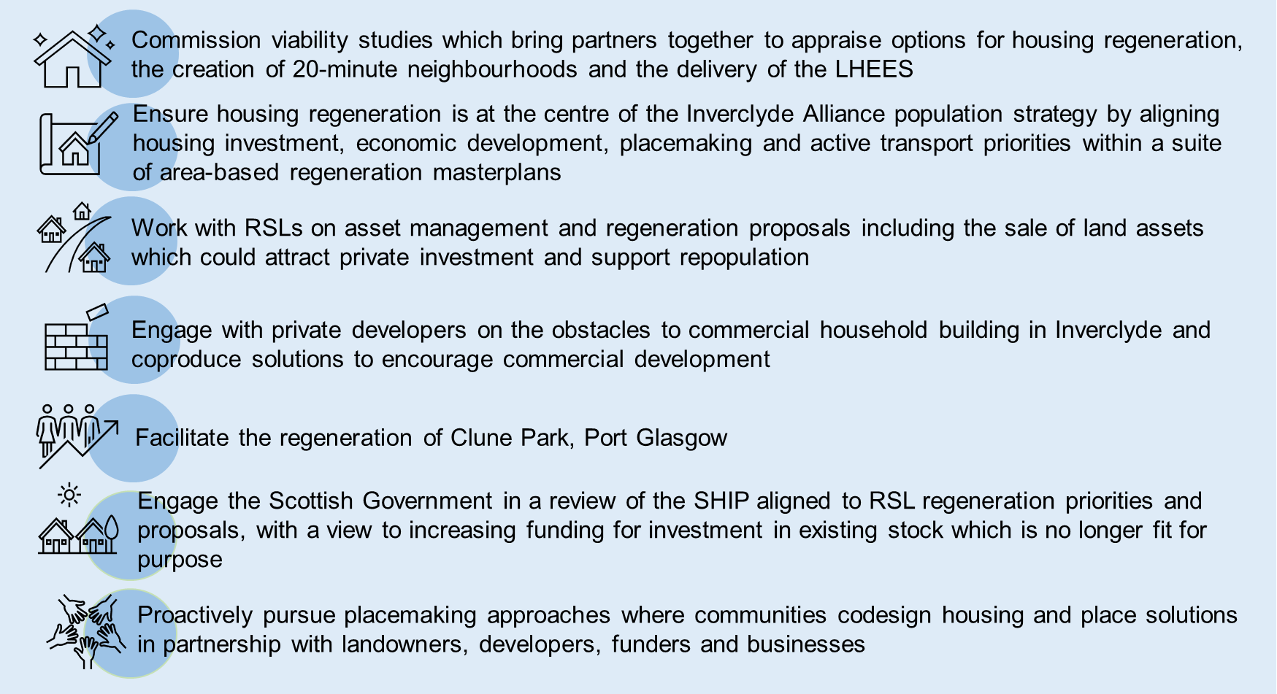

## Setting Housing Supply Targets

As part of the Glasgow City Region Housing Market Partnership, Inverclyde Council have recently completed a Housing Need & Demand Assessment (HNDA3) which provides a statistical estimate of how much additional housing will be required to meet all future housing need and demand in the area. The housing estimates produced by the HNDA provide the starting point for setting a Housing Supply Target (HST) within the Local Housing Strategy.

The Housing Supply Target (HST) sets out the estimated level of additional housing that can be delivered on the ground and informs the definition of the Housing Land Requirement within the Local Development Plan (LDP).

|  |  |
| --- | --- |
| Principle Scenario Projection of New Households | |
| Owner Occupation | 0 |
| Private Rent | 0 |
| Below Market Rent | 0 |
| Social Rent | 180 |
| Total | 180 |

**Table 5.1: Glasgow City Region Housing Market Partnership – Housing Need and Demand Assessment 3**

Local Housing Strategy Guidance (2019) requires the HST to take a policy view informed by the HNDA estimate, of the number and type of dwellings that can realistically be delivered over the period of the LHS.

The HNDA 3 total estimate figure of 180 new homes over the next 19 years, is not considered to be a realistic starting point for setting Housing Supply Targets.

In setting Housing Supply Targets, the need for housing investment to realise the Inverclyde’s wider ambitions for social and economic regeneration is essential. A bold ‘policy on’ approach to setting Housing Supply Targets which moves beyond demographic projections and reflects wider economic and placemaking strategies for Inverclyde is central to driving regeneration and has been the basis for setting the HST.

It has therefore been assumed that despite forecasted slowdown in the Scottish and UK economy in the immediate future, the transformational economic strategy under development by the Inverclyde Task Force[1] will mitigate risks of further economic decline in Inverclyde. As new jobs are created, it is assumed that housing delivery much keep momentum with recent housing completions rates over the last decade (c. 150 units per year). Moving beyond this, a growth in completions post Covid offers confidence of construction industry capacity to deliver in the Inverclyde area, which could be further encouraged by strategic commitments to develop a land offer that stimulates interest in speculative market investment. It has therefore been assumed that a 25% growth in completions beyond average annual delivery over the last decade, can be justified.

Aligned to the Inverclyde Alliance repopulation strategy, there is recognition that future housing supply needs to offer credible market options as well as a greater diversity of housing options to retain and grow Inverclyde’s working age population. Aligned to programmed investment in below market housing options via the Strategic Housing Investment Plan, it has been assumed that at least 60% of future housing completions should deliver market homes. This reflects Outcome 1 of the new Local Housing Strategy which prioritises the regeneration of communities via affordable housing investment programmes in contrast to a new supply agenda. Taking these factors into account, it has been assumed that housing supply targets should pivot towards private sector completions over the next decade.

Therefore, taking the HNDA estimates, the Minimum All Tenure Housing Land Requirement and other economic and regeneration factors into account; an annual Housing Supply Target (HST) for Inverclyde has been set at **187 units** per annum with a target of **75 affordable dwellings per annum** and **112 market dwellings per annum.**

A briefing paper detailing the full methodology for setting housing supply targets is available online at <https://www.inverclyde.gov.uk/housing/policy-and-strategy/local-housing-strategy>.

# LHS Priority 2: People in Inverclyde find it easier to access and sustain a home

The Local Housing Strategy (LHS) provides the overarching framework to mitigate the impact of housing affordability pressures on the ability of local households to access suitable housing options. It sets out housing’s role in improving housing choice and the LHS contribution to tackling income poverty and child poverty.

The LHS also provides the framework for the further development of the Council’s Rapid Rehousing Transition Plan (RRTP), building on national principles which seek to transform the delivery of homelessness services across Scotland.

Tackling and preventing homelessness is an ongoing housing priority both nationally and in Inverclyde. Ensuring local households have good awareness of housing options and are empowered to find the right home to meet their needs, is at the centre of a proactive and preventative model of improving housing access. In Inverclyde this also means finding opportunities to extend the range of quality housing options and choices available where they may be limited, including the acquisition of private sector homes for affordable housing or the transformation of existing low demand housing stock.

Equally, enabling households to keep their current home through the provision of person-centred housing support services is at the heart of LHS ambitions around improving housing sustainment and independent living.

Furthermore, the LHS is required to provide evidence and policy direction in relation to:

* improving the range of housing tenures and accessibility of housing options
* supporting the growth, development and operation of the private rented sector
* delivering proactive housing information, advice and assistance within a preventative housing options framework
* providing support services, which meet housing and underlying needs to enable housing sustainment
* improving housing affordability and enhancing housing’s role in tackling child poverty.

Informed by analysis of the main issues and housing system drivers, LHS Priority 2 focuses on ***‘making it easier for people in Inverclyde to access and sustain a home’*** by:

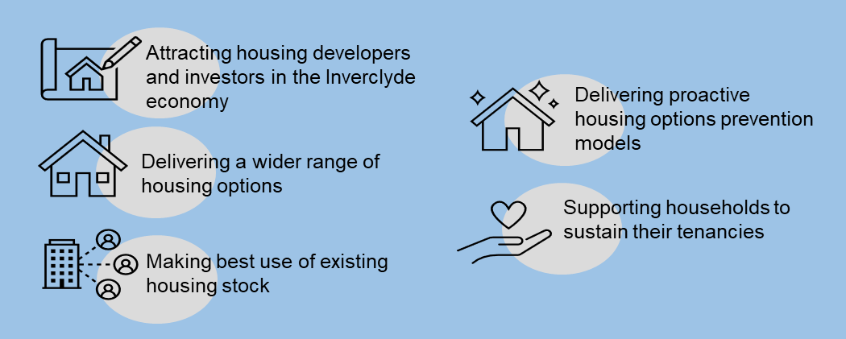

Chapter 6 sets out the evidence base and outlines what Inverclyde Council and partners are doing to address the main challenges in improving housing options, choice and affordability. It concludes with LHS priority actions for partnership, investment and delivery activity.

## LHS Priority 2: What’s our Starting Point?

A detailed briefing which sets out the housing system evidence underpinning LHS Priority 2 can be accessed here: <https://youtu.be/LEWXIB_7R18>.

LHS analysis suggests that the key issues which drive the need for action, investment and partnership to improve the range of quality, accessible, affordable and sustainable housing options in Inverclyde is as follows:

The housing system in Inverclyde is dominated by owner occupation with a similar proportion of homes in this tenure (57%) as is the case nationally (59%). The social housing sector in Inverclyde accommodates 25% of local households, slightly higher than the Scottish average (23%).

The value of household incomes in Inverclyde makes affordable housing options central to meeting housing need particularly for working age households who may have no eligibility for social housing. A survey of local households to inform the Local Housing Strategy priorities reveals that limited housing options are a challenge for many households. Limited housing options for young people and families was identified as a concern for 39% of LHS survey respondents, with limited alternative housing options such as low cost home ownership, shared ownership and mid-market rent a concern for 33%.

Demographic projections for Inverclyde show a decline in the population of working age households in Inverclyde by 15% over the next 5 years. It is important that housing investment is maximised as part of Inverclyde’s economic strategy and that a wider range of good quality housing options are made available for the working age population. Barriers to working households accessing quality, affordable housing options include:

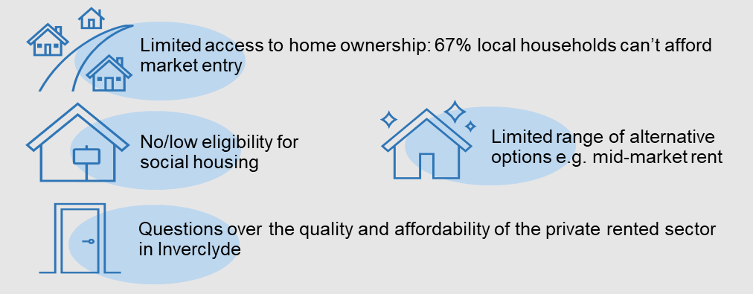

Housing and economic regeneration are fundamentally linked, and a lack of suitable, affordable housing can be a barrier to the economy being able to recruit and retain staff to grow their businesses and in turn grow the local economy. Housing has an important contribution to make to the growth of the local economy, ensuring that the working age population can be recruited and retained by connecting jobs to quality, affordable housing options.

The private rented sector in Inverclyde is slightly smaller (13%) than is the case for Scotland (14%) but plays a key role in meeting housing need locally. The PRS sector in Inverclyde doubled in size between 2005 and 2015. The PRS is an important transitional and flexible tenure which offers accessible housing options to those who have no eligibility for social housing and those who cannot access the housing market. It often provides options to low income working households who may have limited choices.

There are currently almost 3,700 properties currently registered under the Private Landlord Registration Scheme in Inverclyde across 2,662 landlords. The private rented sector has historically had higher levels of disrepair and poorer National Home Energy Ratings (NHER) than owner-occupied or social rented homes. There are many reasons for this, including the age profile of the private rented housing stock and historic under-investment by some landlords. The condition of PRS properties in Inverclyde are very varied, ranging from particularly problematic areas of Port Glasgow to high value new build developments. Increasingly problems of poorly maintained and managed housing are within areas that have high density private rented sector properties.

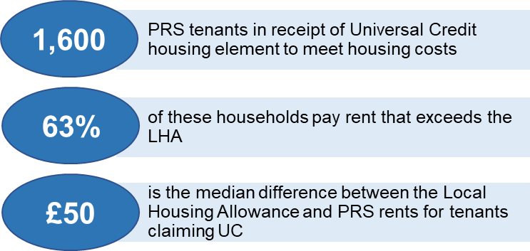There is evidence of a significant reliance on welfare subsidies to meet the costs associated with private renting in Inverclyde. Furthermore, there is clear evidence of affordability pressures in the Inverclyde PRS, with households on low to moderate incomes unable to afford market rents. A household requires to earn up to £23,450 to be able to afford the average PRS rent if they devote 30% of their income to housing costs. This is significantly beyond lower quartile incomes in Inverclyde (£13k).

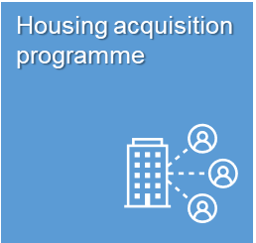Delivering new housing is not always the most appropriate method of meeting housing need particularly in Inverclyde where the condition of some private sector stock is substandard. This can contribute to public health issues, deprivation and can make the area less appealing to housing developers.

A lack of factoring arrangements within some mixed tenure areas has led to difficulties in delivering common repairs and improvement works. To address these issues and to improve the sustainability of communities and places, Inverclyde Council and local RSLs have recognised the importance of investing in existing poor quality housing through a Housing Acquisition Programme negotiated with the Scottish Government in 2021.

The Acquisition Programme has been designed to complement the Affordable Housing Investment Programme providing additional affordable housing in areas of poor quality private sector housing. Buying properties from the market allows social landlords to repair, renovate and regenerate; whilst continuing to address the need for additional specialist provision and homeless accommodation in areas where new homes cannot be built.

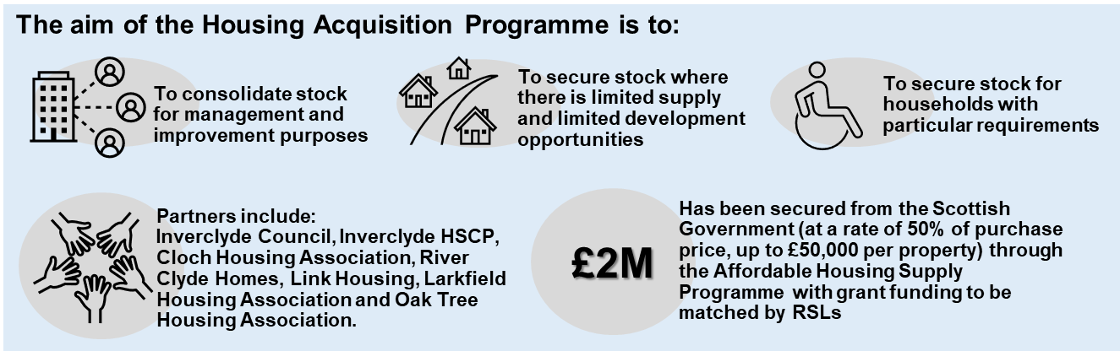

Partners have secured £2M of funding from the Affordable Housing Supply Programme to fund property acquisitions which improve stock condition and management, and positively impact on public health and community cohesion. The Strategic Housing Investment Programme (2022/23 – 2025/26) assumes 40 properties will be acquired each year, totalling 200 over the 5 year programme.

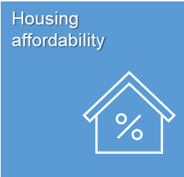Average incomes in Inverclyde are 21% below the Scottish average at £31,165. In 2020, 5.1% of the local population was unemployed, which is above the Scottish rate of 4.3%. Inverclyde has the highest proportion of households living in the top 20% most deprived areas in Scotland.

Deprivation and regeneration are long recognised priorities in Inverclyde. These priorities have a close relationship with housing in terms of neighbourhoods and tenure. The social sector has increasingly focused on accommodating households that are income-poor or otherwise deprived, due to the impact of housing policies such as the Right to Buy. Spatial concentrations of deprived households and people have become closely tied to spatial concentrations of social housing.

Analysis of housing affordability in Inverclyde reveals there are clear pressures locally, particularly for those on low household incomes. This is significant given that more than half of all households in Inverclyde (53%) earn less than <£25,000 per annum.

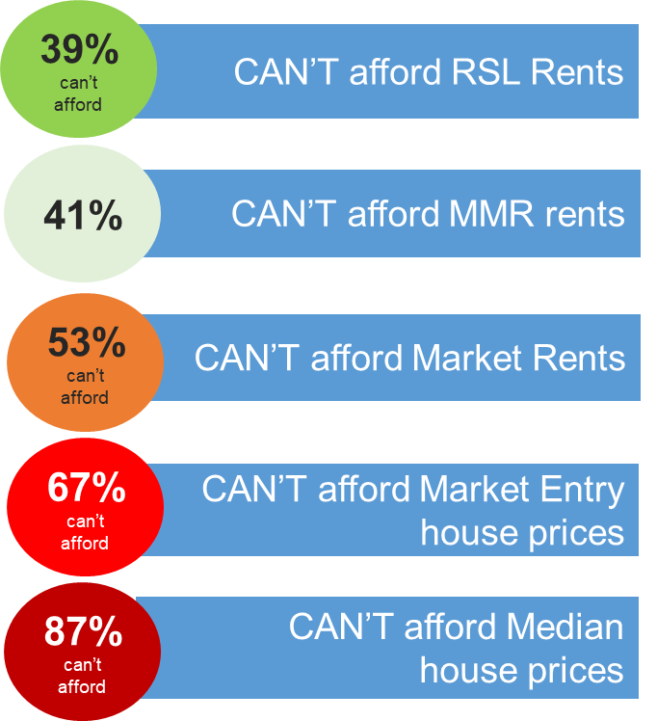As part of the insight to inform the LHS, the Council carried out housing affordability analysis to test the value of local incomes to meet housing costs across a range of housing tenures. The analysis demonstrates the affordability pressures faced by local households when devoting 30% of household income to housing costs. The proportion of local households who cannot each tenure is set out on the right.

Two thirds of households cannot afford the market entry point in Inverclyde, which is extremely problematic given the dominance of owner occupation as a housing option in the area.

Whilst social housing rents are affordable to more than 61% of households in Inverclyde without subsidy, social housing is only available to roughly 25% of local households.

Providing a more diverse and affordable range of quality tenure options is therefore a key priority of the new Local Housing Strategy.

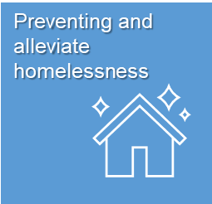In 2021/22, 323 households made applications for assistance under the homeless legislation in Inverclyde, up 4**%** on the previous year. This number has been increasing since 2016-17, with a 28% increase over the period. On average over the past 5 years, 260 households made homeless applications in the Inverclyde area.

To reverse this trend, a two-year change programme commenced in 2022 to transform Inverclyde’s Homelessness Service. The service was relaunched with a stronger focus on homelessness prevention through multi-agency collaboration. As a result, between 2021/22 and 2022/23, a reduction in the number of homeless applications was achieved from 323 to 292.

In Inverclyde, 82% of all homeless applicants are assessed as unintentionally homeless and in priority need, a similar proportion to Scotland. The average time to discharge the homeless duty from application to final outcome in 2021/22 was 23 weeks, which is significantly lower than the Scottish average at 37 weeks. However, the average time to discharge the duty has increased by 17% in the last 5 years (from 19 weeks in 2016/17).

The main reason for homelessness in Inverclyde in 2021/22 is ‘asked to leave current accommodation’, which is experienced by 1 in 4 people who approached the service. Beyond this, 21% of applicants experienced a non-violent dispute in their household, followed by 14% who experienced a violent dispute within their household. 5% of homeless applicants in Inverclyde were discharged from an institutional setting.

Almost a quarter (23%) of reasons for failing to maintain accommodation in 2021/22 related to financial difficulties/debt/unemployment, which perhaps reflects current cost of living pressures in a household population which experiences some of the highest income poverty and deprivation in Scotland.

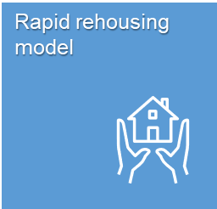Currently, there are 79 units of temporary accommodation across Inverclyde, comprising of 49 units of dispersed accommodation provided by local RSLs and 30 units of hostel accommodation within the Inverclyde Centre. Through service design, the longer term strategy for temporary accommodation in Inverclyde is to increase the number of community based dispersed tenancies, reducing the number of hostel units as a result of decommissioning the Inverclyde Centre.

Homelessness prevention and faster access to settled housing are the cornerstones of the Rapid Rehousing model in Inverclyde. The RRTP sets a partnership and resource framework in Inverclyde to transform the delivery of homelessness services. There are four key priority areas of the Inverclyde Rapid Rehousing Transitions Programme including:

1. Developing a preventative housing options model
2. Creating new pathways to settled housing
3. Improving access to housing through private sector initiatives
4. Improving access to support services to enable sustainment

In 2022, RRTP principles informed the approval of a change programme to transform homelessness services in Inverclyde. The change programme focuses on three key areas – support, staffing and accommodation. This change programme is the catalyst for transforming homelessness services in Inverclyde and will include the following actions:

* Develop rapid rehousing support team with clear objectives to meet individual outcomes for service users
* Develop future workforce model fit for modernised Housing Options and Homeless service
* Undertake options appraisal for any future housing models based on service user needs and demand.

Over the last 12 months, the change programme has been successful in achieving:

* the creation of a new Rapid Rehousing Support Team to provide intensive wrap around support to homeless households with complex support needs, leading to a reduction in repeat presentations by 27% and 21% drop in long-term homeless cases
* staff and service user engagement to redesign and restructure staffing arrangements ensuring that lived experience evidence influences the design principles of the new homelessness service
* significant upscaling of the Housing First model with over 40 households receiving support by March 2023
* improved collaboration and process development with Criminal Justice and Health services leading to a 30% reduction in homelessness by those leaving an institutional setting in 2022/23
* the phased decommissioning of the Inverclyde Centre including the closure of 7 rooms in parallel with an increase in community based dispersed accommodation provided by RSLs
* the conversion of 23 temporary tenancies to permanent settled housing.

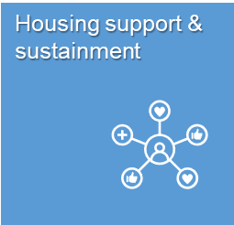It is estimated that up to 60% of homeless applicants in Inverclyde have no identified support needs. This is higher than with the homeless population with no support needs in Scotland (52%). This group simply require access to settled housing to resolve their homelessness. For the 42% who do have support needs, a further 12% have moderate support needs (i.e. 1 identified need) which (if required) could be met by visiting support services

It is estimated that up to 24% of homeless applicants have high support needs, with a further 6% having multiple or complex needs. Homeless households with complex support needs may need wrap around support services to enable resettlement and independent living following housing crisis. Short–term housing support is important to help reduce homelessness and increase tenancy sustainment. There is a legal requirement to assess and provide short-term housing support where needed for all homeless and potentially homeless people.

**As outlined in the RRTP, the delivery of person centred, and proactive housing support services is key to housing sustainment and homelessness prevention.** Partners suggest that responding to the additional support needs of those who present as homeless is the biggest challenge to achieving rapid rehousing in Inverclyde. Recent analysis has exposed that the homeless problem in Inverclyde should be framed from a mental health and addictions perspective, as it is clear that people have more specialist requirements above their housing need.

The creation of the Rapid Rehousing Support Team creates the delivery model for person centred, wrap around support services for homeless households experiencing severe and multiple disadvantage. Sincere launch in November 2022, over 40 homeless households are receiving support services at any one time. Early success would indicate this approach has enabled transition into settled housing for long-standing complex cases and seen a reduction in repeat homelessness cases.

The most significant challenges are around engaging and supporting homeless households with moderate – high support needs. Establishing positive outcomes for this group will depend on taking a person-centred approach to addressing both housing and underlying support needs using clear support planning processes. For households with very complex needs, the RRTP seeks to improve access to specialist supported accommodation in order to break the cycle of repeat homelessness.

## LHS Priority 2: What do Residents, Partners and Stakeholders Think?

Informed by resident feedback and housing system analysis, partners and stakeholders came together to define the major barriers that need to be overcome in the new Inverclyde LHS to improve housing choices and support options. Key local challenges which drive the need for future partnership, investment and delivery activity include:

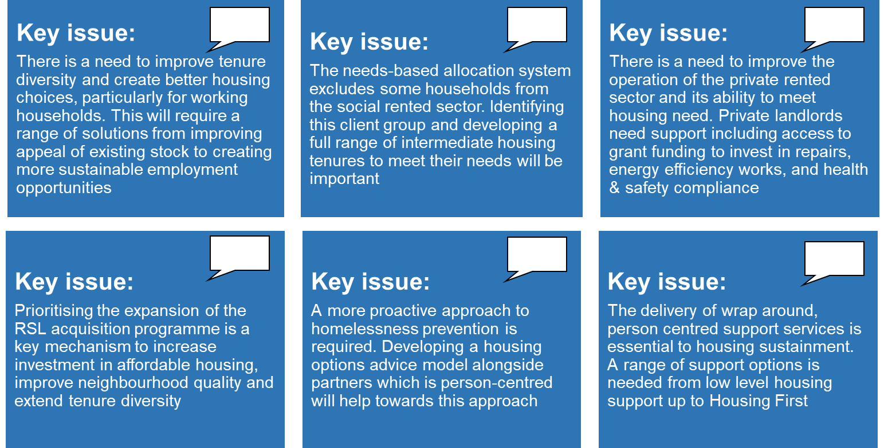

## LHS Priority 2: Our Actions

Partners and stakeholders co-produced a range of options and ideas to proactively address the challenges associated with making it easier for people in Inverclyde to access and sustain a home. The following priority actions have been identified to enable the Council and partners to deliver LHS Priority 2 Outcomes over the next 5 years:

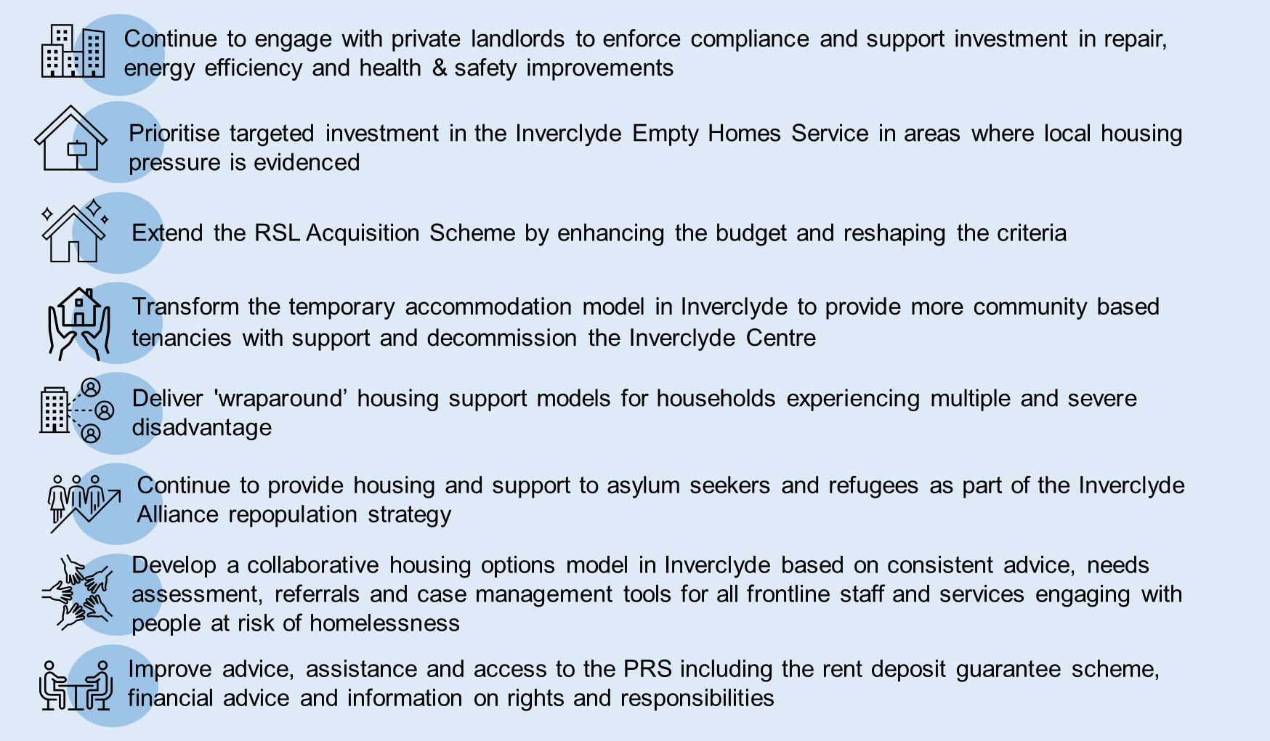

# LHS Priority 3: People in Inverclyde are supported to live independently and well at home

Through the delivery of the Housing Contribution Statement (HCS), the LHS has a key a role to play in meeting national health and wellbeing outcomes in Inverclyde. The HCS sets out housing’s contribution to achieving Inverclyde Health and Social Care Partnership’s Strategic Plan to support more people to live at home or within a homely setting and to promote independent living.

The LHS plays a significant role in supporting people to live independently and well at home by setting the framework for delivering accessible homes, wheelchair homes and specialist forms of provision such as supported accommodation for key client groups. The LHS also sets the framework for enabling people to live independently and well for as long as possible through investment in property adaptations, technology, care and support services.

Aligned to improving access to specialist housing and enabling independent living, the LHS is required to provide evidence and policy direction in relation to:

* targets for delivering wheelchair, accessible and specifically designed homes
* mechanisms to enable existing homes to be adapted to meet the changing needs of households via the Scheme of Assistance and the investment programmes of social landlords
* need for specialist housing provision across key client groups
* the delivery of preventative housing support services to promote independent living
* maximising the use of technology enabled care in homes across Inverclyde.

Informed by analysis of the main issues and housing system drivers, LHS Priority 3 focuses on ensuring ***people in Inverclyde are supported to live independently and well at home*** by:

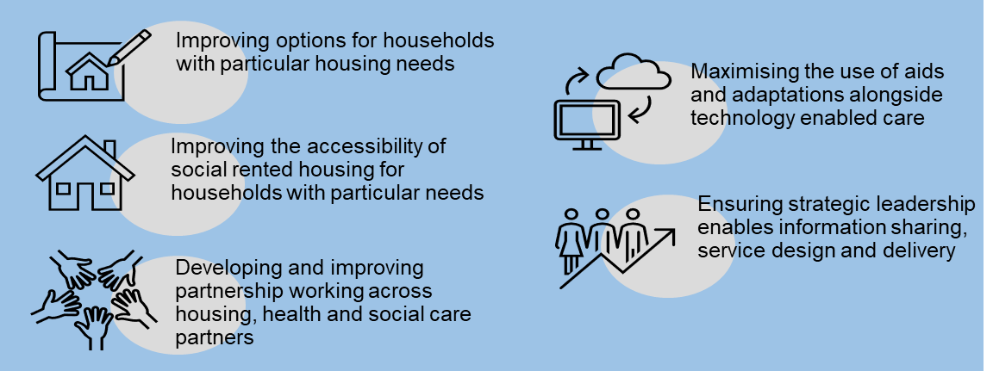

Chapter 7 sets out the evidence base and outlines what Inverclyde Council and partners are doing to address the main challenges to supporting people in Inverclyde to live independently and well at home. It concludes with LHS priority actions for partnership, investment and delivery activity.

* 1. **LHS Priority 3: What’s our Starting Point**

A detailed briefing which sets out the housing system evidence underpinning LHS Priority 3 can be accessed here: <https://youtu.be/WGfR6EFsFNg>.

LHS analysis suggests that the key issues which drive the need for preventative housing solutions which enablepeople to live independently and well at home are as follows:

There are 709 units of specialist housing held by Registered Social Landlords (RSLs) in Inverclyde. This accounts for 7% of all social rented stock in Inverclyde. Amenity and sheltered housing account for 85% of specialist provision consisting of 279 sheltered housing units and 321 amenity housing units. The remaining 15% of the specialist stock in Inverclyde consists of 66 wheelchair and 43 ambulant disabled homes.

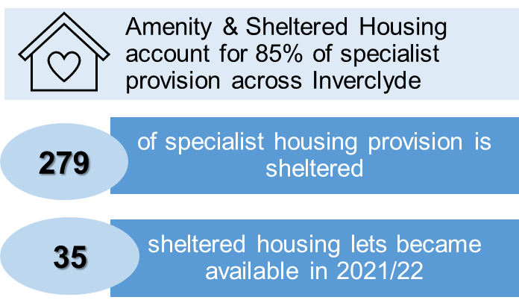Analysis of the number of lets in specialist housing suggests that turnover is relatively high with 35 sheltered housing lets (12.5%) taking place in 2021/22. However, this figure does vary across the RSL providers from 4% to 13%.

Further analysis of RSL housing lists shows the number of allocations to households requiring a wheelchair adapted property is around 40 lets per annum in 2021/22. Over and above this, across the three largest providers, only 2 of the 66 fully wheelchair accessible units became available in 2021/22 suggesting there is limited access to specifically designed wheelchair housing in Inverclyde.

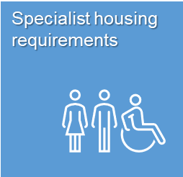The Inverclyde Common Housing Register identifies applicants with particular needs and health-related conditions which can be adversely affected by their housing circumstances. As of August 2022, there were over 3,500 people on the housing list. Of these, there are 73 applicants seeking wheelchair housing and a further 221 applicants who require level access housing. Furthermore, 52 applicants have a high (gold) priority for health/medical reasons.

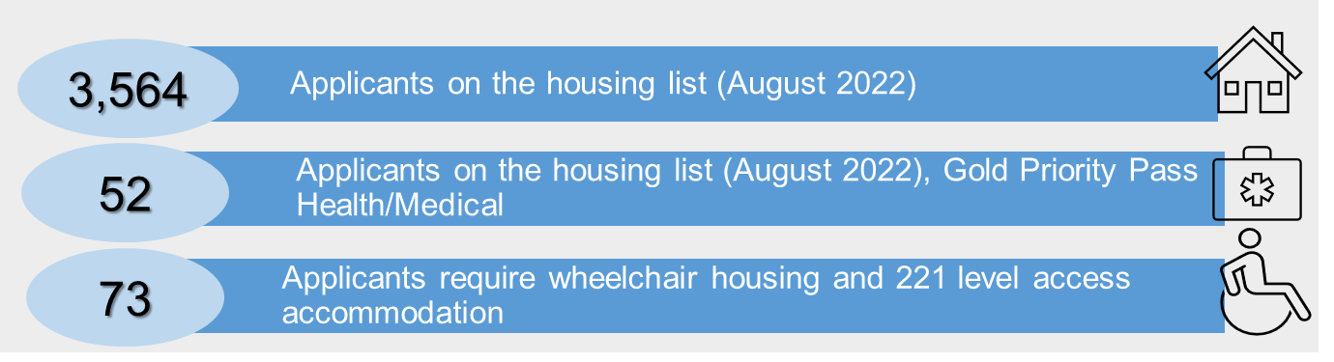

Based on further analysis of evidence from the Inverclyde Housing Register, it is estimated that over 1,200 households may require specialist forms of housing across Inverclyde due to having a long term health condition or disability.

*As part of the 2022 LHS Household Survey, local residents were asked to list their top 5 housing challenges for Inverclyde*. *205 respondents (43.2%) thought a “Lack of accessible housing options for people with health problems or disabilities including wheelchair, sheltered or adapted housing” was a key housing challenge in the area.*

In 2019, the Scottish Government issued guidance to all local authorities requiring them to set LHS targets to support the delivery of more wheelchair accommodation across all housing tenures. Following a ‘Specialist Housing Review’ in Inverclyde a new Wheelchair Accessible Housing Policy was approved for inclusion in the Inverclyde Local Development Plan where the Council will seek the provision of 5% wheelchair accessible housing on new build development sites of 20 units or more. Furthermore, the Inverclyde SHIP (2023- 2028) outlines the requirement that all new affordable housing developments are now required to provide wheelchair accessible housing regardless of tenure.

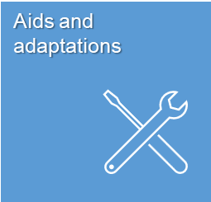As the population ages in Inverclyde there is a likelihood of increasing demand on care services along with a potential need for housing to be adapted to support households to live independently.

Investment in aids and adaptations makes a significant contribution to ensuring that households with health conditions and disabilities can live independently and well in their own homes for as long as possible. Inverclyde Council provide property aids and adaptions to improve the accessibility and suitability of tenants’ homes.

Inverclyde Council and RSLs provide aids and adaptations to tenants through Stage 3 grant funding and supplements this with their own budgetary provision. Average times to complete Council adaptations were 82 days in 2020/21 and 56 days in 2021/22. This is higher than the Scottish average for 2020/21 at 69 days, but lower than the national average in 2021/22 at 62 days.

Inverclyde Council also provides support to homeowners and private landlords through the Scheme of Assistance to receive assistance with disabled adaptations and repairs and maintenance to their properties. The Scheme of Assistance provides information on the support the Council can provide in relation to repairs, maintenance and adaptations in private sector housing. Priority is given to essential adaptions for people with disabilities.

Despite a projected overall decline in Inverclyde’s population of almost 15% between 2021 and 2043, the population of older people in Inverclyde is expected to substantially increase over the same period. Between 2021 and 2043 the 65 to 84 year old age group is projected to increase by 15% and the over 85 age group by 48%.

These projections will have a major impact on the provision of housing, health and care services and the interventions required to support the growing population to live independently and well at home. With just 35 sheltered housing units available for let in an average year, this increase in population raises the question of whether it will be necessary to develop new accessible housing as well as increases in the provision of adaptations to enable older people to live well at home in the community they prefer.

The Inverclyde Health and Social Care (HSCP) Strategic Plan 2019 - 2024 Strategic has 6 Big Actions, with Big Action 4 focusing on the delivery of supporting more people to live at home or within a homely setting and to promote independent living. The Housing Contribution Statement (HCS) 2019-2024 is aligned to the Big Actions within the HSCP Strategic Plan with the following three outcomes underpinning the HCS.

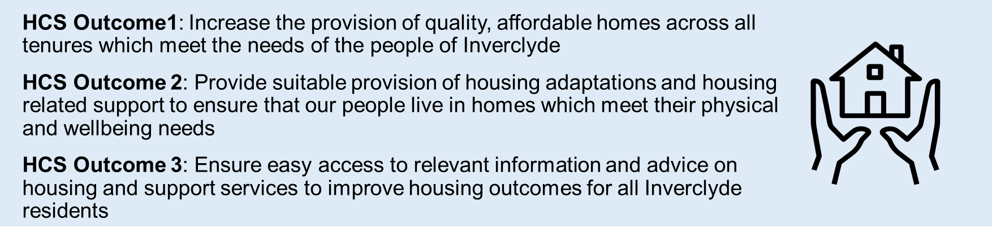

The provision of Assistive Technology and Homecare are important services to enable households to remain living at home. Assistive technology is the use of community alarms and telecare technology in the provision of care services at a distance using a range of analogue, digital and mobile technologies. These range from simple personal alarms, devices and sensors in the home, through to more complex technologies such as those which monitor daily activity patterns, home care activity, enable ‘safer walking’ in the community for people with cognitive impairments/physical frailties, detect falls and epilepsy seizures, facilitate medication prompting, and provide enhanced environmental safety.

In 2021/22, 1,971 households across Inverclyde were in receipt of Homecare services, with over 1.2M visits delivered over this 12 month period. The number of visit increased every month in 2021/22, with a shift toward providing HSCP direct services rather than commissioned services.



Almost the same number of households received telecare services in 2021/22 (1,916) as received care at home services (1,971). There has been a decline of 12% in the number of service users engaging with telecare over the last 3 years from 2,184 in 2019/20 to 1,916 in 2021/22. This drop in service users can be attributed to the continuing impact of the Covid-19 pandemic across the service.

Inverclyde HSCP Technology Enabled Care has been reviewing current community alarm equipment following an announcement by Ofcom that the analogue telephone network will be switched off in 2025 across the UK. The change to a digital network will impact on the analogue community alarm/telecare systems currently supplied to the current population of 2,000 service users. This will require all community alarms/telecare sensors to be replaced prior to the switch off date of 2025. Inverclyde has evidenced the successful operation of digital alarm units connecting through to the alarm receiving centre. A replacement program has been commenced with the first 250 units purchased.

Fully digitising telecare services will be an important aspect of the future strategy to enhance the role of technology enabled care in enabling independent living in Inverclyde.

The Council retains a statutory duty to assess the housing and support needs of Gypsy/ Travellers and to ensure that appropriate provision is made available. Inverclyde Council does not own or manage any Gypsy Traveller sites. In recent years, on average around 6 roadside encampments were reported to the Council which is a reduction from historic trends and in line with the national profile. Encampments are generally small in scale, typically 3 caravans or less. Improving the lives and outcomes of Gypsy/Traveller communities is an equality outcome for Inverclyde Council.

* 1. **LHS Priority 3: What do Residents, Partners and Stakeholders Think?**

Informed by resident feedback and housing system analysis, partners and stakeholders came together to define the major barriers that should be overcome in the Inverclyde LHS to ensure people in Inverclyde are supported to live independently and well at home. Key local challenges which drive the need for future partnership, investment and delivery activity include:

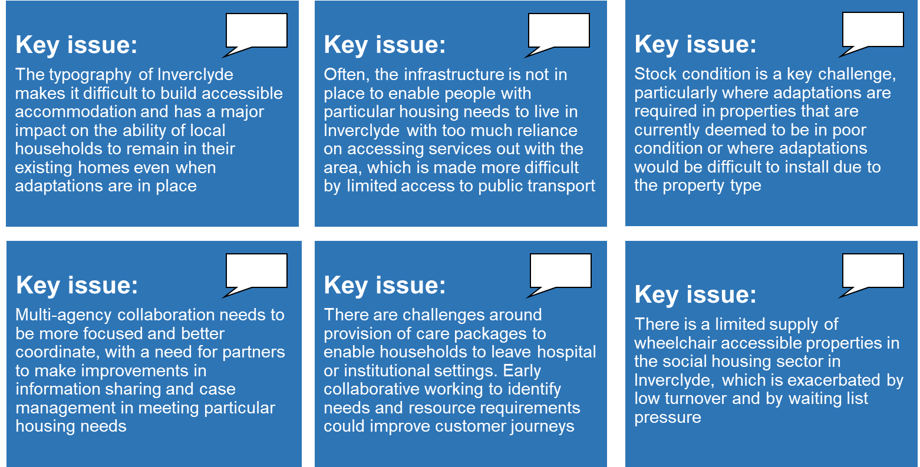

**7.3 LHS Priority 3: Our Actions**

Partners and stakeholders co-produced a range of options and ideas to proactively address the challenges associated with supporting people to live well at home by investing in preventative housing solutions. The following actions are key priorities established through option appraisal with the full list of Priority 3 actions detailed further in Chapter 10.

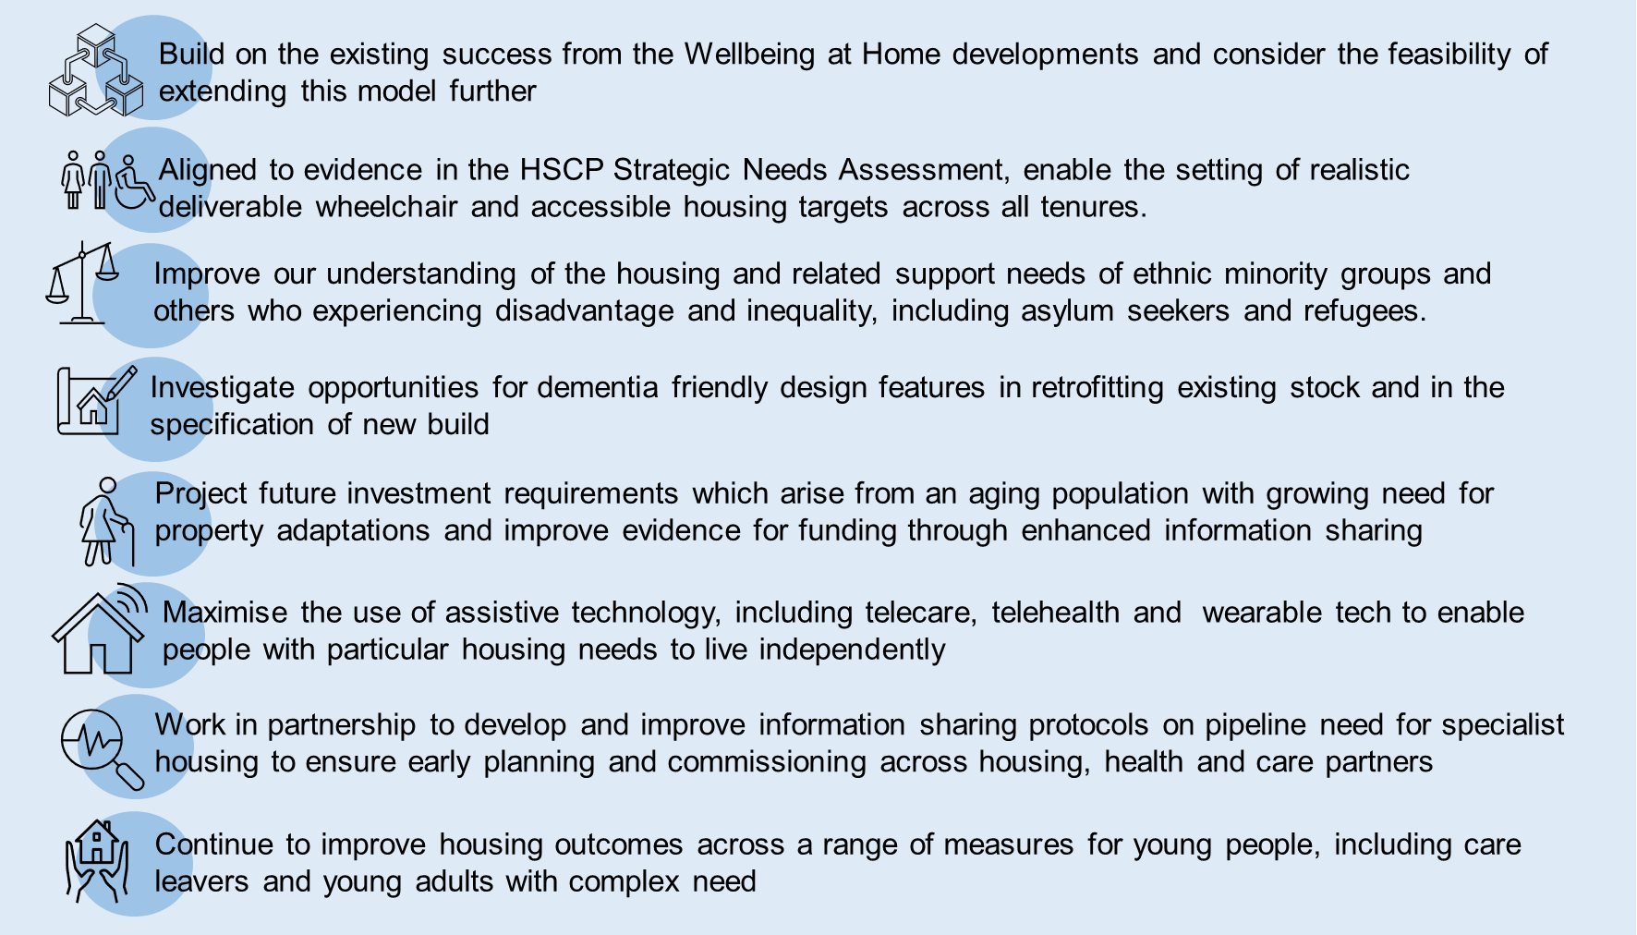

# LHS Priority 4: People in Inverclyde live in good quality, carbon friendly homes and energy efficient homes which reduce fuel poverty

The Local Housing Strategy (LHS) provides the strategic framework for improving the quality and energy efficiency of homes across Inverclyde, driving improvement in housing induced poverty and proactively tackling fuel poverty.

The LHS has a significant role to play in enabling the Inverclyde area to meet the ambitious energy efficiency, climate change and housing quality targets set by the Scottish Government. It sets out how affordable warmth can be delivered through investment in housing condition and energy improvements, and details key partnership approaches for reducing domestic carbon emissions. The LHS also details the framework for improving the condition and quality of housing across all tenures, setting out the mechanisms and support to enable private landlords and homeowners across Inverclyde to invest in repair and maintenance.

Aligned to improving housing condition, energy efficiency and reducing carbon emissions, the LHS is required to provide evidence and policy direction in relation to:

* the strategy for delivering energy efficiency standards including the Energy Efficiency Standard for Social Housing (EESSH2) and targets for private sector homes set in the Heat and Buildings Strategy. EESSH2 is currently under review to strengthen and realign the standard with the target for net zero heat in houses as set out in the Climate Change Update, the Heat in Buildings Strategy, and the Housing to 2040 Route Map. Whilst the EESSH2 standard is currently suspended, a revised standard will be published in 2023
* delivering affordable warmth and driving housing’s contribution to climate change
* improving the condition of all homes by meeting housing quality and repairing standards
* supporting private owners and landlords to invest in housing repair and maintenance through the Scheme of Assistance

Informed by analysis of the main issues and housing system drivers, LHS Priority 4 focuses on ensuring ***‘people in Inverclyde live in good quality, carbon friendly homes and energy efficient homes which reduce fuel poverty’*** in Inverclyde by:

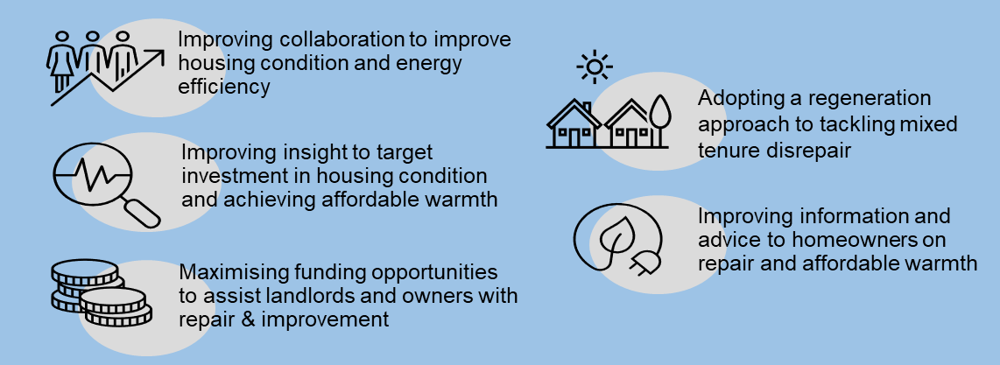

* 1. **LHS Priority 4: What’s our Starting Point?**

A detailed briefing which sets out the housing system evidence underpinning LHS Priority 4 can be accessed here: <https://youtu.be/uz13jPDXEXY>.

LHS analysis suggests that the key issues which drive the need for action, investment and partnership to improve housing condition, energy efficiency and reduce carbon emissions in Inverclyde are as follows.

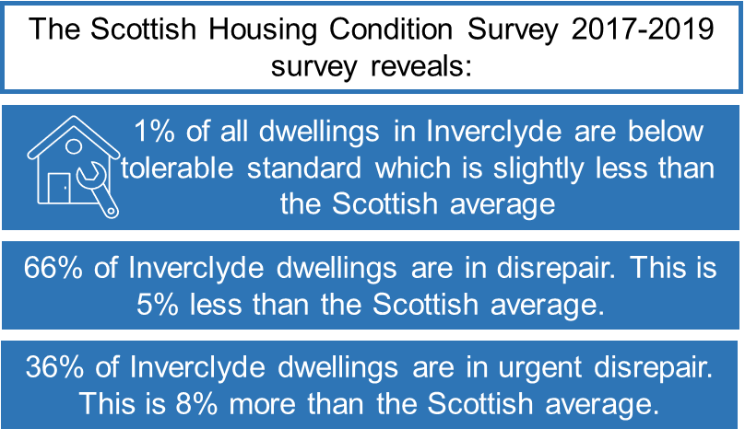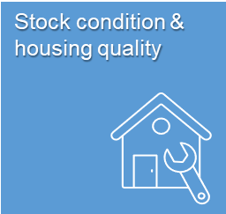Of the 38,000 residential homes in the area, Inverclyde has a similar number of older homes as Scotland with 29% of all dwellings built before 1945. In contrast, Inverclyde has a significantly higher proportion of homes which are flats with 53% flats than the Scottish profile (36%). High levels of flatted accommodation exacerbate housing quality issues as a result of the complexities of managing common repair. The extent to mixed tenure housing in the area compounds this issue.

Below tolerable standard (BTS) levels in Inverclyde are 1% which is slightly less than the Scottish average. Equally, dwellings in disrepair account for 66% of homes in Inverclyde which is 5% than the Scottish average. However, the number of dwellings in need of urgent repair in Inverclyde is 36% which 8% more than the Scottish average.

Early findings from a new private sector stock condition survey carried out by David Adamson & Partners (2023) reveal a very different profile of disrepair than reported in the Scottish House Condition Survey of 2019. Housing conditions are not comparable to the most recent Scottish national figures for 2019 as a number of changes to repair and quality standards have introduced since this date. In 2019 it is estimated that just 2% of national private sector occupied dwellings failed the tolerable standard, whereas finding from the 2023 Inverclyde Private Sector House Condition Survey suggest that over 38% fail this aspect. This increased non-compliance rate is related to the introduction of new heat and CO detection requirements.

Furthermore, 2023 Survey suggests that only 1% of dwellings exhibit major external repairs above the compliance threshold; with 16,781 dwellings (55%) requiring minor or localised repairs and the remaining 13,659 dwellings exhibiting no disrepair (44%). There is a major divergence in the proportion of dwellings with no external disrepair by area. In West Greenock LHMA only 5% of dwellings have no external disrepair compared to 74% in Inverkip & Wemyss Bay. There is also significant variation in rates of internal disrepair by area with only 11% of dwellings in Port Glasgow exhibiting no internal disrepair compared to 87% of dwellings in Kilmacolm and Quarriers Village.

The full results of the 2023 Inverclyde Private Sector House Condition Survey will be used to inform the development of housing-led regeneration masterplans in designated priority place areas as well as detailed analysis of the extent and nature of housing need.

As of 31 March 2022, 62% of Registered Social landlord (RSL) housing stock In Inverclyde met the Scottish Housing Quality Standard (SHQS) which is substantially lower than the Scottish average of 91%. The proportion of stock meeting the SHQS in 2021/22 ranged across the four mains RSLs from 34% to 74%. Compliance with the standard has dropped in recent years due to the publication of technical standards on EESSH.

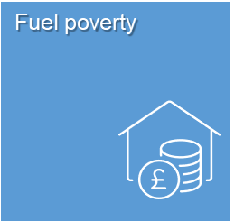Inverclyde Council’s Scheme of Assistance sets out the means by which the Council will provide advice, information and assistance to homeowners, eligible tenants and disabled occupants living in private sector housing. The aim of the scheme is to help improve quality, and to help meet the needs of disabled occupants of private sector housing stock in Inverclyde with adaptations. Of the 162 Scheme of Assistance grants awarded in 2021/22, all were allocated for disabled adaptations totalling £602k, an average of around £3.7k per household. In 2022/23, again all of the 128 Scheme of Assistance grants allocated, supported the delivery of disabled adaptations totalling £560k, an average of around £4.3k per household. Financial advice assistance with managing disrepair and maintenance in private sector housing was therefore not supported despite evidence of a higher level of serious disrepair than in other areas of Scotland. Having said this, over 2,000 households were provided with non-financial advice and assistance including advice and almost 1,000 home visits.

The Scottish Housing Condition Survey of 2017-19 reveals that Inverclyde has a higher level of fuel poverty across all housing tenures than the Scottish average. 28% of households in Inverclyde are estimated to be fuel poor compared to 24% in Scotland.

Furthermore, 13% are estimated to be in extreme fuel poverty in Inverclyde compared to 12% nationally.

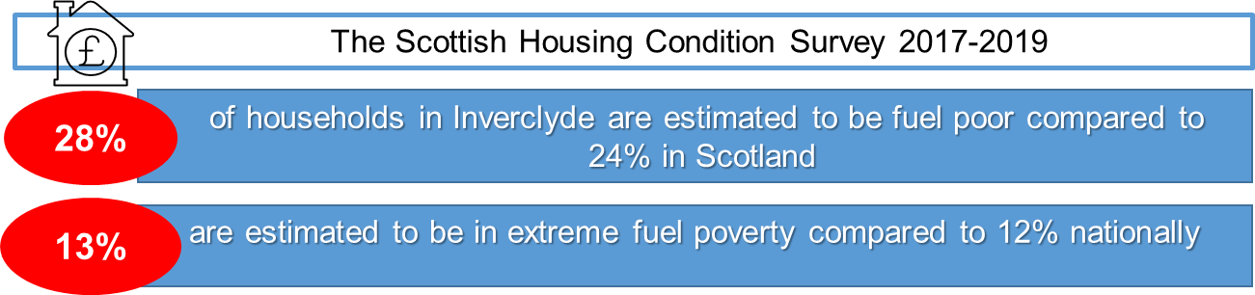

The Scottish Household Condition Survey sample size is too small to determine accurately the proportion of fuel poverty across tenures, however older people have a higher prevalence rate of fuel poverty with 31% being considered as fuel poor in Inverclyde.

Given that one of the three factors influencing fuel poverty is the energy efficiency of the housing stock alongside fuel prices and household incomes, the LHS has an important role in contributing to reducing fuel poverty through actions aimed at improving the energy performance of existing and new homes, providing energy advice and influencing income maximisation.

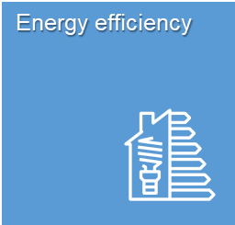Energy Efficient Scotland Area Based Schemes (ABS) is the Scottish Government initiative to tackle fuel poverty and increase energy efficiency in homes.

ABS schemes are designed and delivered by local authorities, in combination with local delivery partners. The scheme is primarily an insulation programme delivering solid wall and hard-to-treat cavity wall insulation. The funding often ‘unlocks’ larger mixed tenure schemes where a mix of social and private sector properties are involved.

In the last decade, over £15M of ABS funding has been invested in improving the energy performance of Inverclyde homes. More recently, over the past 3 years (2019/20-2021/22), £4.9M of HEEPS ABS funding has supported investment in energy efficiency improvements across Inverclyde, with 441 households assisted over this period. ABS funding provides improvements to private households in or at risk of fuel poverty that help reduce energy usage and costs. It will enable and support eligible homes to achieve an EPC rating equivalent to a C or better by 2030.

Delivering a renewable energy programme and implementing energy efficient practices which reduce fuel poverty is a corporate planning priority in Inverclyde and the Local Housing Strategy provides an opportunity to demonstrate how housing will contribute to achieving this.

The Scottish Government’s Heat in Buildings Strategy, published on 7 October 2021, outlines a pathway to net-zero emission homes and buildings by 2045. The Strategy includes an overarching ambition for all homes to achieve at least EPC band C by 2033 where feasible and cost effective. The second EESSH2 milestone is that all social housing will meet EPC B or be as energy efficient as practically possible by 2032 and the Scottish Government has committed to setting up a Social Housing Net Zero fund that will assist landlords to meet some of the costs associated with this target. In addition to this, by 2030 the vast majority of off gas homes that use high emission oil, LPG and solid fuels will have to convert to zero emission heating.

The following map produced by Changeworks, shows the extent and distribution of cold homes across Scotland, with Inverclyde estimated to have between 47% and 53% of properties with an EPC rating of D or lower. From the latest Annual Return on the Charter, of the 8,021 of the RSLs existing stock with a valid EPC, just 14% of this stock meets the EPC rating of B.

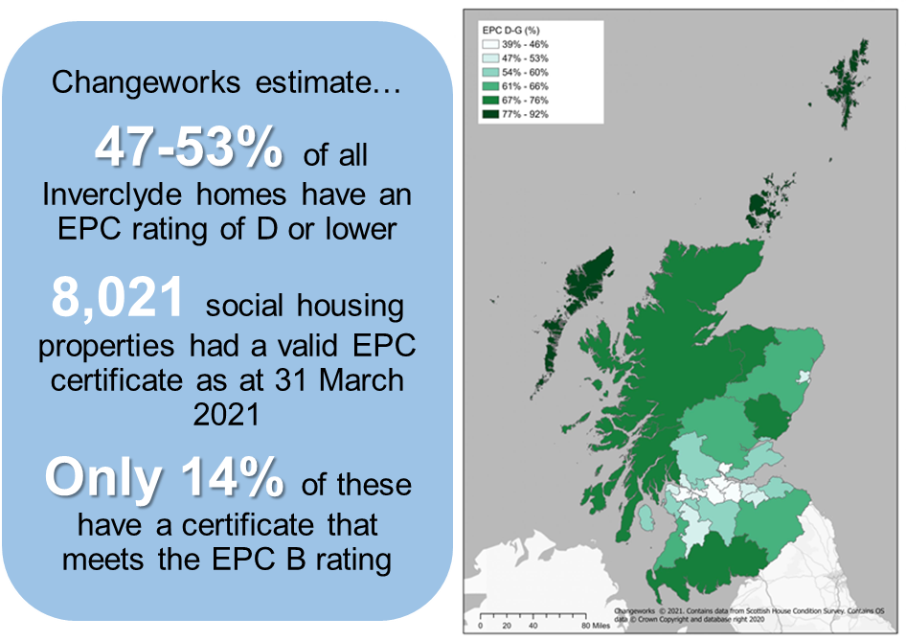

Early findings from the 2023 Inverclyde Private Sector Stock Condition Survey suggest that 29% of private sector dwellings fail to comply with the energy efficiency requirements of the Scottish Housing Quality Standard.

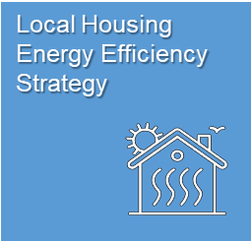Following a phase of pilot projects, all local authorities in Scotland will have a statutory duty to develop a Local Heat and Energy Efficiency Strategy (LHEES) and an associated Delivery Plan by 31 December 2023. The Heat in Buildings Strategy published in October 2021 sets out a detailed description of what LHEES are expected to include and commits to publishing LHEES for all local authority areas by the end of 2023. The preparation of the Inverclyde LHEES will help identify the most appropriate approaches to low carbon heat in different housing contexts (e.g. some areas are better suited to heat networks and others to heat pumps) and help phase the delivery of the plan.

Current work is underway across RSLs in Inverclyde to pilot scenarios to identify energy efficiency measures and heat decarbonisation measures across the domestic building stock to assess technical, financial and regulatory impacts alongside funding availability and fuel poverty impacts.

In developing the new Local Housing Strategy, an ambitious framework of actions has been defined including work to determine the feasibility of setting up a public interest energy company (i.e. a not for profit Energy Savings Company (ESCO)), the delivery of design led approaches to decarbonising homes, and collaborative engagement with public and private funders to finance the scale of the housing investment programme involved. Development and delivery of the LHEES in Inverclyde therefore has the potential not just to transform the condition and energy performance of the housing stock and built asset but the potential to support job creation in the construction and energy sectors on a scale which could be transformational in terms of economic growth and tackling poverty. The contribution of the Local Heat and Energy Efficiency Strategy to addressing the challenges associated with poverty, economy, wellbeing and place in Inverclyde is significant. To achieve this, elevating the development and delivery of the LHEES on the corporate and community planning agenda will be essential.

Almost 41.3% of all Inverclyde’s CO2 emissions are estimated to come from the domestic sector. Since 2005 there has been a 0.7% reduction in the emissions from domestic electricity in Inverclyde with emissions from other domestic fuels remaining fairly static over the same period.

Renewable electricity installation will have been a contributing factor in lowering CO2 emissions. Inverclyde’s renewable electricity installations mostly come from Photovoltaics. There were 742 renewable energy installations in Inverclyde in 2021.

Inverclyde’s Net Zero Strategy 2021 -2045 sets out Inverclyde Council’s route map to achieving net zero direct greenhouse gas emissions from its operations by 2045 and incorporates an interim target for 2031. The strategy covers reducing as much as possible emissions from Inverclyde Council’s buildings, transport street lighting, water and waste and options for offsetting the emissions that cannot be eliminated. The Net Zero Strategy aims to deliver 73% reduction of carbon footprint and improvement to net zero by 2045.

Digital inclusion covers digital skills, connectivity and accessibility. Barriers to digital inclusion include access and ability to connect to internet and go online, skills, confidence and motivation. Not everyone feels using the internet is relevant or helpful.

The Scottish Government’s Digital Strategy, Realising Scotland’s Full Potential in a Digital World, sets out the national digital agenda and vision. The aim is to put digital at the heart of inclusion, economic growth, reform of public services and preparing the younger generation for the workspace of the future, will ensure Scotland can anticipate and react in an agile way.

Inverclyde Council’s Corporate Digital Strategy 2021-2024 promotes a ‘***Digital Council - Digital Services - Digital people’***, with five key workstreams in place. There are currently a number of digital projects underway in Inverclyde including free Wi-Fi in public spaces and expansion of super-fast broadband.

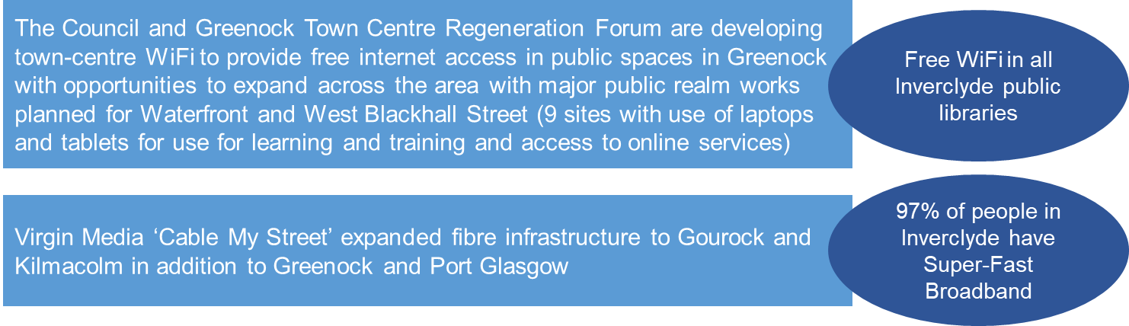

There are certain groups of people who are more likely to be digitally excluded including, people in social rented housing, homeless people, older people, lower income groups or people without a job, people with disabilities, people living in rural areas. Therefore, the LHS has a role in delivering outcomes which ensure digital connectivity across housing and housing related services.

* 1. **LHS Priority 4: What do Residents, Partners and Stakeholder Think?**

Informed by resident feedback and housing system analysis, partners and stakeholders came together to define the major barriers that need to be overcome in the Inverclyde LHS to improve housing condition, energy efficiency and carbon emissions. Key local challenges which drive the need for future partnership, investment and delivery activity include:

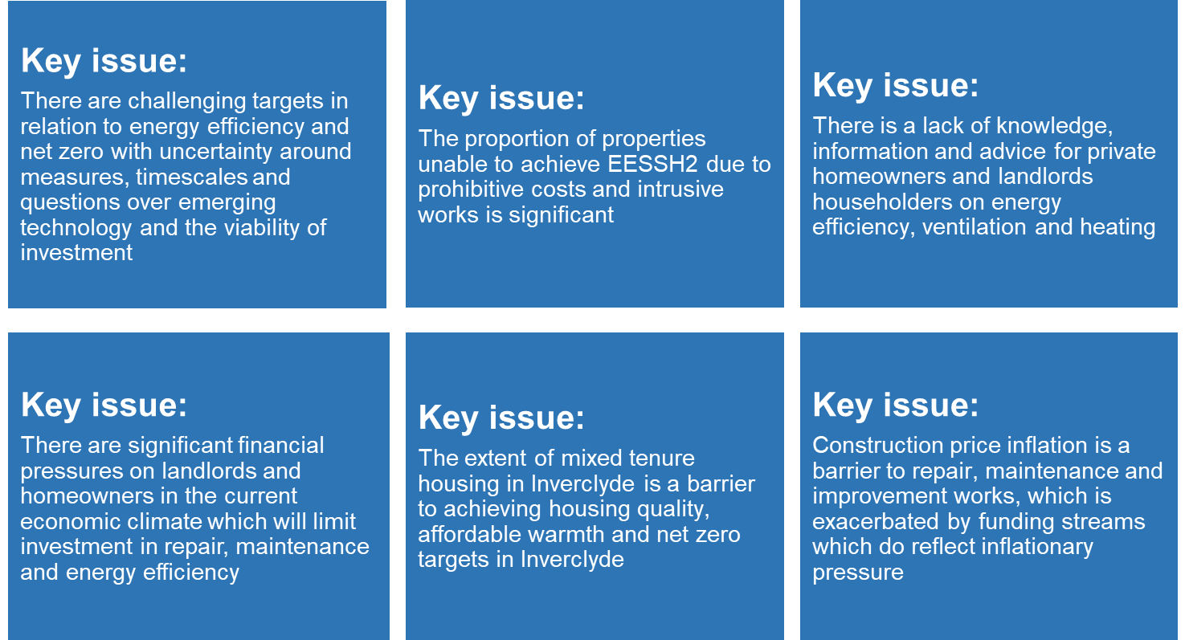

* 1. **LHS Priority 4: Our Actions**

Partners and stakeholders co-produced a range of options and ideas to proactively address the challenges associated with delivering quality homes which deliver affordable warmth and low carbon emissions. The following priority actions have been identified to enable the Council and partners to deliver LHS Priority 4 Outcomes over the next 5 years

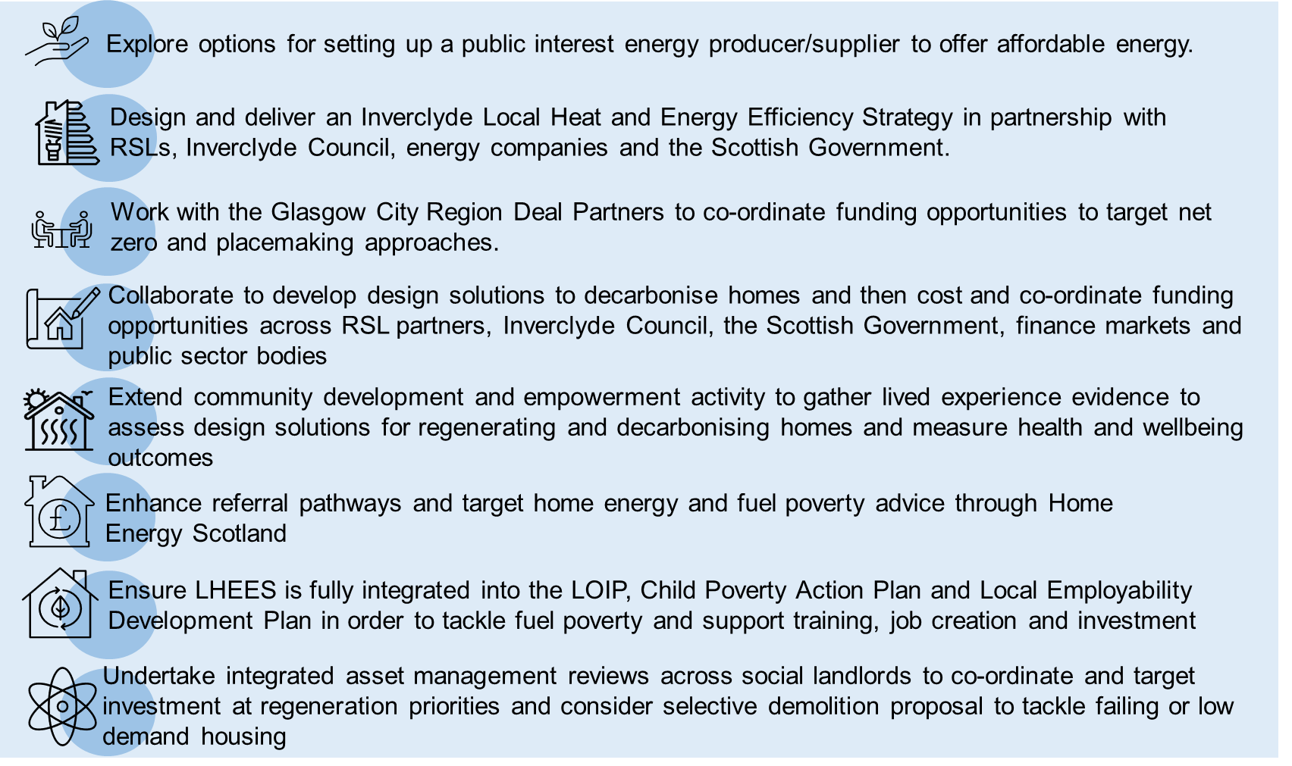

# Delivering Local Housing Strategy Outcomes

* 1. **LHS Implementation Framework**

The delivery framework for each LHS outcome has been developed into a series of detailed action plans which set specific timescales, resources and partner responsibilities to guide implementation and provide a strong basis for monitoring LHS progress.

A range of LHS milestones have been developed to track change over time including baseline indicators and delivery targets. The LHS Action Plan therefore provides the framework for evaluating the impact of LHS related led activity, partnership and investment.

LHS Outcomes are best delivered through a strong partnership network. The LHS Delivery Group is a new mechanism to stimulate and co-ordinate this partnership activity based on the LHS Steering Group assembled to co-ordinate LHS development. The LHS Delivery Group includes partners from Inverclyde Council, (Safer Communities, Planning, Housing Strategy, Regeneration, Planning and Performance), Inverclyde Health & Social Care Partnership (Alcohol and Drug and Homelessness Services), CVS Inverclyde and Registered Social Landlords including Cloch Housing Association, Oak Tree Housing Association, Larkfield Housing Association and River Clyde Homes.

The objectives of the LHS Delivery Group are as follows:

* to track progress and measure impact via the LHS Monitoring and Evaluation Framework
* to ensure that LHS outcomes are linked effectively into other strategic plans across Inverclyde partnerships
* to consider investment priorities and maximise shared resources
* to exchange information and planning data
* to review outputs from housing related research and insight, making recommendations to inform LHS implementation.

The LHS Delivery Group will link into a number of existing partnership forums which plan, implement and deliver housing related investment and activity. The activity across this network will be coordinated by the LHS Delivery Group to ensure partnership, investment and collaboration maximise opportunities to deliver LHS outcomes.

* 1. **Monitoring and Evaluation**

The LHS evaluation framework sets outcome targets for each LHS priority, together with the high level inputs, indicators and timescales that will underpin successful delivery. To develop the LHS Action Plan, Subject Matter Expert (SME) Groups were assembled for each LHS Outcome to screen, finalise and appraise LHS options for inclusion within the action planning framework. Using the same networks, SME Outcome Groups will monitor progress in the delivery of LHS action points on a quarterly basis, tracking progress and enabling remedial actions to be pursued. This approach will ensure milestones are achieved, with ongoing assurance that services/partners are on track to deliver specific LHS workstreams.

Based on this monitoring activity, LHS action plans will be reviewed annually by the LHS Delivery Group. In addition to strategic evaluation, partners will be responsible for monitoring the progress of related housing plans including the Strategic Housing Investment Programme, the Rapid Rehousing Transition Plan, the Housing Contribution Statement, and the Local Heat and Energy Efficiency Strategy.

* 1. **Resources**

This is an ambitious Local Housing Strategy with considerable investment required to deliver each LHS outcome. LHS delivery is set within a challenging economic context not only across the Glasgow City region but in Scotland and the UK. This challenging financial and resource context is set against a backdrop of increasing need for housing services and demand for high quality affordable housing options. There is therefore a real need to ensure that LHS resources are maximised through partnership, innovation and targeting preventative activity over the next 5 years.

There are substantial resources dedicated to or available for Local Housing Strategy activity in Inverclyde, as outlined for each LHS Priority below.

**Table 9.1: Main Resource & Funding Sources for each LHS Outcome**

|  |  |  |  |
| --- | --- | --- | --- |
| LHS Outcome 1: People in Inverclyde live in quality homes in connected communities | LHS Outcome 2: People in Inverclyde find it easier to access and sustain a home | LHS Outcome 3: People in Inverclyde are supported to live independently and well at home | LHS Outcome 4: People in Inverclyde live in good quality, carbon friendly and energy efficient homes which reduce fuel poverty |
| Scottish Government AHSP  RSL investment  Council Tax 2nd Homes  Private Developers Section 75 Contributions  Private developer investment  Regeneration Capital Grant Fund (RCGF)  Vacant & Derelict Land Fun  Glasgow City Region Deal funding  UK Government Levelling Up funding | Homeless Services (Inverclyde Council General Fund)  Scottish Government RRTP Funding  RSL investment  Private Sector Landlord investment  Private developer investment  Voluntary Organisations development funding | HSCP Funding  Scottish Government Aids & Adaptations Funding  Inverclyde Council General Fund  NHS Greater Glasgow & Clyde resources  Voluntary Organisations development funding  Aspiring Communities Fund | Scottish and UK Government Funding Initiatives  Energy Efficiency Grant schemes including HEEPS:ABS  Climate Change Fund  Utility company funding  RSL investment  Private Sector owner and landlord investment  Private sector lenders |

In addition to dedicated resources delivering LHS outcomes, LHS implementation is supported by a wider resource framework of staff, land resources and the existing housing stock in Inverclyde.

* 1. **Affordable Housing Supply Programme**

Inverclyde’s affordable housing supply programme is supported by grant subsidy from Scottish Government’s Affordable Housing Supply Programme. Based on SHIP Projections for 2022-2027, total investment in affordable housing will be £42M over the lifetime of this SHIP, including £38.6M of grant funding and contributions from Council Tax Second Homes discount funding, Developer Contributions (from Section 75 Agreements) and private finance from RSLs.

The Resource Planning Assumption (RPA) for the Council’s strategic local programme for 2022/23 was £9.6M, with future subsidy amounting to £38.6M. This investment will support delivery of up to 710 new affordable homes across Inverclyde.

**Table 9.2: SHIP Programme Resource Planning Assumptions 2022/23 – 2026/27**

|  |  |
| --- | --- |
| Financial Year | Resource Planning Assumptions |
| 2022/23 | £9.6M |
| 2023/24 | £9.5M |
| 2024/25 | £9.6M |
| 2025/26 | £9.7M |
| 2026/27 |
| 5 Year RPA Funding | £38.6M |

*Used 2025/26 RPA as per Guidance

**Developer Contributions**

As of 31st March 2023, there was £220k of Developer contributions made as a result of the Inverclyde Affordable Housing Policy to support the delivery of affordable housing. Section 75 and other mechanisms are used, where justified, to secure developer contribution where there is a demonstrable need for affordable housing. In recent years, as a result of a less confident housing market, the SHIP has had to become less reliant on the Affordable Housing Policy to ensure sufficient levels of programming for the Council and other developing partners.

**Council Tax Reserve Income from Reduction of Discount for Empty and Second Homes**

Inverclyde have funding available through income raised each financial year from the Council Tax levy associated with Empty Homes and Second Homes. This funding assists in supporting the delivery of the affordable housing programme including funding for land and infrastructure. Typically, surplus revenue from long term empty homes per annum totals £280k per annum.

* 1. **LHS Resource Projections**

Lead partners have responsibility for meeting LHS resource requirements to deliver LHS outcomes including the Scottish Government, Inverclyde Council, local RSLs, NHS Greater Glasgow & Clyde as well as the independent and private housing sectors and other public bodies.

Whilst it is difficult to predict the level of Scottish Government Funding to be allocated to local authorities over the next five years, the 2023/24 baselines position provides an indication of potential funding availability.

Housing related expenditure for Inverclyde is outlined in Table 9.3 below. This housing related expenditure of £8.5M per annum over the next five years, includes £1.24M of Inverclyde HSCP funding for homelessness and temporary accommodation, £5.51M on housing support services and £1.14M of Inverclyde Council General Services funding for Scheme of Assistance activities supporting private sector disabled adaptations, repair and maintenance.

Housing support funding relates primarily to services that enable people with learning disabilities to live independently in their communities (70%), followed by households with mental health conditions (13%). Homelessness housing support services account for 2% of all housing support expenditure (£118k in 2022/23). Community Care grants are provided to assist tenants moving into new or vacated RSL properties.

**Table 9.4: Inverclyde Council General Fund Expenditure 2022/23**

|  |  |
| --- | --- |
| Council General Fund and HSCP Expenditure by Category | Total projected expenditure (2023/24) (£) |
| Homelessness and Temporary Accommodation (HSCP) | £1,240,000 |
| Housing Support Funding across Key Client Groups (HSCP) | £5,510,000 |
| Private Sector Housing (Inverclyde Council General Fund) | £1,145,000 |
| Private Landlord Registration | £17,000 |
| Scheme of Assistance including Private Sector Disabled Adaptations | £720,000 |
| Care and Repair | £130,500 |
| Council Tax Levy on Empty Homes | £277,500 |
| Community Care Grant Expenditure | £600,000 |
| Total General Fund Housing Resources | £8,495,000 |

Spending on new housing and housing services across the next 5 years by the main RSLs operating in the Inverclyde area (Cloch Housing Association, Oak Tree Housing Association, Larkfield Housing Association, Link Housing Association and River Clyde Homes) is outlined below. Over the period of the new LHS, RSLs are projected to spend over £207M, with over £112M on housing related services through revenue funding and £95M to be invested in stock improvement through capital funding.

|  |  |  |
| --- | --- | --- |
| RSLs | Expenditure Category | Total Expenditure (£) |
| Revenue | Housing Management | 53,686,888 |
| Revenue | Housing Maintenance | 55,133,252 |
| Revenue | Wider role | 3,555,663 |
| Capital | Planned Maintenance EEESH | 11,155,400 |
| Capital | Planned Maintenance SHQS | 39,163,242 |
| Capital | Disabled Adaptations | 2,474,798 |
| Capital | New Build Housing | 6,141,251 |
| Capital | Regeneration Activity | 36,314,000 |
| **Total RSL Expenditure 2023/24 – 2027/28** | | **£207,624,493** |

Combining these resources with SHIP expenditure suggests that over the 5-year period of the LHS, social landlords in Inverclyde are projected to spend just under £250M on the delivery of housing and housing services.

Over and above this Inverclyde Council and the HSCP will spend over £39.5M on the delivery of housing services to local residents over the next 5 years. **Direct investment in housing over the life of the LHS is therefore somewhere in the region of £289M within the next 5 years.**

The resource impact of the Local Housing Strategy therefore stretches far beyond meeting housing need. The delivery of housing and related services within Inverclyde supports the local economy and construction sectors, employment in the public, private and independent sectors alongside the valuable impact of preventative investment in housing on meeting health and social care needs.

# Local Housing Strategy Action Plan

The LHS Outcomes address the main housing issues which need action, investment and partnership over the next 5 years and have been co-produced with partners and stakeholders from public, private and independent sectors. A full option appraisal was undertaken as part of the LHS development process which systematically assessed and prioritised the actions required to deliver LHS Outcomes in terms of impact, equalities and maximising resources.

Full details of these LHS actions are detailed in the following Outcome Action Tables. Based on the outcomes of the option appraisal process, LHS Actions have been sequenced in order of importance.

The Action Plan, activities and targets will be reviewed annually to ensure partners are able to respond flexibly to changes in need across the Inverclyde region.

|  |  |  |  |  |  |  |  |  |  |  |  |  |
| --- | --- | --- | --- | --- | --- | --- | --- | --- | --- | --- | --- | --- |
| LHS Outcome 1: People in Inverclyde live in quality homes in connected communities | | | | | | | | | | | | |
| **Supporting National Priorities, Plans and Targets and links to Local Improvement Plan/Locality Plans and Local Authority Plan Outcomes:** 2022 Glasgow City Region HNDA, Planning Advice Note (PAN) 2/2010: Affordable Housing and Land Audits, Inverclyde Local Development Plan 2021, Scottish Planning Policy (SPP), ‘A Place to Stay, A Place to Call Home: a Strategy for the Private Rented Sector in Scotland’, Public Health Priority, Scotland’s National Performance Network, Creating Places –A Policy Statement on Architecture and Place for Scotland, Designing Streets, Green Infrastructure: Design and Placemaking, Planning Advice Note 77: Designing Safer Places, Community Empowerment Act 2015, Place Standard, Town Centre First Principle | | | | | | | | | | | | |
| Action No. | | Action(s) and Commitments for Outcome Delivery | | Baseline | | Indicator or Measure | Milestone | | Target/End Point | | Action Lead /Coordinator | |
| 1.1 | | Commission viability studies which bring partners together to appraise options for housing regeneration, the creation of 20-minute neighbourhoods and the delivery of the Local Heat and Energy Efficiency Strategy | | Existing Priority Place Area Masterplans in place with approved costed and funded delivery programmes | | Regeneration outcome measures within PPA masterplans | * Masterplan briefs for Priority Place Areas (PPAs) developed across Housing, Planning and Economic Development partners * Masterplan briefs for PPAs (re)tendered and commissioned informed by community engagement * Housing-led masterplans for Priority Place Areas finalised with implementation plans in place * Project management and governance arrangements approved across partners * Funding proposals assembled across Inverclyde Council, UK, Scottish Government and Glasgow City Region partners aligned to LOIP | |  | |  | |
| 1.2 | | Ensure housing regeneration is at the centre of the Inverclyde Alliance population strategy by aligning housing investment, economic development, placemaking and active transport priorities within a suite of area-based regeneration masterplans | | Existing housing outcomes within LOIP Framework | | Housing-led regeneration outcome measures within LOIP Delivery Framework | * Integration of LHS Delivery Group and LOIP Board * Review LHS objectives and other Corporate Strategies and Plans for alignment * Update LOIP and economic development strategy to align with regeneration masterplan vision * Maximise partnership opportunities to access housing regeneration and infrastructure funding streams * Identify solutions to address low demand housing stock aligned to economic development proposals | |  | |  | |
| 1.3 | | Work with RSLs on asset management and regeneration proposals including the sale of land assets which could attract private investment and support repopulation | | Status of stock transfer agreement outcomes  RSL led housing regeneration proposals | | Number of RSL led regeneration proposals approved for delivery  Increase in mixed development funding to support housing investment | * Review Inverclyde Stock Transfer Agreement * Draft protocol on development of RSL led regeneration proposals for approval by Inverclyde Council * Develop governance arrangements to approve regeneration proposals * Design costed mixed development regeneration proposals aligned to PPA masterplans | |  | |  | |
| 1.4 | | Engage with private developers on the obstacles to commercial household building in Inverclyde and coproduce solutions to encourage commercial development | | Number of private sector completions  Private sector planning applications  Effective land supply for private development | | PD engagement outcomes  LDP planning policy framework  Incentive framework and land assembly proposals developed | * Design private developer engagement programme in partnership with Homes for Scotland * Review research and engagement feedback on main barriers * Scope and test the feasibility of development incentives in partnership with private developers * Develop appropriate local development planning policies * Launch development incentive package to stimulate commercial housebuilding | |  | |  | |
| 1.5 | | Facilitate the regeneration of Clune Park, Port Glasgow | | Approved Eastern Gateway Masterplan in place with costed and funded delivery programme | | Regeneration outcome measures within Eastern Gateway Masterplan | * Review the Eastern Gateway Regeneration Masterplan * Deliver acquisition programme for remaining homes in private ownership * Project management and governance arrangements approved across partners * Funding proposal assembled across Inverclyde Council, UK, Scottish Government and Glasgow City Region partners aligned to Inverclyde Task Force strategy | |  | |  | |
| 1.6 | | Engage the Scottish Government in a review of the SHIP aligned to RSL regeneration priorities and proposals, with a view to increasing funding for investment in existing stock which is no longer fit for purpose | | 2022-27 SHIP delivery framework | | AHSP funding directed towards demolition and housing renewal activity | * Annual SHIP delivery plan reviewed * More Homes Division Liaison Meetings on AHSP funding criteria * Regular RSL meetings to develop housing led regeneration proposals * Define solutions to address low demand housing stock aligned SHIP funded housing renewal strategy * Maximise partnership opportunities to access housing regeneration funding streams | |  | |  | |
| 1.7 | | Proactively pursue placemaking approaches where communities codesign housing and place solutions in partnership with landowners, developers, funders and businesses | | Existing community planning structures  Current community development partnership projects | | Collaborative approaches to placemaking and neighbourhood investment developed  Joint projects identified and progressed | * Develop and implement community capacity building opportunities to support master planning, delegated decision making and budget management * Develop clear definitions for lifetime 20-minute neighbourhoods that enable partners, stakeholders and investors to target investment in physical, social and digital infrastructure * Pursue a community led master planning and land assembly approach engaging landowners, developers, infrastructure providers, funders, planning and communities | |  | |  | |
| 1.8 | | Consider and address the sustainability of low demand housing stock as part of a targeted housing-led regeneration programme | | Number of RSL units classified as ‘low demand’ in ARC | | Reduction in number of low demand housing assets | * Define/map extent and nature of low demand housing assets in partnership across RSLs * Assess low demand asset performance and prioritise ‘at risk’ assets for inclusion with Priority Place Area masterplans * Identify solutions to address low demand housing stock aligned SHIP funded housing renewal strategy * Maximise partnership opportunities to access housing regeneration funding streams | |  | |  | |
| 1.9 | | Work with national government and public bodies to explore funding mechanisms to support mixed tenure regeneration and investment projects in Inverclyde | | Current housing completions by tenure  Effective Land Supply | | Annual number of housing completions by tenure | * Research procurement, funding and partnership models * Carry out feasibility study to determine viability of wider range of affordable housing options * Proactive community engagement to test affordability of and demand for intermediate housing options * Explore AHSP as delivery mechanism for mixed tenure funding proposals * Develop and support funding models that enhance opportunities and innovation | |  | |  | |
| 1.10 | | Work with the Inverclyde Alliance to promote and market Inverclyde as a great place to live aligned to economic development and community planning strategies | | Net outward migration from Inverclyde | | Number of households moving into Inverclyde from out with the area | * Engage community planning and economic development partners in producing a housing led marketing strategy * Housing led marketing strategy developed * Housing led marketing strategy launched | |  | |  | |
| 1.11 | | Work with partners to identify procurement and partnership mechanisms which enhance access to development finance and pursue innovative land and delivery models | | Existing procurement arrangements | | Improved access to development finance  Participation in innovative housing construction projects  Number of procurement partnerships developed and implemented | * Research procurement partnership models and carry out feasibility study on options available * Develop and implement procurement models that enhance opportunities and innovation * Consider feasibility of local procurement frameworks | |  | |  | |
| LHS Outcome 2: People in Inverclyde find it easier to access and sustain a home. | | | | | | | | | | | | |
| **Supporting National Priorities, Plans and Targets and links to Local Improvement Plan/Locality Plans and Local Authority Plan Outcome:** Ending Homelessness Together Action Plan, Equally Safe -Scotland’s Strategy for Preventing and Eradicating Violence Against Women and Girls & the Equally Safe Delivery Plan, Inverclyde Council Rapid Rehousing Transition Plan (2021), Scottish Social Housing Charter | | | | | | | | | | | | |
| Action No. | Action(s) and Commitments for Outcome Delivery | | Baseline | | Indicator or Measure | | | Milestone | | Target/End Point | | Action Lead/Co-ordinator |
| 2.1 | Continue to engage with private landlords to enforce compliance and support investment in repair, energy efficiency and health & safety improvements | | Number of enforcement actions per annum  Number of PRS landlords engaging with Scheme of Assistance services | | Number of engagement opportunities provided  Number of landlords supported  Information and advice materials developed | | | * Engage and consult with private landlords and stakeholders to establish what support is required to enhance compliance * Review outcomes of private sector stock condition survey to target assistance on improving housing quality * Update and further develop suite of information, advice, and support tools for private landlords (including advice on rights and responsibilities) * Launch awareness campaign on available support across landlord population | |  | |  |
| 2.2 | Prioritise targeted investment in the Inverclyde Empty Homes Service in areas where local housing pressure is evidenced | | Number of empty homes brought back into use per annum  Number of empty homes brought back into use per annum in regeneration areas | | Annual target of 12 empty homes brought back into use (60 units in Years 1-5)  Number of landlords provided with advice and support  Number of landlords provided with incentives | | | * Mapping exercise of empty homes in regeneration areas completed * Empty Homes Strategy developed using new guidance template produced by Scottish Empty Homes Partnership * Empty Home Strategy launch and delivery | |  | |  |
| 2.3 | Extend the RSL Acquisition Scheme by enhancing the budget and reshaping the criteria | | Existing acquisition scheme criteria and budget | | Annual number of properties purchased under RSL Acquisition Scheme  Annual number of properties acquired for use as (i) specialist housing; (ii) temporary accommodation | | | * Review of Housing Acquisition Scheme operation and criteria * Liaison with More Homes Division to review scheme criteria * Approve revised guidance and criteria * Develop acquisition priority framework aligned to RRTP, Housing Contribution Statement and Priority Place Areas * Implement targeted programme of property acquisitions in partnership across RSLs | |  | |  |
| 2.4 | Transform the temporary accommodation model in Inverclyde to provide more community based tenancies with support and decommission the Inverclyde Centre | | Number of community based dispersed accommodation units  Number of hostel units | | Inverclyde Centre decommissioned  Community based dispersed accommodation units in place | | | * Review/refresh temporary accommodation modelling analysis * Develop dispersed accommodation acquisition plan * Engage RSL partners in temporary accommodation acquisition plan * Develop decommissioning plan for Inverclyde Centre * Deliver decommissioning plan for Inverclyde Centre | |  | |  |
| 2.5 | Deliver 'wraparound’ housing support models for households experiencing multiple and severe disadvantage | | Number of households experiencing severe and multiple disadvantage supported by commissioned Housing Support Services | | Increase in number of households experiencing severe and multiple disadvantage receiving supported by Commissioned Housing Support Services  Number of households experiencing severe and multiple who access and sustain settled housing | | | * Develop rapid rehousing support team to meet the needs of households experiencing severe and multiple disadvantage * Enhance the provision of supported accommodation as a means of providing long-term suitable accommodation households experiencing severe and multiple disadvantage * Develop personal housing plan process in partnership with HSCP Resource Group | |  | |  |
| 2.6 | Continue to provide housing and support to asylum seekers and refugees as part of the Inverclyde Alliance repopulation strategy | | Number of refugees and asylum seekers provided with accommodation and support in | | Review housing and support model for asylum seekers and refugees  Inverclyde in conjunction with COSLA and the Home Office has an agreed number of 32 dispersed bed spaces for asylum seekers awaiting a HO decision.  The number of refugees will be decided as per HO and Scottish Government schemes on an ongoing basis. | | | * Review LHS objectives and Inverclyde Population Strategy to improve alignment * Integrate LHS Delivery Group with Refugee Integration Team * Ongoing engagement across RSL partners to identify opportunities to support resettlement * Review capacity and effectiveness of housing and support model aligned to resettlement proposals | |  | |  |
| 2.7 | Develop a collaborative housing options model in Inverclyde based on consistent advice, needs assessment, referrals and case management tools for all frontline staff and services engaging with people at risk of homelessness | | Number of PREVENT 1 cases who successfully avoid housing crisis  Number of person led housing option interviews and interventions | | Review complete  Increase in PREVENT 1 cases which avoid housing crisis  Number of person led housing option interviews and interventions  Housing Options Training Toolkit Roll-out complete  Ask and Act model developed as part of new prevention duty | | | * Review and update housing options advice and assistance model and support assessment tools * Develop multi-agency referral and consent to share framework * Develop case management model to enable coordinated partner interventions * Promote housing options advice and information across public sector bodies aligned to delivery of new ‘Ask and Act’ duty * Multi-agency roll-out of Housing Options Training Toolkit | |  | |  |
| 2.8 | Improve advice, assistance and access to the PRS including the rent deposit guarantee scheme, financial advice and information on rights and responsibilities | | Number of advice and assistance interventions to PRS tenants | | Increased awareness of PRS tenancy rights and options  Number rent deposit referrals which result in PRS tenancies | | | * Review of information, advice, and support materials to households in or seeking PRS housing * Improve and market information, advice and support services to PRS tenants | |  | |  |
| 2.9 | Deliver intergenerational, sustainable communities by considering a mix of private and affordable housing on the same site, working in partnership with developers and landlords to extend the range of options available | | Current housing completions by tenure  Effective Land Supply for mixed tenure development  Approved SHIP proposals  Existing levels of Shared Ownership, Shared Equity and MMR | | Annual Number of housing completions by tenure  Annual levels of Shared Ownership, Shared Equity and MMR | | | * Deliver community engagement activity to determine affordability of and need for alternative tenures * Carry out feasibility studies on development proposals * Identify and develop partnerships to deliver wider range of affordable housing options * Explore AHP as delivery mechanism for Shared Equity Housing * Continue to develop model to deliver MMR and other tenures | |  | |  |
| 2.10 | Develop capacity to deliver the right intensity of person-led housing support which prevents homelessness and enables tenancy sustainment | | Number of households receiving commissioned housing support services  Number of housing support plan with positive outcome | | Increase in number of households whose homelessness is prevented  Increase in households receiving support in temporary accommodation  Increase in homeless households who sustain settled housing after 12 months | | | * Improve awareness and access to housing support services for households at risk of homelessness * Develop housing support planning tools and reporting frameworks * Develop multi-agency case management model which enables resettlement and housing sustainment | |  | |  |

|  |  |  |  |  |  |  |
| --- | --- | --- | --- | --- | --- | --- |
| LHS Outcome 3: People in Inverclyde are supported to live independently and well at home | | | | | | |
| **Supporting National Priorities, Plans and Targets and links to Local Improvement Plan/Locality Plans and Local Authority Plan Outcome:** Public Health Priority, National Health and Wellbeing Outcomes, 2022 Glasgow City Region HNDA, Good Mental Health for All, Keys to Life, Age, Home and Community –The Next Phase, Scottish Strategy for Autism, Race Equality Action Plan, Site Standards -Scottish Government guidance on minimum sites standards and site tenants' core rights and responsibilities, Scottish Social Housing Charter, Improving the lives of Gypsy/Travellers 2019-21, Foundations for well-being: Reconnecting Public Health and Housing, Inverclyde HSCP Strategic Plan 2019-24, Inverclyde Housing Contribution Statement 2019-24 | | | | | | |
| Action No. | Action(s) and Commitments for Outcome Delivery | Baseline | Indicator or Measure | Milestone | Target/End Point | Action Lead/Co-ordinator |
| 3.1 | Build on the existing success from the RCH ‘Wellbeing at Home’ developments and consider the feasibility of extending this model further. | Existing RCH Wellbeing at Home tenancies | Increase in ‘Wellbeing at Home’ tenancies | * Continue to monitor and evaluate the wellbeing at home model including customers’ experience at RCH development in Port Glasgow * Undertake feasibility study on extending the Wellbeing at Home service identifying the impacts, development and operational requirements, timelines and cost implications * Review funding and commissioning options across RSLs and HSCP |  |  |
| 3.2 | Enable the setting of realistic and deliverable wheelchair and accessible housing targets across all tenures aligned to evidence in the HSCP Strategic Needs Assessment | HNDA3 Housing Estimates, LDP and SHIP  HSCP Strategic Needs Assessment | Annual Wheelchair and Accessible Housing Target achieved per tenure | * Set Housing Supply Targets across all tenures and aligned with the HSPC Strategic Needs Assessment * Set cross-tenure wheelchair and accessible housing targets aligned to the HSPC Strategic Needs Assessment * Work in partnership with developers across all tenures to identify opportunities for wheelchair and accessible housing development * Set up data partnership on wheelchair and accessible housing need with planners, commissioners and RSL/private developers * Review design guides for accessible and wheelchair housing aligned to changes in the Housing for Varying Needs and Building Standards |  |  |
| 3.3 | Improve our understanding of the housing and related support needs of ethnic minority groups and others who experience disadvantage and inequality, including asylum seekers and refugees | Existing knowledge base  Number of Households receiving housing and related support service by category | Improved knowledge base/support need profile for ethnic minority groups, asylum seekers and refugees | * Commission research to establish baseline understanding of housing and related support needs of minority client groups * Engage with stakeholders and service users to understand client group requirements * Review existing advice and information provided * Provide communication materials in accessible formats to raise public and staff awareness of housing and support services * Develop process to record number of ethnic minority households accessing information and advice * Deliver staff equalities training and development * Review housing options materials and service access points to improve access to ethnic minority groups |  |  |
| 3.4 | Investigate opportunities for dementia friendly design features in retrofitting existing stock and in the specification of new build | HSCP Strategic Needs Assessment | Research completed and dementia friendly housing design specification in place  No of units with dementia friendly design features | * Carry out research to identify opportunities for dementia friendly housing in existing and new stock in Inverclyde * Evaluate findings and develop a action plan to inform RSL investment strategies & SHIP * Develop a dementia friendly housing design specification for retrofitting and new build * Pilot dementia friendly design specification in retrofit standards |  |  |
| 3.5 | Project future investment requirements which arise from an aging population with growing needs for property adaptations and improve evidence for funding adaptations through enhance information sharing | Existing Scheme of Assistance adaptations and spend  Existing Stage 3 HAG adaptations and spend  Scottish Household Survey | Projected increase in Scheme of Assistance adaptations and spend  Projected Stage 3 HAG adaptations and spend | * Carry out research evaluation of the projected future needs of Inverclyde’s aging population and identify future unmet needs * Develop and implement information sharing protocols to evidence the evaluation work * Estimate future investment requirements and report on costed options to meet the needs for future property adaptations |  |  |
| 3.6 | Maximise the use of assistive technology including telecare, telehealth and wearable tech to enable people with particular housing needs to live independently and well at home | Existing assistive technology packages in use | More households using assistive technology to live independently at home | * Carry out a review to improve understanding of existing assistive technology in use, its uptake and its effectiveness * Evaluate findings and develop recommendations to inform future use of assistive technology * Develop information/knowledge hub to support roll out of assistive technology * Develop and promote advice and information guide for service users and landlords * Consider SMART Homes pilot and development of SMART Homes Standard for Inverclyde newbuild * Achieve transition from analogue to digital across older persons housing |  |  |
| 3.7 | Work in partnership with legal services to develop and improve information sharing protocols on pipeline need for specialist housing to ensure early planning and commissioning across housing, health and care partners | Existing joint evidence | Information sharing protocol in place  Joint evidence base developed | * Develop and implement data sharing arrangements and GDPR protocols * Analyse requirements across the partners, including information gaps * Develop data sharing partnership and processes to assess current and future specialist housing requirements * Develop reporting mechanisms to ensure best use of data insights * Develop shared evidence base |  |  |
| 3.8 | Continue to improve housing outcomes across a range of measures for young people, including care leavers and young adults with complex needs | Current housing outcomes for young people | Increase in positive housing destinations achieved by looked after young people  Increase in number of tenancies sustained by young people for more than 12 months  Increase in number of young people with complex needs receiving housing support | * Map housing and support needs of young people, including previously looked after children, to identify gaps in insight and baseline needs assessment * Review care pathways for care experienced young people and young adults with complex needs * In partnership with HSCP, develop processes and procedures to plan housing outcomes for young adults based on their housing need * Ensure consistent approach to identifying and planning for housing needs of young adults across Inverclyde |  |  |
| 3.9 | Develop pilots for housing design and innovative housing support models that meet the needs of a range of client groups and carers | Existing housing support models in place | Preferred models agreed  Pilots developed and evaluated | * Identify and prioritise the client groups most in need * Research innovation in housing design and housing support models to define pilot opportunities * Identify and agree preferred models for Inverclyde * Pilot and evaluate innovative models for key client group * Evaluate and review findings across planning and commissioning partners and housing developers |  |  |
| 3.10 | Increase tenure choice for older people by encouraging the delivery of intermediate and market housing options | Number of older peoples’ homes completed (all tenures) | Annual increase in provision of older persons housing across all tenures | * Carry out research to understand current and future housing options for older people and investment requirements across tenure * Explore delivery of Intermediate Housing and Shared Ownership opportunities through Affordable Housing Policy * Deliver older persons housing through RSL newbuild programmes * Improve access to older person housing through development of proactive housing advice and information |  |  |

|  |  |  |  |  |  |  |
| --- | --- | --- | --- | --- | --- | --- |
| LHS Outcome 4: People in Inverclyde live in good quality, carbon friendly and energy efficient homes which reduce fuel poverty | | | | | | |
| **Supporting National Priorities, Plans and Targets and links to Local Improvement Plan/Locality Plans and Local Authority Plan Outcome:** Local Heat and Energy Efficiency Strategies (LHEES), Sustainable Housing: Fuel Poverty and Climate Change Advice Note, Scottish Government’s Energy Efficient Scotland Route Map, Fuel Poverty (Targets, Definition, and Strategy) (Scotland) Act 2019, Climate Action Plan (December 2021), Scottish Housing Quality Standard, Energy Efficiency Standard for Social Housing, Scottish Social Housing Charter | | | | | | |
| Action No. | Action(s) and Commitments for Outcome Delivery | Baseline | Indicator or Measure | Milestone | Target/End Point | Action Lead/Co-ordinator |
| 4.1 | Explore options for setting up a public interest energy producer/supplier to offer affordable energy | Existing affordable energy provision in Inverclyde | Public Interest Energy Producer/Supplier research outcomes and delivery recommendations  Options appraisal analysis on delivery options | * Identify and agree partners in research steering group * Agree governance and funding arrangements for research and feasibility work * Develop tender brief and commission feasibility study * Deliver research project * Share recommendations with economic development and LOIP partners to enable strategic alignment * Deliver feasibility study including option appraisal on delivery model * Project management and governance arrangements approved across partners * Funding proposals assembled across Inverclyde Council, Glasgow City Region partners, energy companies, private funders and RSLs |  |  |
| 4.2 | Design and deliver an Inverclyde Local Heat and Energy Efficiency Strategy (LHEES) in partnership with RSLs, Inverclyde Council, energy companies and the Scottish Government | Current energy improvement projects  Number of energy efficient properties by tenure (EPC B or C)  Current funding opportunities | Inverclyde LHEES developed  Implementation of LHEES Delivery Plan and project completions  Increase in number of energy efficient properties by tenure (EPC B or C) | * Build partnership network to develop LHEES including targeted implementation plan * Develop funding plan across Inverclyde Council, Glasgow City Region partners, energy companies, RSLs and private funders * Maximise the use of national funding programmes aligned to priority LHEES proposals * Encourage and support owners and private landlords to accessing funding opportunities that enable participation in LHEES projects * Enhance assistance pathways to improve housing quality and energy efficiency in private sector housing |  |  |
| 4.3 | Work with the Glasgow City Region Deal partners to co-ordinate funding opportunities to target net zero and placemaking approaches | Existing funding opportunities and projects | Identify partners and priority LHEES projects  Agree funding arrangements | * Identify partners and map joint contribution to achieving net zero in Inverclyde * Map out existing funding opportunities and projects * Develop and agree arrangements for coordinating funding for future projects * Agree and implement funding performance criteria |  |  |
| 4.4 | Collaborate to develop design led solutions to decarbonise homes and then cost and coordinate funding opportunities across RSL partners, Inverclyde Council, the Scottish Government, finance markets and public sector bodies | Existing information/best practice prototypes on design led solutions.  Existing funding awards from local and national funding programmes | No of homes achieving reduction in carbon emissions | * Identify collaborative research partnerships to test design led solutions to decarbonise homes * Identify costs and map funding opportunities across the housing sector * Develop and implement processes for the co-ordination of funding opportunities * Develop a register of good practice and innovation with learning outcomes * Develop collaborative procurement arrangements * Integrate approach to procuring and maintaining renewable energy installations |  |  |
| 4.5 | Extend community development and empowerment activity to gather lived experience evidence to assess design solutions for regenerating and decarbonising homes and measure health and wellbeing outcomes | Existing community development activity  Existing health and wellbeing outcomes | Community empowerment engagement programme deployed  Lived experience evidence assembled  Outcomes monitoring implemented | * Extend community empowerment and development model to coproduce options for regenerating and decarbonising homes * Evaluate outcomes to evidence the most effective design solutions * Integrate proposals and design solutions into LHEES delivery plan * Develop health and wellbeing outcomes framework aligned to LHEES delivery plan |  |  |
| 4.6 | Enhance referral pathways and target home energy and fuel poverty advice through Homes Energy Scotland (HES) | Number of households in fuel poverty  Existing number of households accessing advice and assistance | Reduction in number of households in fuel poverty  New referral pathway/access route in place  Households most at risk identified for targeted advice | * Review and update current advice and referral pathways for fuel poverty and energy advice with Home Energy Scotland and other relevant partners * Identify households most at risk coordinating information across partners * Promote the enhanced advice pathway to targeted groups |  |  |
| 4.7 | Ensure LHEES is fully integrated into the LOIP, Child Poverty Local Action Plan and Local Employability Development Plan in order to tackle fuel poverty and support training, job creation and investment | Existing housing outcomes within the LOIP, Child Poverty Local Action Plan and Local Employability frameworks | Integration of LHEES with identified plans and strategies completed  LHEES outcome measures within LOIP, Child Poverty Local Action Plan and Local Employability frameworks | * Identify key strategies LHEES should be aligned to and agree governance arrangements. * Review LHEES objectives and LOIP, Child Poverty Local Action Plan and Local Employability Strategy for alignment * Update LOIP, Child Poverty Action Plan and economic development strategy to align with LHEES vision * Maximise partnership opportunities to access housing investment and infrastructure funding streams |  |  |
| 4.8 | Undertake integrated asset management reviews across all landlords to coordinate and target investment at regeneration priorities and consider selective demolition proposals to tackle failing low demand housing | Existing asset management proposals to tackle low demand housing | Collaborative asset management review complete  Selective demolition and housing renewal proposals in place | * Review existing asset management plans and insights across RSLs * Undertake integrated asset management review of social housing stock across assessing financial, asset, demand and place performance * Review existing low demand information for social housing stock and develop low demand housing strategy * Review existing demolition programme alongside regeneration priorities and identify areas for priority investment * Develop fundable proposals to tackle failing or low demand |  |  |
| 4.9 | Use the outcome of the private sector stock condition survey to target investment and enforcement activity via the Scheme of Assistance | Private Sector Stock condition profile – number of homes in serious disrepair | No of private sector houses improved through Scheme of Assistance  Investment in private sector properties through the Scheme of Assistance | * Identify key properties and locations to be targeted via enforcement and through the Scheme of Assistance * Develop proposals to establish grant funding mechanism to support Scheme of Assistance model * Integrate private sector stock condition survey into PPA regeneration masterplans and LHEES priority proposals * Maximise partnership opportunities to access housing repair and maintenance funding streams |  |  |
| 4.10 | Enhance and promote advice and assistance pathways to encourage owners to maintain their properties and make use of statutory powers if necessary | Current advice and assistance available to owners  Number of owners engaging with Scheme of Assistance services | No of private sector houses improved through Scheme of Assistance  Investment in private sector properties through the Scheme of Assistance | * Review and update advice and assistance tools and advice pathways for owners living in poor quality housing * Develop a wide range of channels to promote the advice and assistance available to owners to improve housing quality * Assist owners to improve housing quality through advice and assistance and where available financial support |  |  |

1. The Inverclyde Task Force is a partnership focused on the transformation of economic outcomes in Inverclyde with membership including Inverclyde Council, other public bodies, the Inverclyde Alliance and the Scottish and UK governments.