# My Wellbeing Assessment

# This is me

# Name

This is what I would like you to know about me:

My views:

How I want to be known, who I live with and where I live:

## My assessment

|  |  |  |
| --- | --- | --- |
| Choose an item. | Choose an item. |  |

|  |  |  |  |
| --- | --- | --- | --- |
| **About me** | | | |
| **Name** | | **Known as** | **Date of Birth and Age ( )** |
|  | |  |  |
| **Pronoun:** | Choose an item. | | |
| **Address:** |  | | |

**My Family (parent/carers/brothers/sisters)**

|  |
| --- |
| **Name:** |
| **Address:** |
| **Relationship to me:** |
|  |
| **Name:** |
| **Address:** |
| **Relationship to me:** |
|  |
| **Name:** |
| **Address:** |
| **Relationship to me:** |
|  |

|  |
| --- |
| **Others important to me** |
| **Name:** |
| **Address:** |
| **Relationship to you:** |

|  |
| --- |
| **Family I wish to spend time with** |
|  |

|  |  |  |
| --- | --- | --- |
| **Child and Family Centre/Nursery/School Currently attending (if appropriate)** | | |
| *Child and Family Centre/Nursery* | *School* | *Other (eg out of area school):* |
| Choose an item. | Choose an item. |  |
| **Year Group:** | Choose an item. | |

|  |  |  |  |  |  |  |  |
| --- | --- | --- | --- | --- | --- | --- | --- |
| **Agencies already known to be involved** | | | | | | | |
| Education |  | Health |  | Social Work |  | Housing |  |
| Police |  | Voluntary Sector |  | Advocacy |  | Other |  |

|  |  |
| --- | --- |
| **Has a referral to Advocacy been accepted/declined** |  |
| **Reason, if declined** |  |
| **Name of Advocacy service/worker** |  |

|  |  |  |
| --- | --- | --- |
| **Name** | **Role** | **Contact details** |
|  |  |  |
|  |  |  |
|  |  |  |
|  |  |  |
|  |  |  |
|  |  |  |
|  |  |  |
|  |  |  |
|  |  |  |
|  |  |  |
|  |  |  |

**CHILD PROTECTION**

|  |  |
| --- | --- |
| **Date and time referral received** |  |
| **Dates of any previous Child Protection Referrals** |  |
| **Dates of any previous CP Registration** |  |
| **Details of child/young person not living at home** |  |
| **Was medical carried out** |  |
| **Do the concerns meet the criteria for a referral to SCRA** |  |

**REASON FOR ASSESSMENT (*what the assessment is for, the tools that will be used in this assessment, how this will be undertaken e.g. home visits, individual work, and with whom.*** [Inverclyde GIRFEC](https://www.inverclyde.gov.uk/education-and-learning/girfec/practitioners)

|  |
| --- |
|  |

**PROCESS OF INVESTIGATION/RESPONSE (Please include IRD, any safety plan, relevant information regarding anyone being moved, consultation with agencies and intervention with my family)**

|  |
| --- |
| **How my assessment was completed:** |

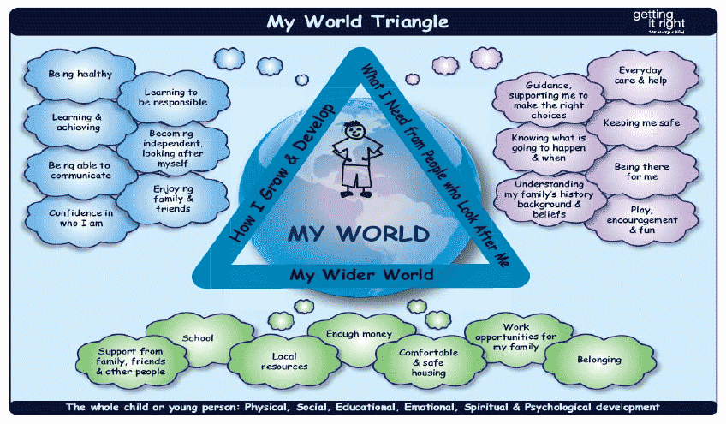

## Assessment - How I grow and develop (My development from when I was born to now using the headings from My World Triangle)

|  |
| --- |
| **Being Healthy**  **Learning and Achieving**  **Being able to communicate**  **Confidence in who I am**  **Learning to be responsible**  **Becoming independent looking after myself**  **Enjoying family and friends** |

**Assessment – What I need from people who look after me** (using the headings from My World)

|  |
| --- |
| **Everyday Care & Help**  **Keeping me safe**  .  **Being there for me (Emotional Warmth)**    **Play encouragement and fun**  **Knowing what is going to happen and when (stability)**  **Understanding my family background** |

**Assessment – My wider environment** (using headings from My World Triangle)

|  |
| --- |
| **Support from family and friends**    **Housing**  **Enough Money/Work Opportunities**  **Belonging/Local Resources** |

## Risks and Protective Factors

*Refer to the Resilience Matrix if helpful which can be found with other evidence informed tools by following this link* [*National Risk Framework*](http://www.gov.scot/Resource/0040/00408604.pdf) *including shared agency chronologies.*

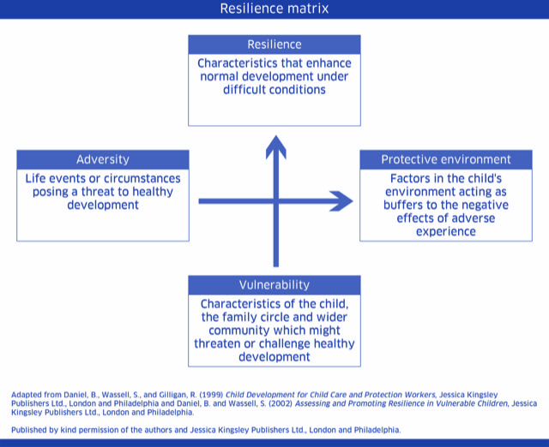

|  |
| --- |
| What is working well, What protective factors and strengths, |
|  |

|  |
| --- |
| What are we worried about and what do we need to know more about? What are the risks to me? |
|  |

|  |
| --- |
| What has been tried and why has it been successful/unsuccesful in the past? |
|  |

## Views of my assessment

It is important to gather views my views and my parent or carer. Evidence informed tools which assist practitioners to communicate with children, young people and their parents or carers can be found by following the link- Link to Direct work document

|  |  |  |  |  |
| --- | --- | --- | --- | --- |
| **What are my views of the assessment?**  How were my views sought?  Do I feel safe where I am?  What am I worried about?  If I am not able to provide an informed view please comment on how I present and observations/interactions. | | | | |
| **Has consent been given to share information?** | Yes |  | No |  |

|  |  |  |  |  |
| --- | --- | --- | --- | --- |
| **What are the views of my parent/carer on the assessment** | | | | |
| **Has consent been given to share information?** | Yes |  | No |  |

|  |  |  |  |  |
| --- | --- | --- | --- | --- |
| **What are the views of other important people to me?** | | | | |
| **Has consent been given to share information?** | Yes |  | No |  |

**Analysis of assessment**

**Summary analysis of my needs based on information gathered with a focus on strengths and understanding of pressures.**

Evaluate the data and draw conclusions that are clear and easy to follow. What **needs** arise, how do those needs impact on my **outcomes** and what outline **plans (**interventions or offers of help)need to be put in place to ensure my outcomes are achieved.

|  |
| --- |

**What Needs to Happen/Safety Goals?**

|  |  |  |  |  |  |  |  |
| --- | --- | --- | --- | --- | --- | --- | --- |
| Maintain current support |  | Implement further actions (see outline plan below: |  | Hold a Child/Young Person’s Multi Agency Planning Meeting |  | Other (please specify) |  |
|  |
| **Reasons for decisions/Recommendations:**  **Is Registration required?** | | | | | | | |

| **If a safety plan is required, what is my safety plan** |
| --- |

**My Plan**

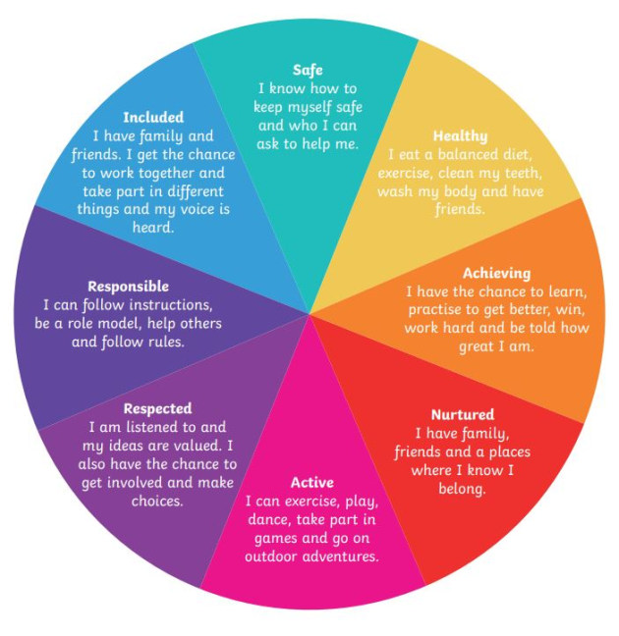

|  |  |  |  |
| --- | --- | --- | --- |
| **Using the SHANARRI diagram for all wellbeing assessments and for Initial Children’s Hearing Reports where the recommendation is no further action** | | | |
| **Agreed goals/outcomes** | **Agreed Action** | **By Whom?** | **By When?** |

|  |  |
| --- | --- |
| **Has a copy of the Wellbeing Assessment of Need been given to me?** |  |
| **Has a copy of the Wellbeing Assessment of Need been given to my parent/carer?** | Choose an item. |

|  |  |  |
| --- | --- | --- |
| **My Lead Professional completing the assessment** | **Job Title** | **Date** |
|  |  |  |

**Service Manager Comments**

|  |
| --- |
| * *To be completed by Service Manager* |

|  |  |
| --- | --- |
| **Formal Information Section about me** | |
| **Non-Disclosure –** is current address withheld/ restrictions |  |
| **Anyone not to know my address** |  |
| **Any relevant Legislation** |  |
| **Who has Parental responsibilities and rights:** |  |
| **Named Person** |  |
| **Are there any additional support needs** |  |
| **Are there culture/ religious beliefs/ethnicity** |  |
| **What is your first language** |  |
| **Is an interpreter required** |  |
| **Swift number/reference number** |  |