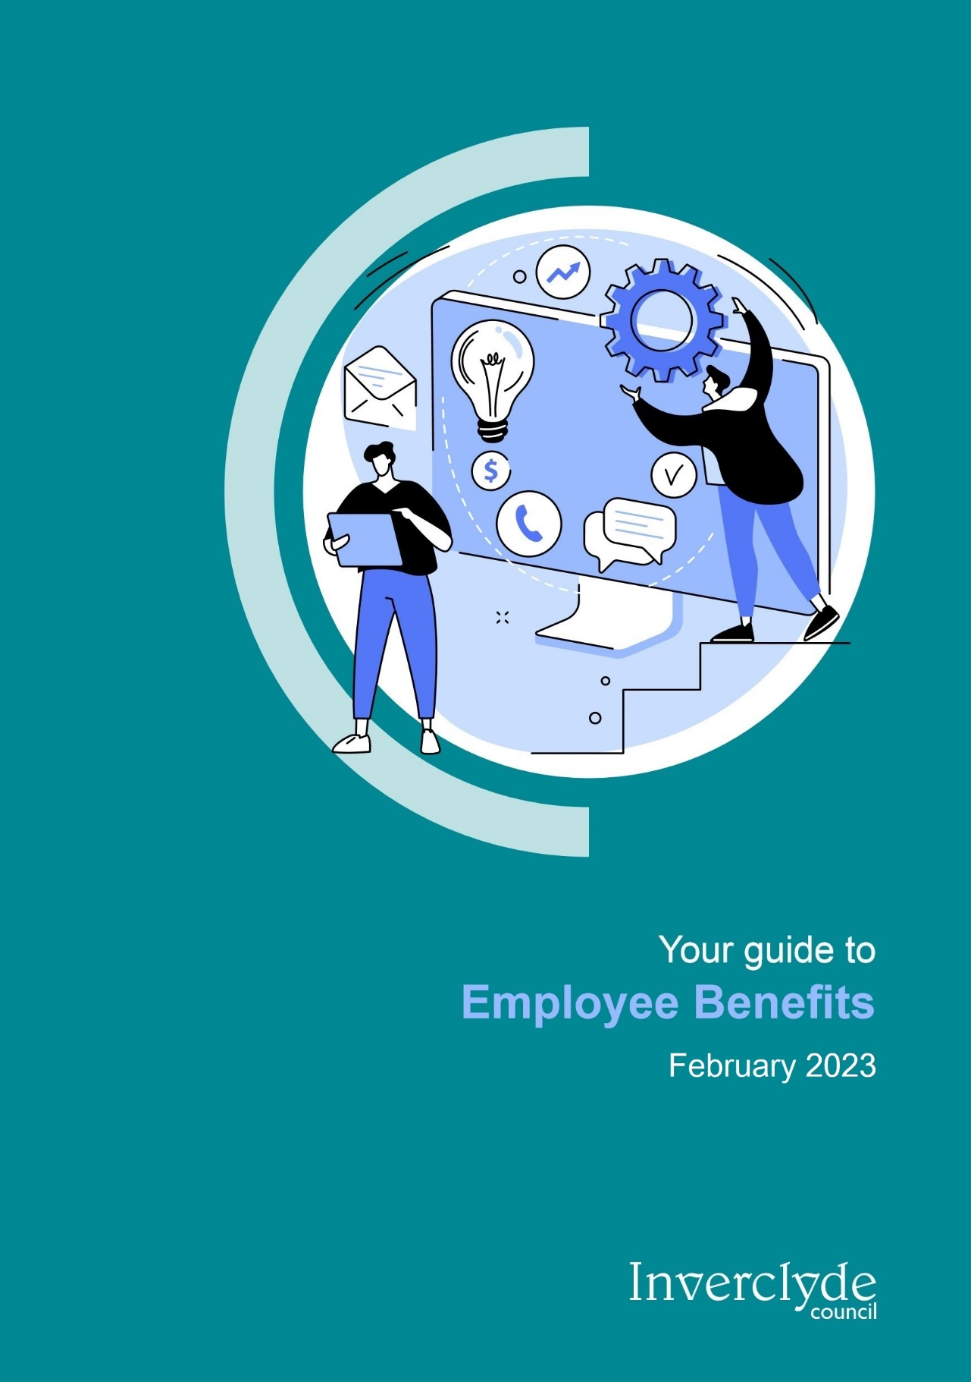

Introduction
At Inverclyde Council, we recognise that our employees are our most valuable asset. This booklet is designed to provide an overview of all of the benefits available to you as an Inverclyde Council Employee.
Benefits offered by the Council include excellent terms and conditions of employment, discounts at a range of local companies, pension schemes, eye test reimbursement, cycle to work scheme, a wide range of flexible working options as outlined in our Flexible Working Policy, a range of discounts through the Kaarp employee benefits scheme, occupational health support, car mileage allowance, saving schemes and a thorough learning and development programme - to name a few!

Buying and Banking Leave Scheme
The Buying and Banking Leave Scheme is part of a wider package of benefits aimed at enabling employees to achieve a healthy work-life balance as follows;
- To give employees greater flexibility and choice over how and when they take their holidays (must be agreed in advance of the relevant holiday year commencing);
- To promote a culture of work-life balance;
- To align the taking of holidays with the needs of each service.
- To enable employees to purchase holidays through two windows a year
Further information can be found in the Buy and Bank Leave Policy.

Terms and Conditions

Holiday entitlement
Inverclyde Council offers excellent terms and conditions for all employees. The holiday entitlement for local government employees is up to 34 days per year depending on the length of service.
In addition, local government employees will receive seven days fixed public holidays, which include Christmas Day, Boxing Day, 1st of January, 2nd of January (or the following working day, if these holidays are on Saturday or Sunday), and also Good Friday, Easter Monday, and May Day Holiday. For more information please refer to the Conditions of Service Document.
Teachers annual leave provisions are in accordance with Part 2 Section 5 of the SNCT handbook.

Salary Protection
The Council has a salary protection policy that currently protects the salary of permanent employees redeployed into a post which is graded lower than the employees previous salary, as a result of organisational change, any pay protection is on a cash conserved basis for one year.
Conservation for teachers is in accordance with Part 2 Section 1 of the SNCT handbook.

Continuous Service
Many new employees to Inverclyde Council come to us from other local authorities and public bodies. If this is the case then service from previous organisations will be recognised for the purpose of enhancing certain statutory entitlements such as annual leave, maternity pay, sickness allowance. Redundancy pay can also be enhanced for organisations covered by the Redundancy Modification Order.

Relocation and Repopulation Packages
The Council wishes to encourage its employees to live within the Inverclyde area in order to promote population and economic growth. Relocation expenses will therefore be applicable where an employee moves into the Inverclyde area, within 12 months of starting employment with the Council.
Further information is available from Organisational Development and Human Resources (OD & HR).

Living Wage Employer
Inverclyde Council is a Living Wage accredited employer and applies the Living Wage as the first point of our pay scale to ensure all employees are paid the real Living Wage. This currently exceeds the National Minimum wage and the National Living Wage for workers over 23 years old. For more information please visit www.livingwage.org.uk.

Health and Wellbeing

Free Eye Examination
Standard eye examinations are free in Scotland however the free eye exam does not cover the requirements of work related DSE test. Therefore, an eye examination, which will be paid for by the Council, will reveal whether there is any defect of sight which may adversely affect your ability to carry out work at a visual display unit. The Council will provide you with a voucher which can be taken to any Specsavers Optician. This will entitle you to an eye examination in relation to your work and contribution towards corrective eyewear if required for work.

Cycle to Work Scheme
This scheme is a government approved salary sacrifice initiative allowing you to hire a bike and accessories for up to £2000 for the purpose of cycling to work (or part of the journey). The hire is free of Tax and National Insurance. Keep an eye on ICON for information on the next launch date of the scheme alternatively contact OD & HR on 01475 712740.

Occupational Health Support
Inverclyde Council offers a generous sickness benefit scheme which gives you up to a maximum of six months full pay and six months half pay in the event of illness. This is subject to qualifying criteria. In addition, the occupational health service offers support to people with long term sickness, a musculoskeletal condition, or a stress-related condition. Based on the occupational specialist’s report, reasonable adjustments in the work place will be made in order to enable the employee to return to work as soon as possible.

Health and Wellbeing Hub
Wellbeing is commonly defined as the state of being comfortable, healthy and happy. Inverclyde Council recognises that a good working environment can positively impact on the health and happiness of our staff and aim to provide a workplace that embraces inclusivity and flexibility and provides everyone with the opportunity to manage your time and commitments in the best way that you can. Looking after your own wellbeing is key to feeling good and functioning well.
The Health and Wellbeing Hub offers information and resources to fully support employee wellbeing in day to day life and find the support you need. These pages can be found here: Health and Wellbeing Hub - Inverclyde Council

Learning and Development
Our e-learning platform, Inverclyde Learns, has been developed over time by the Organisational Development team alongside the Clyde Valley Training Consortium and it provides a wide variety of e-learning courses.
We want our staff to be skilled, motivated and driven to deliver excellent customer service to the residents of Inverclyde. This means your continual learning and development is important to us. You can learn through on-the-job training, face-to-face courses and e-Learning.
The login page for Inverclyde Learns e-learning platform can be found here: Inverclyde Learns - Login (tessello.co.uk)
You can book yourself on to any of our face-to-face courses via the CourseBooker on ICON. The corporate course planner is updated every six months. Also, you can also access all e-learning courses from the comfort of your own home on a laptop, PC, tablet and/or smart phone. For more information on all of the above please see the Learning and Development page on ICON or contact your line manager.
One of the most important areas where you will see our training programmes being used is in conjunction with your Performance Appraisal. Your manager and you will indicate areas for improvement and create systematic plans for your personal and professional development.

Financial Benefits

Pension Scheme
Inverclyde Council offers a generous pension scheme to both local government and teaching employees.
The local government pension scheme is administered by the Strathclyde Pension Fund and Inverclyde Council currently contributes a percentage of your pensionable pay to your pension account.
For teachers the Scottish Teachers’ Superannuation Scheme (STSS) is administered by the Scottish Public Pension Agency and Inverclyde Council currently contributes 23% pensionable pay to your pension account.
Other benefits include tax-free lump sums in exchange for some of your pension, death in service protection etc. Inverclyde Council also offers flexible retirement and the 50/50 scheme. Further details are available on ICON or from OD & HR.

Car Mileage Allowance
Inverclyde Council is a small local authority area, so you’ll be pleased to know that your job will not require an excessive amount of driving. However, if you do require to use your car for business purposes you will be reimbursed in the form of a mileage allowance.

Savings and Investments
As an Inverclyde employee, you have the option of joining the Scotwest Credit Union. Scotwest serves the employees working for public service organisations and Colleges of Further Education within the West of Scotland and their families. It has over 19,000 members, and is now one of the largest Credit Unions in the UK.

www.scotwest.co.uk
Employees can also access independent financial advice, through our providers, Blythswood Associates.
www.blythswood.co.uk

Vivup
All staff will be able to access a range of employee benefits from our new health and wellbeing partner Vivup. These are designed to improve your financial, mental and physical wellbeing and are additional to existing staff benefits already in place.

AVC Wise
Inverclyde Council are also working with AVC Wise to introduce a new salary sacrifice Shared Cost Additional Voluntary Contribution (Shared Cost AVC) employee benefit that enables you to make cost efficient retirement savings alongside your Local Government Pension Scheme, helping you enjoy a more comfortable retirement. If you are a current AVC contributor, you will receive a separate letter outlining the additional new benefits you can now access. This Shared AVC scheme is not applicable to Teachers or Elected Members.

Self-register on inverclyde.vivup.co.uk, by signing up using your work email address, or a personal email address if you do not have a work one and choosing the Inverclyde Council or Inverclyde Teacher option as appropriate from the drop down menu. Alternatively contact the Vivup Customer Services team for support.

Local Discounts
There are fantastic discounts available to Inverclyde Council employees at the following places;
- Waterfront Cinema Reduced tickets prices on Thursdays and Tuesdays
- Inverclyde Leisure 50% off initial joining fee for all memberships
- Inverclyde Physiotherapy £5 off all physiotherapy appointments
- Copperbox Boutique, Greenock 10% discount on in-store and online purchases with code COPPERBOX10
- The Cove, Gourock 7% off bills with valid ID
- Duo Menswear, Gourock 5% discount, earned via customer rewards scheme
- JD Gyms, Greenock Use of gym free of charge for one day
- Kilted Kin, Greenock 10% discount off any purchase, including jewellery (excludes hires and sale items)
- Lock & Sole 15% off keys, shoe repairs, engraving. (Excludes watches, merchandise, shoe care and any deals already discounted)
- Opal Hair – Kimberley Rankin £10 discount on colour services and £5 off cut and blow-dry services, with private appointments
- Pampered Pets, Greenock 10% off full grooms for all dog breeds
- Tip Top Tails 5% off full grooms with valid employee ID

- Tonino’s Pizzeria 15% off all orders over £60 for collection with proof of ID, and all deliveries to council buildings. Confirm promotion when ordering.
- Treasured, Gourock 10% discount on purchases instore and online using code INVERCLYDE10
- Tulsi Indian Aroma, offer 15% discount on their take-away and delivery orders.
- Vodafone Access to their Employee Advantage Scheme offering a range of discounts and offers, for more information sign up via their website

- Hilton Hotels Up to 25% off leisure breaks and best available rates at participating UK, Ireland and continental
European hotels as well as 15% off Hampton by Hilton Hotels
For full range of local discounts visit the local discounts page on Icon (http://icon/employee-benefits/local-discounts/ )

Other Discounts
Kaarp is a web-based discount site which you can access at:

www.kaarp.co.uk
(User Name: INVERCLYDE Password: BENEFITS).
A number of discounts and offers are available here including:
- Discounted theme park entry and days out vouchers. E.g. Alton Towers, Edinburgh Dungeons.
- Special deals on private medical care, travel insurance etc.
- Money off fitness supplies and spa break vouchers.
- Fantastic deals on hotels and car hire.
- Deals for shops including Currys, The Hut, Letterbox Gifts, Kind Clothing, etc.

Further Information
Information relating to all employee benefits is available on ICON; http://icon/employee-benefits
All policies and procedures mentioned in this booklet are on ICON; http://icon/hr/policy-a-z
If you have any questions regarding employee benefits you can discuss them with your line manager.
The OD and HR team are also here to advise you, so if you would like to speak to them directly you can call them on 01475 712740. Employees without access to ICON please contact your manager or OD & HR for further information on any of the benefits listed.

Get in touch
Phone:

01475 712740
Email:

human.resources@inverclyde.gov.uk
Write to:

Organisational Development,

Policy & Communications

Inverclyde Council

Municipal Buildings

Greenock

Inverclyde PA15 1LX
www.inverclyde.gov.uk

