[](https://www.google.co.uk/url?sa=i&source=images&cd=&cad=rja&uact=8&ved=2ahUKEwjU8du-_bHbAhUFLVAKHTvoCCIQjRx6BAgBEAU&url=http://www.communityscot.org.uk/spotlight/article/your-voice-inverclyde-community-care-forum/&psig=AOvVaw1f-0Ofv12AIp5AZmUn5qcF&ust=1527925822678640)

[Image result for scottish fire and rescue logo](https://www.google.co.uk/url?sa=i&source=images&cd=&cad=rja&uact=8&ved=2ahUKEwigtZDe_LHbAhWHY1AKHR2QDvgQjRx6BAgBEAU&url=http://www.scottisharchives.org.uk/preservation/fire/gavingray&psig=AOvVaw3yC7XOC8ziJNnSmNLge0nQ&ust=1527925633381505)

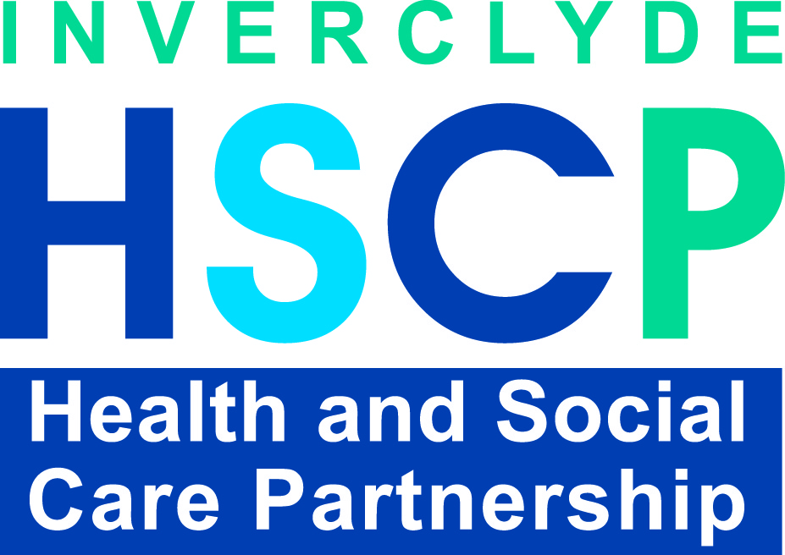

GetAsset



[](https://www.google.co.uk/url?sa=i&source=images&cd=&cad=rja&uact=8&ved=2ahUKEwjdxeSaw5nbAhWlK8AKHVTIC04QjRx6BAgBEAU&url=http://www.scotland.police.uk/whats-happening/news/2017/september/police-scotland-rolls-out-english-gaelic-logo&psig=AOvVaw1m9Hcx2u_8t6_1dYGgjApO&ust=1527085448649223)

**2020 - 2022**

**Report**

**Biennial**

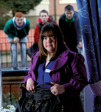

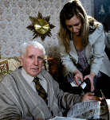

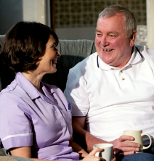

Inverclyde

**Adult Protection Committee**

**Contents**

1. Foreword 4

2. Inverclyde Adult Protection Committee 5

2.1 Inverclyde Quality and Policy Sub Group 6

3. Covid-19 7

3.1 Adult Protection Committee 7

3.2 Health and Social Care Partnership (HSCP) 7

3.3 Police Scotland 8

3.4 Scottish Fire and Rescue 8

3.5 Care Homes 9

3.6 Registered Social Landlords (RSLs) 9

3.7 Partnership with Third Sector 10

3.8 Closure of Greenock Sheriff Court 10

4. What Your Data Tells You 11

4.1 Adult Protection Referrals 11

4.1.1 Source of Referral 11

4.1.2 Outcome of Referrals 12

4.2 Investigations 13

4.2.1 Gender 13

4.2.2 Age Groups 14

4.2.3 Client Category 15

4.2.4 Principle Category of Harm 16

4.2.5 Location of Harm 17

4.2.6 Sources of Harm 18

4.2.7 Outcome of Investigation 18

4.2.8 Types of Case Conferences 18

4.2.9 Protection Orders 19

4.2.10 Initial and Significant Case Reviews (ICR & SCR) 19

5. Outcomes, Achievements and Service Improvements 20

5.1 Joint Inspection of Adult Support and Protection in the Inverclyde partnership 20

5.1.1 Progress Statements 20

5.1.2 Methodology 20

5.1.3 Summary of Strengths 21

5.1.4 Progress Question 1 21

5.1.5 Progress Question 2 22

5.2 Specific Covid-19 Efforts and Achievements 22

5.3 Policies and Procedures 22

5.4 Inverclyde Council Environmental and Public Protection Trading Standards 23

5.5 Domestic Abuse Multi Agency Risk Assessment Conference (MARAC) 23

6. Training, Learning and Development 24

6.1 Level 1 Adult Protection Awareness and Financial Harm Training 24

6.2 Level 2 Training 25

6.3 Adult Protection Learning and Self Evaluation Events 26

6.4 Adult Protection Committee Developmental Sessions 27

6.5 Greater Glasgow and Clyde, Adult Support & Protection Level 3 - Learning & Education Training Sessions 27

6.6 Multi-Agency Learning and Development Strategy 27

7. Engagement, Involvement and Communication 28

7.1 Ault Protection Committee Membership 28

7.2 Service User and Carer Evaluation 28

7.3 Independent Advocacy 28

7.4 Public Information 29

7.5 Outcomes for Adults at Risk 29

8. Challenges and Areas for Improvement 31

8.1 Inspection Improvements 31

8.1.1 Summary of Improvement Plan Progress 31

8.2 Learning and Development 32

9. Looking Forward 33

10. Appendices 34

10.1 Source of Referral 34

10.2 Outcome of Referrals 35

10.3 Investigations by Gender 36

10.4 Investigations by Age Group 36

10.5 Investigations by Client Category 36

10.6 Investigations by Category of Harm 37

10.7 Investigations by Location of Harm 37

10.8 Investigation by Source of Harm 38

10.9 Outcome of Investigation 38

# 1. Foreword

The Adult Support and Protection Act (Scotland) 2007 aims to protect adults who are unable to safeguard their own interests and are at risk of harm because they are affected by disability, mental disorder, illness or physical or mental infirmity. The Act places duties on councils and other organisations to investigate and, where necessary, act to reduce the harm or risk of harm.

Section 46 of the Act requires the Convenors of Adult Protection Committees to produce a biennial report analysing, reviewing, and commenting on APC functions and activities in the preceding two years, and I am pleased to present this report on activities and actions in Inverclyde, led by the Adult Support and Protection Committee.

I am grateful for the help of members of the Committee for their dedication and support through the last two years, from the grim early days of the pandemic, when we all struggled for an understanding of its likely impact, to the organisation of systems, approaches, and activity to support the local population through those challenging two years.

I would also wish to recognise the activities of staff and volunteers who worked through the two years, adapting and re-organising how they worked to support people and to continually focus on issues beyond their immediate families as they supported people in the community. The committee was greatly assisted by the focus, leadership and support of the Chief Officers Group Public Protection and their partnership organisations throughout the last two years.

Finally I would need to mark the assistance and dedication of the Adult Support and Protection team in supporting me as Independent Chair.

Alex Davidson

Independent Chair

September 2022

# 2. Inverclyde Adult Protection Committee

The principal functions of the Adult Protection Committee (APC) are to promote the support and protection of adults at risk of harm through strategic planning, leadership, agreed priorities, objectives and actions.

The APC leads on developments and improvements in the following key areas:

* Procedures and practice;
* Skills and knowledge;
* Information and advice;
* Co-operation;
* Continuous Improvement.

The membership of the Committee includes all the statutory bodies with a role to play in adult protection along with the voluntary sector and Third Party service providing organisations. Representatives of the Mental Welfare Commission, Office of the Public Guardian, Care Inspectorate, and Health Improvement Scotland are invited to attend, with minutes being sent out to all agencies.

The membership of the APC is kept under review to ensure that as the body of evidence around adult support and protection matters evolves and agencies who contribute to the local agenda are represented. In the context of an Inverclyde Significant Case Review it was identified that links were required with the Department of Works and Pensions (DWP) and local college. The Committee now has representation from both.

The Joint inspection of adult support and protection of the Inverclyde partnership was undertaken during the period of this biennial report .The findings of our inspection were positive .The inspection findings are referenced where relevant throughout this report but a summary of the main findings are outlined in Section 5 with progress on improvements included at Section 8.

The APC continues to work to the Biennial Business Plan which accompanies each Biennial Report. Our plan and the Improvement Plan are reviewed and updated as part of the business of the Committee and the Quality and Policy Subgroup (Section 2.1).

During the period of this report the Committee renewed its constitution. Our inspection report noted that ‘the updated constitution clearly outlined the roles and responsibilities of those involved in the committee. Importantly, most staff agreed that local leaders provided a clear vision and worked hard to raise awareness of adult support and protection work’.

The inspectors also ‘saw evidence of the partnership’s vision/priorities outlined in both the adult support and protection biennial report and adult support and protection business plan 2018-20, which has since been appropriately updated’. This report and the accompanying business plan provides the ongoing evidence of our vision and priorities and of our planned actions for the next two years.

## 2.1 Inverclyde Quality and Policy Sub Group

The APC viewed that leadership for operational and strategic collaborative working among key agencies required to be strengthened. The outcome from these discussions was the establishment of the Quality and Policy Subgroup in 2018. This continues to be held 6-weekly and works to an action log that is reviewed and updated at each meeting.

The Quality and Policy Sub Group is the key forum for progressing operational and collaborative working among social work, police, health and other partners for adult support and protection. This is chaired by the Head of Health and Community Care. Membership comprises senior managers with frontline responsibilities from key partner agencies to ensure leadership for operational and collaboration on adult support and protection matters.

The action log was developed to identify specific actions required at operational level to continue to improve this collaborative approach. This is reviewed at each meeting and provides an overview of all actions and agreed progress.

The identified actions from the Business Plan, post inspection Improvement Plan and Action Log are progressed by working groups or task and finish groups. Membership for each is agreed by the Quality and Policy Subgroup on basis of having right knowledge, skills and experience to effectively progress the action required.

# 3. Covid-19

The period of this Biennial Report has been a time of considerable uncertainty and difficulty due to the effect of Covid-19 and its effects on the health and well-being of the community. The focus within Inverclyde is to support the general population, to support staff, and to ensure the effects of the pandemic are managed and mitigated to the best of our abilities, supported by the Chief Officers Group, Public Protection which brings the protection agenda together across the partnership.

## 3.1 Adult Protection Committee

The last Biennial Report highlighted key areas that are viewed by the APC as central to recovery and in building resilience. These are;

* Understanding new challenges in mental health, addictions, domestic abuse and in safeguarding areas (Section 6.3)
* Service user engagement, best practice in virtual meetings and a concern for relationships (Section7)
* Communication and development of support mechanisms, appropriate and safe social media usage (Section 7)
* Reset forms of engagement recognising the impact of trauma, and of building relationships in adult protection work (Section 6.1)
* Continuing support to independent providers in care settings and in care at home (Section 3.5 and 9)
* Developing the training and staff development agenda in new ways (Section 6)
* Continuing the committed human rights approach in support and protection activity.

Following the first lockdown the APC quickly moved from 8 to 4 weekly meeting for the first 6 months. Initially this was with members of the Committee working in Public Bodies and meetings were by telephone conferencing moving to an online video conferencing platform once available. The move to video conferencing also facilitated the full membership of the APC attending committee. Standing agenda items continue to include the ‘Partners Update on Pandemic Operational Issues’ and update as to the support to Inverclyde care homes.

## 3.2 Health and Social Care Partnership (HSCP)

At the outset of the pandemic the HSCP organised into hubs with staff working in teams on a rota basis. With a move to open plan offices and agile working some years earlier the HSCP workforce was well placed in having necessary IT equipment to facilitate this.

All caseloads and referrals were reviewed and prioritised to ensure scheduled contact with service users/patients and their carers by the most appropriate member of HSCP staff by the most appropriate means. In person contact was maintained with the most vulnerable individuals when assessed as required. Community nurses continued to visit people at home during Covid-19 restrictions and ‘demonstrated a clear commitment to monitoring the welfare of the people they visited’ (Inspection Report). By June 2020 services were starting to be re-established and more visits were starting to be undertaken.

Given the confidence in existing adult support and protection processes and procedures no changes were introduced. However at times there was a need to think differently as to how information was gathered. A Standard Operating Procedure was quickly in place to minimise risk to the public and HSCP staff where any in person contact or visits were assessed as necessary.

In considering the impact of Covid-19, the Joint inspection of adult support and protection in the Inverclyde partnership (June 2021) found that;

* The screening and triage of adult support and protection referrals before and during Covid-19 restrictions was of a good standard.
* Well-established referral processes between agencies were in place and were effective.
* Reassuringly, visits to adults at risk of harm were still being carried out in the most critical instances.
* Commendably, the partnership convened timely initial adult support and protection case conferences on almost all occasions and ensured that other professionals and agencies were invited to attend.

In relation to Adult Protection Case Conferences, the aim is for the adult at risk and/or their supporter to be invited and supported to attend including virtual meetings however there can be reasons as to why some may not. The long established template for case conferences includes a section on whether the adult was invited or not. The reason for not being invited or choosing not to attend is recorded. The findings of our inspection provides evidence this approach;

‘Adults at risk of harm should always be at the centre of adult support and protection activity but were only invited to attend in just over half of those situations proceeding to initial case conference. There are often good reasons why some adults at harm might not attend case conferences and the partnership typically reflected this well in minutes of these meetings. Those adults at risk of harm, and unpaid carers, who did attend were well supported to participate’.

## 3.3 Police Scotland

Police Scotland has continued undertaking duties as before throughout the pandemic with the exception of entering households where COVID 19 is present. Police continue to raise Concern Reports as before including in respect of adult protection via the well-established referral processes that the inspection found were in place.

## 3.4 Scottish Fire and Rescue

The programme of Home Fire Safety Visits was suspended at the start of the pandemic. Local Fire Services screened their records daily to identify and contact those at high risk. The Committee Fire and Rescue representative in conjunction with HSCP did a piece of work in respect of vulnerable groups. Whilst there has been an increase in fire related deaths nationally there has been no increase in such deaths locally for Inverclyde. The view is that the work on this issue undertaken locally in recent years and reported in previous Biennial Report could be why Inverclyde has not experienced same. By September 2020 Home Fire Safety Visits had started to resume. This was initially prioritised for individuals identified as high risk.

## 3.5 Care Homes

At the outset the daily ‘safety huddle’ concerning care homes and chaired by a Head of Service was established to share information, review events and plan ahead. Matters considered included provision of PPE, staffing levels, infection control and the testing regime. The care home sector attracted considerable attention not only in Inverclyde but across Scotland.

The Scottish Government published guidance setting out arrangements care homes should put in place to improve the professional oversight of care provided during the pandemic. This resulted in new and additional responsibilities for leads in the Health Board that provide daily support and oversight of the care provided in care homes. It recognised that the good relationship which the Inverclyde HSCP already has with the local care homes greatly assisted when supporting care homes through the most difficult time.

The Good Practice Guidance in Joint Working between Inverclyde Adult Protection Committee and Care Home Providers in Inverclyde for Adult Protection & Adult with Changing Needs was refreshed by a working group comprising of representatives of local care home managers, Care Inspectorate, HSCP Strategic Commissioning Team and the Adult Protection Coordinator and agreed in 2019. Local care homes continued to raise any concerns they had throughout the pandemic and were encouraged to do so. This was regardless of whether they were sure the threshold for adult support and protection was reached. This was to ensure the necessary advice and support was available to address concerns.

## 3.6 Registered Social Landlords (RSLs)

River Clyde Homes is the representative on the Committee and by September 2020 had begun an ‘as near as normal’ letting service. Following government guidance a number of measures were put in place in sheltered housing complexes. At September there were no real issues apart from residents wanting to spend time in communal lounges but restrictions meant that a return to this was not feasible at that stage however visiting in sheltered housing was being piloted. Visits to tenants from Housing Officers and Financial Wellbeing Officers slowly resumed with strict protocols in place. During the height of the pandemic housing staff provided support to tenants by conducting or receiving welfare calls and this was identified as a good way of referring or signposting people to appropriate services. Following a successful bid to the Scottish Government Wellbeing Fund by River Clyde Homes and a network of community groups, residents of Inverclyde impacted by the pandemic benefited from food and energy vouchers and activity packs. It was viewed that one of the positives to emerge from these uncertain times was an improved support network of organisations in Inverclyde with an impressive community response to the pandemic.

During the period of this Biennial Report the Good Practice Guidance in Joint Working between Inverclyde Adult Protection Committee and Social Housing Providers in Inverclyde for Adult Protection and Adults in Need was reviewed, refreshed and agreed by all parties including a housing provider new to Inverclyde.

## 3.7 Partnership with Third Sector

Your Voice and Ardgowan Hospice, including Compassionate Inverclyde, are members of the Committee. The Council (including HSCP) Resilience Management Team met three times per week from the outset of the pandemic. The APC received updates at each meeting on the humanitarian and community safety efforts put in place to support the most vulnerable that also aided the identification and referral of those in need and most at risk.

In a coordinated approach meals were provided to the most vulnerable through community groups such as Community Voluntary Service (CVS), Compassionate Inverclyde and the Community Response Team. As referenced in Section 3.6, Community Groups also received additional funding from the Scottish Government to provide vulnerable people with energy vouchers and food.

With the pandemic Compassionate Inverclyde was prevented from its normal activities. However its ‘back home boxes’ routinely provided to people living alone after they have been discharged from hospital was extended to cover people isolating during the coronavirus epidemic. These boxes include essentials like tea, coffee, long life milk, biscuits and toiletries and help people relax at home without worrying about going to the shops for groceries.

By the start of May 2020, Your Voice Community Connectors had carried out over 7000 welfare calls with over 2000 packs posted with information on how to get in touch with concerns or to pass a referral on. All the Community Connectors and volunteers were appropriately trained and know where to direct all referrals. There were also engagements made via social media including over 750 in April 2020 alone to promote where and how to access support and assistance including where there were concerns that an adult was at risk.

For the last two years and as has been needed, CVS Inverclyde and Your Voice have continued to retain contact with vulnerable members of the community using virtual methods.

## 3.8 Closure of Greenock Sheriff Court

Whilst the local Court was initially closed due to the circumstances of the pandemic arrangements were made for the current business to be conducted via Paisley Sherriff Court including emergencies. Where possible this work was undertaken via virtual methods. Throughout the pandemic applications continued to be made and progressed as required under the auspices of the Adults with Incapacity (Scotland) Act 2000 and for Inverclyde a Protection Order under the auspices of the Adult Support and Protection (Scotland) Act 2007.

# 4. What Your Data Tells You

Total data for both years is included here and is as reported for National Adult Protection Dataset. A breakdown of the data for each year of this report is included as an appendix (Section 10). In addition at Section 10 there is a further breakdown of data where there is a significant figure for data reported under ‘other’ or for a referral source e.g. NHS. The aim is to aid better understanding of the data provided.

## 4.1 Adult Protection Referrals

There were 196 for 2020/21 and 260 in 2021/22. This is a total of 456.

### 4.1.1 Source of Referral

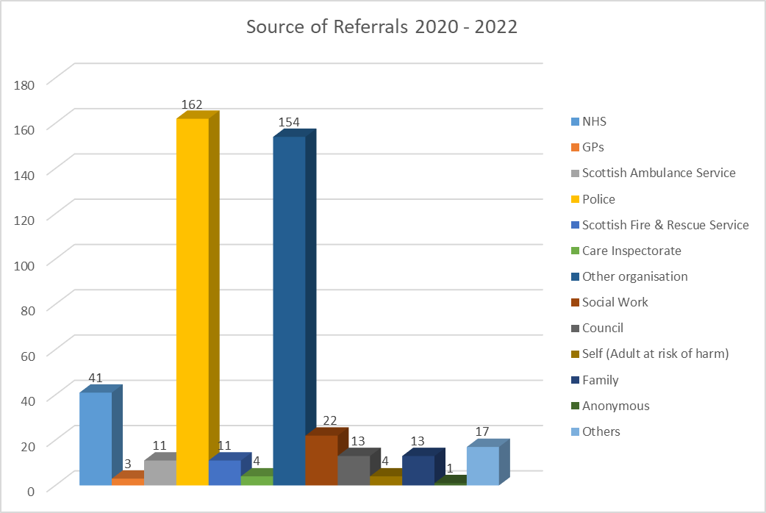

Sources of all AP referrals have only been reported on since 2014 following the introduction and population of the AP Swift module. The ‘source of referral’ is recorded on the basis of the first source to make the referral regarding an adult at risk. In some cases there may have been more than one referral from different sources.

Overall as for previous Biennial Reports the police continue to be the primary source of referral of adults at risk of harm in Inverclyde and this is replicated nationally. Police Scotland submits Adult Concern Reports where there are concerns regarding an adult. For 2016-2018, 248 Adult Concern Reports received were marked as adult protection, for 2018 -2020 this was 138 and for this period it is 162. This is a 17% increase on period of previous report. However the total number of Adult Concern Reports under auspices of both adult protection and adult well-being is stabilising with an increase in more adults being assessed as meeting the criteria for adult protection and the concern raised on this basis.

Given the range of dropdown options available within SWIFT for use by all HSCP service areas, the ‘sources of referral ‘applicable for adult protection are grouped for ‘NHS’, ‘Other Organisations’ and ‘Social Work’. Grouping in this way also meets the requirements of the current national dataset. A full breakdown of referral sources is at Section 10.

Other organisations’ are the next primary source. For 2018/2020 Biennial Report they accounted for 112 of the referrals made. This being a 100% increase when compared with the figures for 2016/18 Biennial Report. For this period there has been a further 37.5% increase.

Referrals from care homes have accounted for 103 of these referrals. Throughout the pandemic, both nationally and locally there is and has been an added focus on adult support and protection and quality of care in care homes and in this context an increase in referrals is understandable. Section 3.5 outlines the activity with and support to care homes.

Health (GP, NHS and Scottish Ambulance Service) referrals accounted for 45 of all referrals made. For the period of the 2016/2018 they accounted for 43 of the referrals made and in 2018/2020 the figure was 39. This equates to a 15% increase on the previous biennial report period and is only marginally higher to the figures reported for 2016/2018.

### 4.1.2 Outcome of Referrals

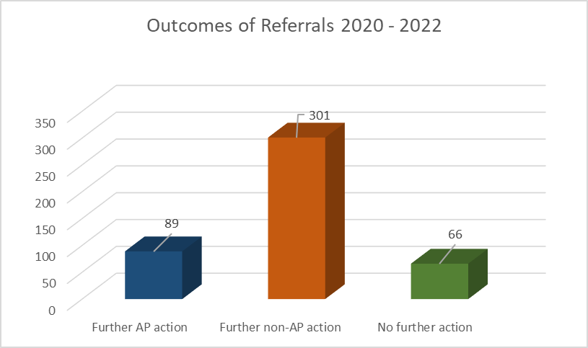

There were 89 cases where the outcome was recorded as ‘Further AP Action’. Following application of the criteria and principles of the adult Support and Protection (Scotland) Act 2007, the majority continue to have an outcome of ‘further non AP action’ where the object of the intervention is progressed via other statutory measures.

## 4.2 Investigations

The conversion rate from referral to investigation had been 10% until 2016/2018 when it rose to 13.5%. Since the period of the 2018/20 Biennial Report the conversion rate has increased to approximately 20%. For the period of this report it is 19.5% of all referrals made under the auspices of adult protection. The number of investigations undertaken has also increased from 59 in 2016/2018 to 86 investigations in 2018/2020 to 89 for this period. It is viewed that the ongoing programme of self-evaluation, audit, and improvements made will impact on the consistency of approach. The refresh of the adult protection courses targeted at Council Officers, their managers and second workers along with the implementation of the APC Multi- Agency Learning and Development Strategy is also viewed as having had an impact. With current course options, their content and method of delivery being reviewed during the pandemic and further refreshed to reflect national developments it is not yet evident as to the potential impact on practice.

### 4.2.1 Gender

More males have been subject to investigation for the period of this biennial report for only the second time in Inverclyde since reports began. The reason for this is not known but may relate to the circumstances of the pandemic. Since the first Biennial Report for 2008/10, with the exception of the 2014/16 period, females are consistently identified as 20% to 50% more likely to be an adult at risk of harm where an investigation has taken place. This is also the picture nationally. It is viewed that women usually featuring more predominately in investigations may be as a result of gender inequalities and demographics.

### 4.2.2 Age Groups

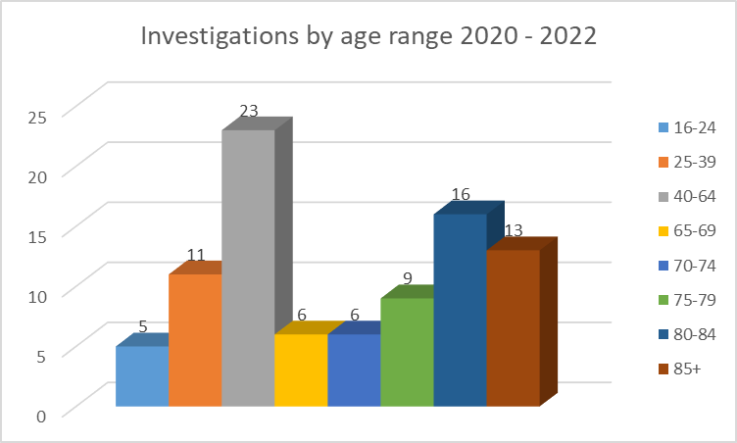

From 2008 till 2014 adult protection investigations were more commonly required for the over 65 years age group however from 2014 to 2020 there has been a more even split between over and under 65 age group. For this period there has been a slight shift to 56% of investigations being in respect of adults at risk over 65 with 58% of these being in respect of those over 80. This may be accounted for by number of referrals from care homes. However 26% of all investigations are in respect of the 40 to 64 age group. As can be seen from client categories this is likely due to the number of adults subject to investigations who have mental health issues, a learning disability or a physical disability being more likely to be predominately under 65 whereas infirmity due to age and dementia will more likely account for those subject to investigation who are over 65 years.

### 4.2.3 Client Category

The principle category recorded is reported here. The adult may be known to services and to more than one when subject to the adult protection process. The principle SWIFT client category is determined by the HSCP service primarily involved although an adult may have comorbid conditions with more than one category being applicable. For example an adult with a substance misuse issues may be known to Drug, Alcohol and Recovery Services but also have a physical disability and be known to Independent Living Services.

‘Other’ includes adults at risk who do not fall into the other categories. Examples of people who would be included in this group include adults on the autistic spectrum, with acquired brain injury and those who have HIV or Aids. For the period of the 2014/2016 report there were 14 people in this category. This figure had steadily reduced to 4 for the last report and increased for this report. The reason for this fluctuation in the numbers for the category ‘other ‘is unknown. A breakdown is not provided as individuals could potentially be identified.

On the basis of the last available analysis of national data the four main client categories locally and nationally are learning disability, mental health, physical disability and infirmity due to age.

### 4.2.4 Principle Category of Harm

Only the principal category of harm can be reported for each investigation but it can be the case that more than one type of harm is applicable. For this period and in most previous years since 2008 physical and financial harm have been two of the 3 main category types for Inverclyde. This is with the exception of the period of the Biennial Report 2016/2018 when recording of financial harm as principle category significantly decreased. The third main category in this period and in most years is neglect. It is recognised that financial gain can often be the main driver for harming an adult at risk with threatened or actual physical harm being the method to exercise control over the adult to achieve this. It is recognised that staff can gravitate towards selecting ‘contact’ harm types as the principle type when more than one type of harm is applicable as these are often viewed as most serious.

### 4.2.5 Location of Harm

As in all previous years private addresses and care home continue to be the primary locations where harm has taken place. Sheltered Housing/Supported Accommodation accounts for third most likely location. Of the 103 referrals made by care homes, 19 were viewed as meeting the threshold to progress under the auspices of the adult protection process.

### 4.2.6 Sources of Harm

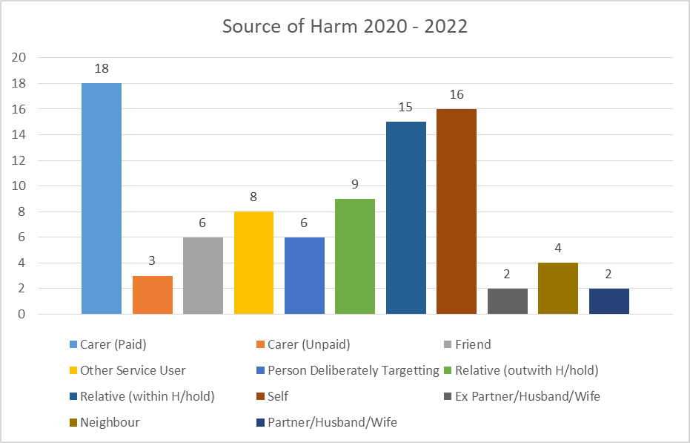

Adults were most at risk from a paid carer, themselves or from a relative living within the household.

### 4.2.7 Outcome of Investigation

The outcome for 18 % of investigations is that ‘Further AP Action’ is required. The conversion rate is down from 25% in the period of the last Biennial Report.

### 4.2.8 Types of Case Conferences

The findings of the inspection commended the partnership on convening timely initial adult support and protection case conferences on almost all occasions and ensured that other professionals and agencies were invited to attend. During the period of this report there were 12 initial case conferences, 6 reviews, and 4 Adults with Incapacity case conferences. In addition a detailed strategy meeting occurred between partners when pandemic restrictions impacted.

### 4.2.9 Protection Orders

During the period of this report one Temporary Banning Order and one Banning Order were applied for and granted. Both were granted with Power of Arrest attached.

### 4.2.10 Initial and Significant Case Reviews (ICR & SCR)

During the period of this report we have been working on an SCR in respect of Margaret Fleming’s disappearance and murder and will report later this year. Despite the pandemic we have progressed this.

# 5. Outcomes, Achievements and Service Improvements

The findings of our inspection provides best evidence of our progress to date and of the partnership’s strengths in terms of outcomes, achievements and service improvements. Our inspection concluded that the ’partnership’s key processes for adult support and protection were effective with areas for improvement. There were clear strengths supporting positive experiences and outcomes for adults at risk of harm, which collectively outweighed the areas for improvement’. The full report is available on the Care Inspectorate website (link below) however what follows provides a summary of the process and methodology; and highlights the identified strengths.

<https://www.careinspectorate.com/images/documents/6111/Inverclyde%20adult%20support%20&%20protection%20report.pdf>

## 

## 5.1 Joint Inspection of Adult Support and Protection in the Inverclyde partnership

The inspection of the Inverclyde partnership commenced at the start of 2020. However In the face of the emerging Covid-19 public health emergency, joint inspection partners took the decision on 17 March 2020 to temporarily suspend the adult support and protection inspection programme. During the suspension, the joint inspection team maintained engagement with the Inverclyde local partnership area to develop remote working arrangements that enabled the programme of inspection to resume. The Inverclyde partnership is pleased to have been involved to create an opportunity for such a development. The joint inspection of the Inverclyde partnership took place between 25 November 2020 and 22 January 2021.

### 5.1.1 Progress Statements

The inspection considered the partnership’s progress in relation to two key questions;

* How good were the partnership’s key processes for adult support and protection?
* How good was the partnership’s strategic leadership for adult support and protection?

### 5.1.2 Methodology

The methodology for this inspection included four proportionate scrutiny activities;

* The analysis of supporting documentary evidence and a position statement submitted by the partnership.
* Staff survey. This was issued to a range of health, police, social work and third sector provider organisations. It sought staff views on adult support and protection outcomes for adults at risk of harm, key processes, staff support and training and strategic leadership.
* The scrutiny of the health, police, and social work records of adults of risk of harm.
* Staff focus groups. There were two focus groups and inspectors met with members of staff from across the partnership to discuss the impact of the Covid-19 pandemic on adult support and protection and adults at risk of harm.

### 5.1.3 Summary of Strengths

The summary of identified strengths is as follows;

* The partnership had taken positive steps to ensure there was improvements in the lives of adults subject to adult support and protection processes, and that they were safer because of the support and protection they received.
* Effective communication, information sharing, collaboration and joint work were positive features of the partnership’s response to adult support and protection work.
* Staff from across the partnership were clear and confident about their responsibilities and protection roles.
* Staff shared a clear and well understood vision for adult support and protection.
* There was a high degree of confidence amongst staff that strategic leaders, including the adult protection committee (APC), provided good leadership for adult support and protection work.

### 5.1.4 Progress Question 1

In relation to the question ‘How good were the partnership’s key processes to keep adults at risk of harm safe, protected and supported’, the inspection concluded ‘the partnership’s key processes for adult support and protection were effective with areas for improvement. There were clear strengths supporting positive experiences and outcomes for adults at risk of harm, which collectively outweighed the areas for improvement’. The key messages were as follows;

* The partnership ensured that adults subject to adult support and protection were safer because of the support they received.
* The quality of screening and triage work was good. Referrals were received and processed accurately and in a timely manner.
* Most risk assessment and protection plans completed were timely, reflected a multi-agency approach, and were of a good quality.
* Initial inquiries, investigations, and case conferences effectively considered the concerns about adults at risk of harm.
* Police Scotland and health services effectively collaborated with social work colleagues to keep adults at risk safe from harm.

As stated above improvements to be made were identified in respect of this statement. These can be found at Section 8 with a progress update as to how addressed. The Committee view that the timeous progress on the improvements required is also an achievement for the partnership.

### 5.1.5 Progress Question 2

In relation to the question ‘how good was the partnership’s strategic leadership for adult support and protection’ the inspection concluded he partnership’s strategic leadership for adult support and protection was effective with areas for improvement. There were clear strengths supporting positive experiences and outcomes for adults at risk of harm, which collectively outweighed the areas for improvement’. The key messages

* There were well embedded strategic governance structures in place across the public protection partnership including adult support and protection.
* There was a clear and well understood vision amongst staff from all agencies for adult support and protection work.
* There was a high degree of confidence amongst staff that strategic leaders, including the adult protection committee, provided good leadership for adult support and protection work.

## 5.2 Specific Covid-19 Efforts and Achievements

Section 3 highlights some of the particular efforts and achievements made in response to the pandemic. These include the;

* Near ‘business as usual approach’ achieved by the partners for adult support and protection
* Continued partnership work with Scottish Fire and Rescue and there being no increase locally of fire related deaths
* Ongoing focus on support to care homes.
* Evident improved support network of organisations in Inverclyde with an impressive community response to the pandemic
* Further development and adoption of virtual and secure online methods of communication by partners to facilitate not only training but the ongoing work of the Committee, the progress of the Significant Case Review, contact with the public and contact with adults at risk as part of the adult protection process
* Review of adult support and protection training and the development of a blended approach to delivery (Section 6).

## 5.3 Policies and Procedures

Achieving the review and implementation of the Good Practice Guidance in Joint Working between Inverclyde Adult Protection Committee and Social Housing Providers in Inverclyde for Adult Protection and Adults in Need during the course of the pandemic is viewed as an achievement . This guidance developed and agreed in partnership with the Inverclyde Social Housing Providers is understood to be unique in Scotland.

The implementation of the refreshed Good Practice Guidance in Joint Working between Inverclyde Adult Protection Committee and Care Home Providers in Inverclyde for Adult Protection & Adult with Changing Needs is also understood to be unique. As we recover from the pandemic further work is needed to support local care homes to revisit improved application of the criteria for adult support and protection to their concerns.

## 5.4 Inverclyde Council Environmental and Public Protection Trading Standards

Whilst Trading Standards are not represented at the APC there is an established history of joint working in two key areas;

* Trading Standards and Adult Protection Coordinator screening of those adults coming to the attention of Trading Standards who are identified as having been scammed. This allows for the correct identification of local victims who may still be at risk and to provide appropriate follow up advice and support to them when needed. This arrangement has continued throughout the last two years
* Development and delivery of Financial Harm courses in conjunction with Police Scotland. As Section 6.1 outlines with the pandemic a blended approach has been developed. Inverclyde Trading Standards are currently involved with refreshing the content of financial harm training and will be once again be supporting the delivery of this training.

## 5.5 Domestic Abuse Multi Agency Risk Assessment Conference (MARAC)

MARACs are recognised nationally as best practice for addressing cases of Domestic Abuse at very high risk of serious harm and Domestic Homicide. The Inverclyde MARAC has been operational in Inverclyde since 2013. MARACs are held monthly. With the restrictions the pandemic brought the meetings moved to being held virtually.

MARAC Inverclyde Operating Protocol was reviewed and agreed in January 2020. The Operating Protocol sets the interface with the broader public protection agenda including adult support and protection legislation. Using the MARAC process and knowledge and expertise of different agencies, the identified risks will be either reduced or managed in the most appropriate way. All appropriate Public Agencies are represented by Strategic Leads working together to achieve this outcome. For HSCP Adult Services the Strategic Leads include representatives from Mental Health, Homeless Persons; Alcohol, Drugs and Recovery Services and the Adult Protection Coordinator. The process includes the identification of all relevant adult services involved ahead of each meeting and where not already represented the involved Team Lead is invited to the meeting.

# 6. Training, Learning and Development

The Inverclyde Adult Protection Committee Developed a Multi-Agency Learning and Development Strategy, Standards and Programme for 2018-2020. In addition to information about training and developmental events delivered via the auspices of the APC, it included key partner agencies adult support and protection learning and development strategies and provided details of other complimentary training courses (child protection, mental health, gender based violence and addiction) to support best practice across the public protection agenda.

With the pandemic this programme of face to face training and events had to be suspended from the first lockdown. As the face to face courses are very interactive, involve a number of trainers, and used a variety of methods to facilitate delivery there was a recognised challenge to unexpectedly adapt and deliver training via a digital platform.

An Inverclyde working group was established to consider the delivery of training potentially in digital format across services and the National Adult Protection Coordinator organised an online session with a digital expert as to what was required and needed to be considered in relation to moving learning online.

## 6.1 Level 1 Adult Protection Awareness and Financial Harm Training

Building on what is outlined above the HSCP Team Leader (Learning & Development) worked in conjunction with the Adult Protection Coordinator with advice from a local digital expert to amalgamate, condense and translate the Level 1 Adult Protection Awareness and Financial Harm training courses for delivery on a digital platform. In addition, a similar condensed format of the same training has been developed for face to face delivery with small groups of homecare staff as required. What was two half day courses is currently delivered as one half day.

The courses were piloted in early 2021 and have since been delivered twice per month since April that year. Pre pandemic face to face courses could accommodate a maximum of 25 participants but with the pandemic, resulting restrictions and the challenges of delivering courses online the number of attendees have had to be reduced. For the 2021/22 face to face courses have had to be restricted to 5 attendees per course and to 15 for the online course.

Whilst the number of participants for each course has had to reduce there have been approximately 240 staff from across agencies and public bodies who have attended since 2021. Demand for the courses remains high with the course information and details as to how to book circulated quarterly to an extensive circulation list that has been developed and updated over the last 13 years.

On this basis attendees have continued to include staff from a diverse range of private, Third Sector and voluntary organisations including Registered Social Landlords, Advocacy Service, care homes and registered care services. Those attending can include staff from these sectors working in maintenance and catering.

For the HSCP both Social Work and Health staff including HSCP Business Support have participated in the courses. Attendees from Health and Social Work continue to attend from across all of adult services. Includes Community Nursing, Community Mental Health Services; Alcohol, Drugs and Recovery Services, Homeless Service, Assessment and Care Management, Care at Home, Independent Living and Learning Disability Services.

The verbal feedback has been positive however the number of evaluations returned by email following each course has been low. On the conclusion of the course those attending are returning to work duties and have competing priorities. Pre pandemic time was allowed in face to face training for attendees to complete an evaluation with the opportunity to leave this anonymously if desired in the tray when leaving. With online training the same options can’t be provided.

The positive feedback has three main strands. These are;

* The informative course content and the methods of delivery used.
* The ‘Thresholds Exercise’ and use of case studies being really good at starting conversations within the groups and being thought provoking. The group interaction is viewed as playing a vital part as to see how others interpret the scenarios considered.
* A very knowledgeable trainer who can answer questions effectively.

In relation to improving the course the three main strands are:

* The training returns to be being face to face as soon as is permitted. It is clear that staff from across agencies miss having the opportunity to directly engage and debate with each other.
* More time to further explore the issues and challenges. Some asked for an advanced full day course or a return to having two half days.
* Trading Standards and Police Scotland staff would have normally assisted in the delivery of the in person training. Course participants have said that it would be beneficial to have their input again when course returns to in person or, in the interim for the online course.

In the context of this feedback and with the aim to have more opportunities face to face training when this is permitted, work is being done to consider what is required to refresh the content and delivery of Level 1 adult protection training. It is agreed that Inverclyde Council Trading Standards colleagues will be supporting this work including being involved in the delivery of parts of the course relating to financial harm and as to their roles and responsibilities. Police Scotland are also being asked to review and refresh the content provided by them.

## 6.2 Level 2 Training

The in person Level 2 Procedures Course is mandatory for Council Officers and their managers, and is for Health and Social Care staff who may act as second worker in an investigation. The in person Level 2 Recording and Defensible Decision Making Course is also mandatory for Council Officers and their managers and recommended for frontline Health Team Leads and health professionals working in integrated teams. The Procedures Course was developed and delivered in conjunction with an external training consultant with the Recording and Defensible Decision Making Course commissioned and delivered from the same training consultant.

As before this training was also immediately impacted by the restrictions arising from the pandemic. Following consideration of the challenges and all possible options in terms of moving the courses and learning on line, Inverclyde is working in conjunction with Argyle and Bute to jointly commission training from same training consultant. A benefit is that staff from both areas will learn together and from each other.

Two courses have been commissioned. The first is a one day Council Officer Refresher training and the second is a 5 day training course for social workers progressing to undertake the role of Council Officer for the first time and for existing Council Officers were it has been agreed they would benefit for a more in-depth refresh. An aim of the refresher course is to inform and challenge participants who are likely to be experienced Council Officers. The 5 day course incorporates recording and defensible decision making.

The content of both courses is regularly refreshed by the training consultant to ensure that the programme content and learning outcomes are up to date; reflecting current research, national guidance and approaches to support best practice such as trauma informed practice. The content is also kept under review by the training consultant in conjunction with both Adult Protection Coordinators to ensure the content reflects adult protection procedures, guidance and protocols; the organisational structures and links to cross cutting public protection processes e.g. Multi-Agency Risk Assessment Conference (MARAC) for each area.

The 5 day Council Officer training will take place in the latter half of 2022. A Council Officer Refresher course has already taken place with a further course arranged for 2022. The feedback from Inverclyde participants has been exceptionally positive. Whilst the initial priority was for existing Council Officers to attend the training it is agreed at the request of staff that for future training dates that places will be made available to Health Team Leads and other social work and health staff experienced in undertaking the second worker role.

With the introduction of both courses an exercise has been undertaken to check adult protection training records and confirm with Social Work Team Leads as to what adult support and protection training the Council Officers in each team have undertaken. This supports the consideration of Team Leads in conjunction with their Council Officers as to which course would be of most benefit to support them in fulfilling statutory functions.

## 6.3 Adult Protection Learning and Self Evaluation Events

Over the last 12 years the APC has continued to be committed to providing multi-agency learning and self-evaluation events and workshops as part of the Biennial Business Plan and Multi-Agency Learning and Development Strategy. These have been developed and delivered in response to emerging issues and topics from local and national adult support and protection themes.

As before, the pandemic has interrupted the APC in being able to deliver such in person events and workshops. The online Adult Support and Protection and Safeguarding Five Nations Conference Series is promoted to HSCP staff. As recovery from the pandemic continues, the aim is to return to such events and a priority is to create multi-agency opportunities to consider the findings, learning and actions required of the Significant Case Review.

## 6.4 Adult Protection Committee Developmental Sessions

The APC has continued with the commitment to provide developmental sessions and inputs to its members. This has been more straightforward to deliver to a smaller group online although not without some technical challenges periodically. The sessions include a developmental event in addition to presentations by and discussion with the:

* National Adult Protection Coordinator providing the keynote presentation for the Committee’s developmental event
* DWP Safeguarding Leader as to their role and responsibilities
* An update on local and national issues and developments from the Inverclyde Human Trafficking and Resettlement Lead
* An update from Inverclyde Alcohol, Drugs and Recovery Services as to current issues, developments and the interface with adult protection
* Lead Inspector as to the findings for Joint inspection of adult support and protection in the Inverclyde partnership

## 6.5 Greater Glasgow and Clyde, Adult Support & Protection Level 3 - Learning & Education Training Sessions

NHS Greater Glasgow and Clyde Public Protection Service have developed two hour Level 3 training sessions for health staff. This training is being delivered remotely twice per month from June 2022. A prerequisite is that the Learnpro Level 1 course must be completed prior to joining this Level 3 training.

## 6.6 Multi-Agency Learning and Development Strategy

This strategy will be reviewed to reflect the developments and progress made to refresh training and to adopt a hybrid model of in person and online training for staff .An aim is to ensure as far as is possible that the methods of delivery are sufficiently robust to ensure that training can continue regardless.

# 7. Engagement, Involvement and Communication

## 7.1 Ault Protection Committee Membership

The APC has been operational since 2009. The membership has included Service User and Carer Representatives since 2010. Support is provided to the representatives by Your Voice, a local third sector organisation commissioned to support service user and carer involvement in the planning and service delivery of health and social care in Inverclyde, including Adult Support and Protection.

Committee members who represent Public Bodies and organisations will change for a variety of reasons. The pandemic brought challenges with the shift to telephone conferencing and online meetings. It was recognised that not all service user and carer representatives would be comfortable with the move away from in person meetings even with provision of equipment and support from Your Voice. However with the support of Your Voice new Service User and Carer representatives were identified. Work is ongoing to support induction and familiarisation with the work of the Committee. This includes attending Level 1 training and providing feedback.

## 7.2 Service User and Carer Evaluation

A new approach to Service User and Carer Evaluation was developed by a short life working group. This included representatives from across partner agencies and the Care Inspectorate to support the development of the Terms of Reference and templates including a questionnaire.

At the start of 2020 the planned evaluation was underway with representatives from Compassionate Inverclyde and River Clyde Homes undertaking conversations with Service Users and Carers to evaluate the ASP process from their perspective. The independence of these agencies supports impartiality and prevents any potential conflict of interest. However due the pandemic this evaluation was been suspended. As part of the 2020/2022 Business Plan, the aim was to reconvene a short life working group to develop a plan to progress evaluation. At the point the Business Plan was written it was not known as to how the pandemic would impact and for how long.

The plan is to reconvene the short life working group and for service user and carer representatives to be members of this group to progress a review of the approach and templates. What was reiterated from the suspended evaluation was that those being interviewed wanted to meet in person and if there was a time gap of more than 6 months since known under the adult protection process there were issues with recollection and/or the adult had moved on in their life. Previous Inverclyde Service User and Carer Evaluations had found same.

## 7.3 Independent Advocacy

The HSCP commission an Independent Advocacy Service to support adults at risk. The Inverclyde Social Work Services Adult Protection Policy, Practice Standards and Operational Procedures outline the importance of advocacy support. This is to ensure that the HSCP is applying the ASP principles, the adult is independently informed of their rights, their views are sought and they are supported to put their views across.

Both previous face to face training and the current online courses has advocacy as a specific section of programme covering the principles, standards and types of advocacy and the importance of its role in engagement with adult at risk.

Our inspection found that ‘nearly all adults at risk of harm who required independent advocacy were offered it although just under half (45%) actually received this very important service. The reasons for this were not always clear from the records. Importantly, where it was accepted, it was deployed at the right time and helped the adult to articulate their needs on every occasion’. In terms of our improvement the aim is to better capture the reasons as why advocacy is not received.

## 7.4 Public Information

In developing our approach to communication and engagement the material we have has been developed with service users and carers to try to ensure it is as accessible as possible in order to improve public awareness of adult protection.

The current ASP leaflets have been up dated. These were originally developed with a range of local service user and carer focus groups with the easy read versions developed in conjunction with Central Advocacy Partners.

A focus group which included local service users and carers was central to the development of the 10 Adult Protection Understanding Harm DVDs which were based on the experience of adult’s at risk of harm in Inverclyde. The purpose was to improve public recognition of harm and to encourage the public to seek help and support. They were available to view on the Inverclyde Council YouTube Channel, Information Screens in HSCP buildings and GP surgeries but a further refresh in our approach to public information is needed. They will however still be used with some training courses.

At the end of 2019 and on behalf of the APC, Your Voice developed and delivered a Twitter Campaign on Financial Harm. A series of twitter images were developed with a range of Twitter Text to accompany. As noted in Section 3.7 the pandemic necessitated a different approach across all services in terms of public information and contact with the public including for adult support and protection. In addition the Committee and Inverclyde Council Corporate Communications worked together to ensure that public information regarding adult support and protection was regularly pushed on social media. Corporate Communications also led on the development of a video for the Committee to publicise National Adult Support and Protection Day. The plan is to review the content of this video so can be used more generally including on screens as well as on social media.

## 7.5 Outcomes for Adults at Risk

Whilst, as described above, we have not been in the position to better understand the experiences of service users and to involve service users in designing, coproducing, and implementing policy and procedures, and services progress as extensively as we planned , our inspection evidenced that;

‘Significantly, almost all adults at risk of harm experienced improvements in their circumstances in relation to safety and protection. This was primarily because of close multi-agency working. A few adults had less positive outcomes. In the main, this was because those adults were legitimately making independent decisions, out with the protection of applicable legislation that put themselves at risk of harm despite the best efforts of the partner agencies’.

## 

# 8. Challenges and Areas for Improvement

## 8.1 Inspection Improvements

From the Joint inspection of adult support and protection in the Inverclyde partnership there were, as would be expected, some areas where the partnership could improve its performance. These were;

* Chronology, risk assessment and protection planning tools and templates need to be standardised to ensure a more consistent adult support and protection approach.
* The Practice Standards and Operating Procedures should be updated to provide a more consistent approach to critical elements of adult support and protection work.
* The partnership should review its key processes documentation to ensure it more accurately records matters in relation to the three-point-test.
* Police Scotland should look to strengthen its evidence of supervisory oversight of interim vulnerable person’s database (iVPD) referrals.
* The partnership's quality assurance performance framework needs further developed and more consistently applied.
* The partnership needs to scrutinise quality assurance activity more thoroughly and accelerate the speed of change and improvement work.

The Adult Support and Protection Improvement Plan was developed and addresses the identified areas for improvement. This plan is approved by both the Committee and the Chief Officers’ Group. Key aspects of the plan were already identified by HSCP officers and part of the established work plan for social work. The Improvement Plan has also been shared and discussed with the Care Inspectorate.

The plan is being implemented with some actions signed off with agreed targets to implement remaining areas by the end of 2022. It will be through the case file audit process scheduled for 2023 that will confirm the success of the plan and that changes are now embedded in practice.

### 8.1.1 Summary of Improvement Plan Progress

The progress made is summarised as follows;

* Chronology Template & Guidance - Training rolled out to all Council Officers and Assessment Staff. Chronology is now in use in line with Guidance
* Revise Risk Assessment and Adult Protection Plan - Risk Assessment Guidance and templates reissued to staff. Staff briefing sessions completed
* Establish explicit recording of the application of 3 point test at all stages of ASP Process- This is in place for HSCP with all adult protection process templates revised to clearly record application of the 3 point criteria at each stage. A new Inquiry template developed by a working group of Council Officers in conjunction with the Adult Protection Coordinator. Staff briefing sessions completed.
* Police Scotland to further develop understanding and application of the 3 point test.
* Implement new recording guidance for SWIFT, CIVICA & EMIS. All revised templates and hierarchy on CIVICA and SWIFT, and all staff briefings completed. New recording guidance for EMIS and staff briefings will be complete by end of 2022
* Interface between Partner’s information systems – Internal to HSCP and all services use SWIFT and CIVICA. Meetings with partners established and this issue fully addressed with new Social work Information System.
* Implement the revised Multi-Agency West of Scotland ASP Procedures & Guidance. Approved by Committee and COG and implemented.
* Refresh Quality Assurance framework across Partnership – Committee Business Plan accelerated and Improvement Plan agreed by Committee. Progressed by established Quality and Development Sub Committee with updates to each Committee and to COG.
* Develop Multi Agency Audit and Governance Programme – Alongside single agency audits, workshop to be arranged for 2022 .This will build on the foundation of multi-agency self-evaluation events and workshops that have previously taken place. The involvement of community voice to support audit is historically part of this process.

The partnership and in particular HSCP officers continue to implement and audit the impact of the Improvement Plan. The current progress and future improvement pathway will continue to make effective progress to ensure reassurance around the protection of adults at risk of harm in Inverclyde. A further series of audits will take place in the first quarter of 2023 with the conclusions reported to Committee, COG, Integrated Joint Board and Social Work & Social Care Scrutiny Panel.

## 8.2 Learning and Development

Moving training courses on line has reduced the number of participants that can attend. This is kept under review and as we recover and restrictions ease numbers attending will increase in line with the guidance.

# 9. Looking Forward

The Business Plan provides the overview and detail of all of our key areas of work and improvements identified for the next reporting. We recognise that there are areas that are our priority to progress;

* Sharing learning and fulfilling actions required for SCR locally and nationally
* Complete implementation of Improvement Plan and evaluate progress and improvements made
* Progress Service User and Carer evaluation and review our approach to public information

Looking forward we will also be keeping under review the potential impact of the cost of living crisis on the local population and in particular for those adult’s most at risk, consider the findings of the Scottish Mental Health review, and of the impact of the National Care Service.

# 10. Appendices

## 10.1 Source of Referral









## 10.2 Outcome of Referrals

## 10.3 Investigations by Gender

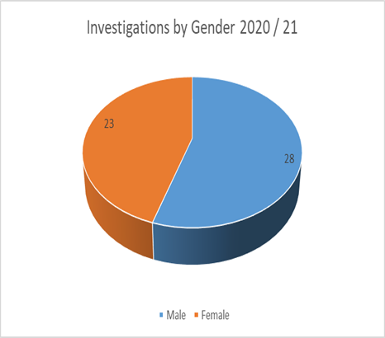 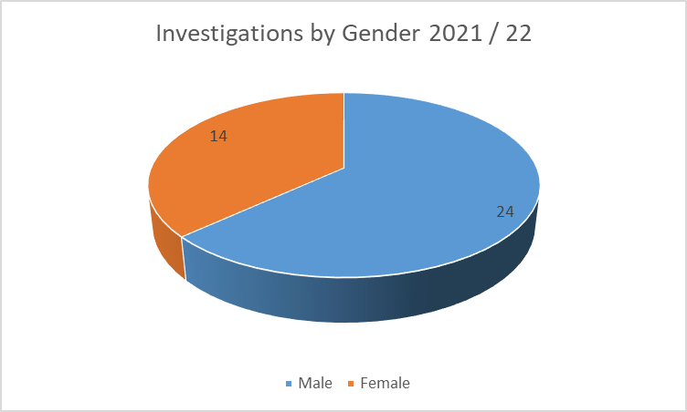

## 10.4 Investigations by Age Group

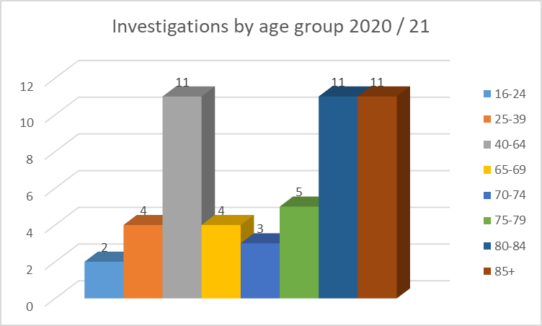 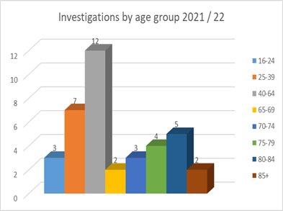

## 10.5 Investigations by Client Category

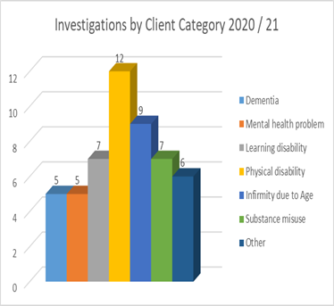 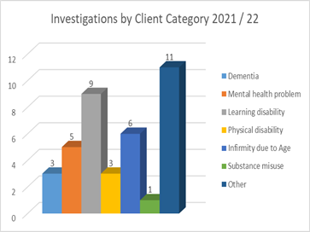

## 10.6 Investigations by Category of Harm

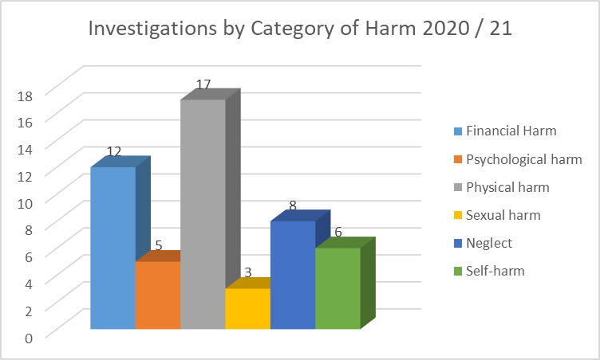 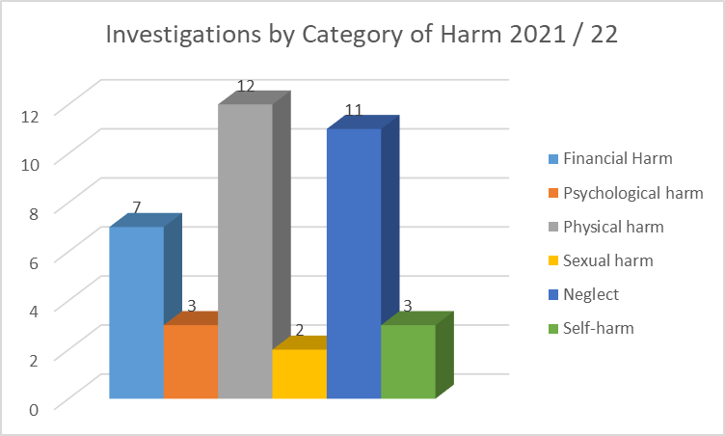

## 10.7 Investigations by Location of Harm

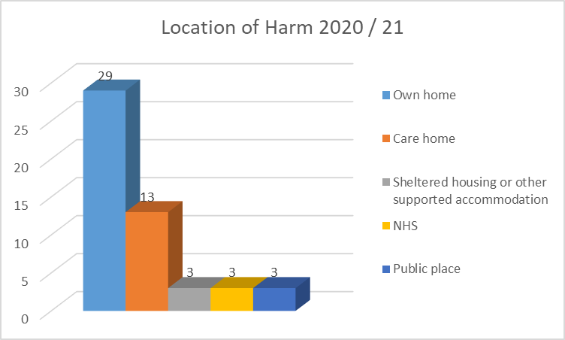 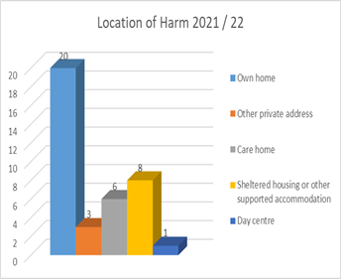

## 10.8 Investigation by Source of Harm

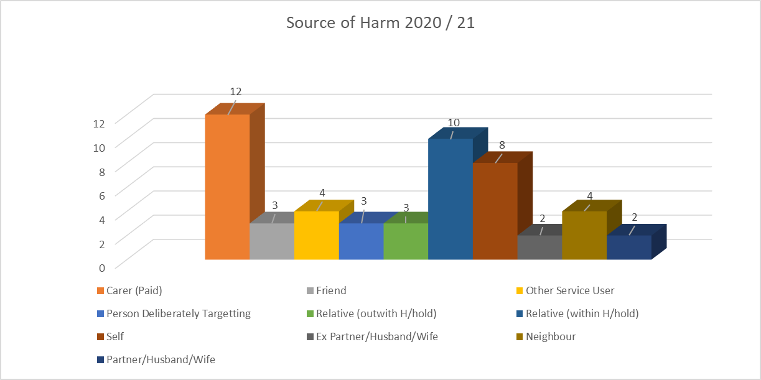

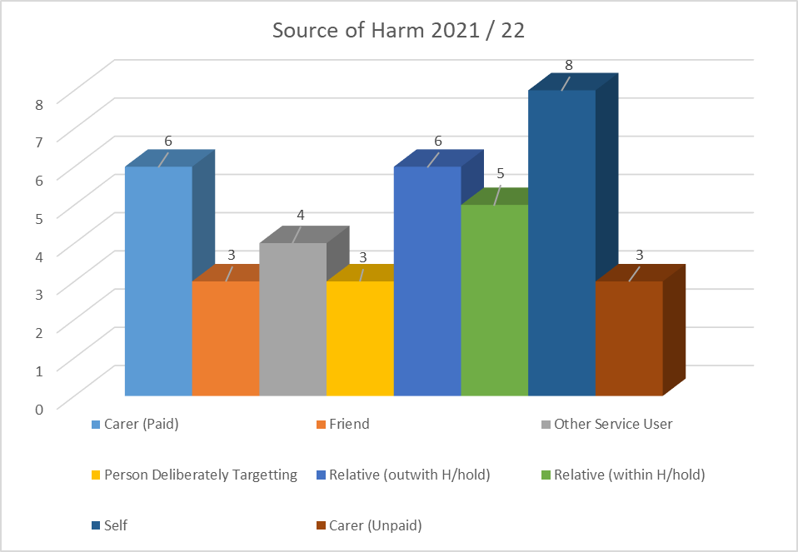

## 10.9 Outcome of Investigation

