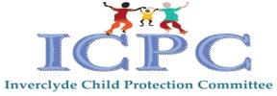

Multi-Agency Guidance for Children and Young People who Display Harmful and Problematic Sexual Behaviours.

June 2023

**1. BACKGROUND**

**1.1 Introduction and Key Themes**

Harmful sexual behaviour (HSB) is developmentally inappropriate sexual behaviour displayed by children and young people under the age of 18 years old, that may be harmful towards self or others, or be abusive towards another child, young person or adult (Hackett, 2014). Google the link below which will give you further information to read alongside this protocol.

<https://www.icmec.org/wp-content/uploads/2019/07/Hackett-Continuum-of-Harmful-Behavior-Excerpted.pdf>

Often, children who have engaged in harmful or problematic sexual behaviours are unique in that society views them differently than if they engaged in other types of hurtful behaviour. However, children and young people who display or engage in harmful or problematic sexual behaviours need to be seen as children first and foremost, recognising that children and young people are developmentally different to adults and responses should reflect this.

Children and young people display a range of sexualised behaviours as they grow up. However some may display problematic or abusive sexualised behaviour. This is harmful to the children who display it as well as the people it's directed towards (NSPCC, 2021). The link below will give you further information about recent research.

<https://www.csacentre.org.uk/resources/key-messages/harmful-sexual-behaviour/>

It is important that everyone in Inverclyde who works with children and young people should be able to distinguish between sexual behaviour that us developmentally typical and sexual behaviours that are problematic or harmful. This will help us to respond appropriately and provide children and young people with the right protection and support, at the right time.

If a child is displaying problematic or harmful sexual behaviour it can be difficult to know how to respond so that you are balancing the needs of everyone involved. We know that this can be particularly difficult within educational establishments.

We need to act appropriately to support and protect any children who have displayed problematic or harmful sexual behaviours and those who have been impacted by the behaviour.

This multi-agency guidance aims to set out an effective and consistent approach in the early identification, assessment and management of children and young people whose behaviour is considered to be sexually harmful or problematic. The guidance should be used to initially assess the risk and needs of the child/young person in order to clearly define what level of intervention may be necessary. In addition, it will inform the wider assessment of risk in relation to those children who have been harmed or are at risk of harm when consideration needs to be given to using Child Protection / Care And Risk Management (CARM) processes to consider what action is necessary to protect them from future harm.

The Guidance should be used for all children and young people who are displaying harmful sexual behaviours. The Guidance should not only be used with those young people who have sexually offended and are held within youth justice / criminal justice systems but also those children and young people within child protection systems whose risk and needs require a multi-agency approach. It requires the key agencies involved to meet regularly on a case by case basis to manage, evaluate and monitor risk or potential risk. The Guidance provides a clear framework for understanding sexually harmful behaviour in the context of child and adolescent development. It is a “systems approach” which considers how all the parts of the system including the family, impact on the young person making risk more or less manageable. **It is intended that this guidance will sit alongside existing Child Protection and Care and Risk Management Procedures.**

**1.2 Principles and Approach**

Responses to children and young people who have displayed harmful or problematic sexual behaviour need to be embedded in a children’s rights perspective, even when their actions have caused harm to others. The aim is of this guidance to ensure the child/young person’s safety and wellbeing and should facilitate opportunities for them to develop alongside ensuring the safety and wellbeing of those they come in to contact with.

This guidance recognises that sexual behaviours take place on a continuum (Hackett, 2010), ranging from behaviours that are considered to be normal, to behaviours that are considered to be sexually abusive or violent.

The following diagram comes from the work of Professor Simon Hackett (2014) and illustrates the continuum of sexual behaviour.

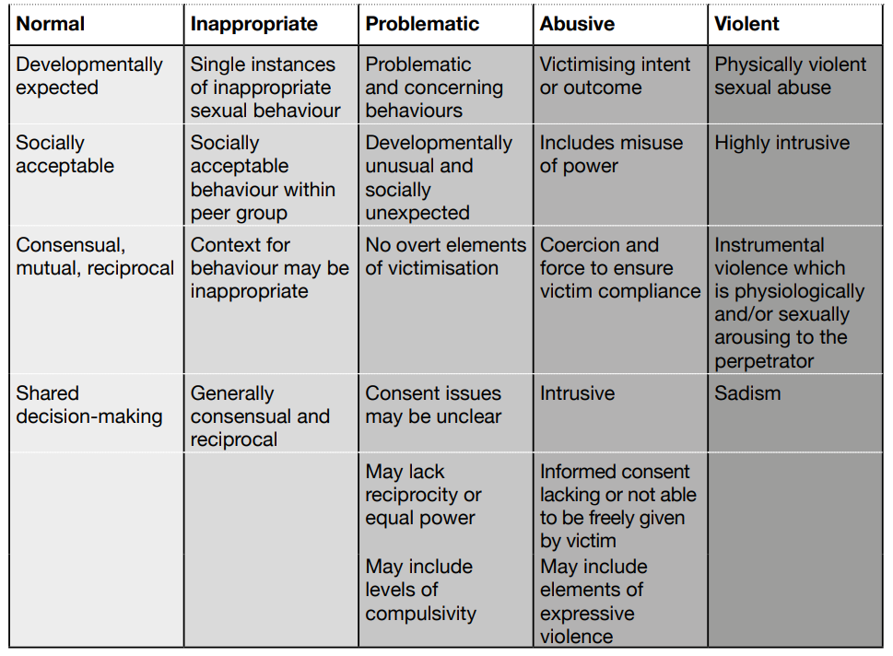

Just as there is a continuum of behaviour, there needs to be a continuum of potential responses from services, acknowledging that children and young people with harmful sexual behaviours are a varied and complex group with diverse needs that cannot be addressed by a ‘one size fits all’ model of service provision (NSPCC, 2019).

Distinguishing between appropriate non-abusive behaviour and inappropriate or abusive behaviour can be a complex task that requires practitioners to understand what is healthy and informed consent and what is abusive or coercive . There is a range of common and healthy behaviours at different developmental stages (Scottish Government, 2021) . The Brook Sexual Behaviours Traffic Light Tool offers guidance for age-appropriate behaviour. A link to this tool can be found at the end of this guidance.

Preventing children and young people who have displayed harmful sexual behaviour from abusing further victims is the primary aim of Child Protection and Care and Risk Management Procedures. However, every child’s plan should be holistic and tailored to need and context. Risk assessment, risk management measures and interventions might be necessary when a child / young person has engaged in harmful sexual behaviours but should be balanced with nurture and encouragement (Scottish Government, 2021)

**The principles applied to effective risk management are as follows –**

• Initial risk assessment should inform risk management planning. This ensures the child’s plan is tailored to the needs of the individual and is proportionate to the level of risk.

• It is important that any risk assessment and intervention is reviewed and adapted following significant changes in the child/young person’s circumstances in order that appropriate risk management strategies can be applied.

• The adults in the systems as far as possible need to be equipped and able to take that responsibility for managing the child/young person’s risk until such times as child/young person can evidence new skills and insights through a programme of work.

• This approach requires those adults around the child/young person having a shared understanding of the needs and potential risks presented by the child/young person with an agreed plan of intervention.



**2. The Guidance**

**Where a child / young person’s behaviour raises concern, the following steps should be taken:**

|  |
| --- |
| 1. If the child is not open to Social Work Services, a referral should be made to the Children and Families Request for Assistance team. 2. If a child is open to Social Work Services, information should be shared with the allocated Senior Social Worker. 3. Inform your Education Officer responsible for your School / Establishment. |

**The Senior Social Worker (SSW) will require to consider –**

|  |
| --- |
| • The seriousness of the behaviours.  • The immediate risk to others.  • The vulnerability of the child/young person.  • All available information from partner agencies.  • The source of concerns and the context in which the child/young person is living.  • Any predisposing factors in the family that would suggest that potential risk could not be managed within the family.  • Whether a multi-agency Harmful Sexual Behaviour Planning Meeting should be convened to share all relevant information. |

In all cases where a child or young person displays sexual behaviour that may cause significant harm, immediate consideration should be given as to whether action should be taken under child protection procedures, in order both to protect children harmed or at risk of harm by the behaviour and to address any child protection concerns that may at least in part explain why the child/young person has behaved in such a way. At this early stage the SSW may identify that the level of risk is such that the case should be managed under CP/CARM, an Inter-agency Referral Discussion (IRD) must be convened as soon as reasonably practicable. IRDs are required to ensure a co-ordinated inter-agency child protection process up until the point a Child Protection Planning Meeting (CPPM) is held, or until a decision is made that a CPPM is not required/that alternative action is required. Further information in relation to this process can be found within Inverclyde Council’s Child Protection and CARM Procedures. Links to these procedures/processes can be found at the end of this document.

In many instances it will be unclear what the level of risk is and what level of intervention may be necessary. In such situations, a multi-agency Harmful Sexual Behaviour Planning Meeting should be held to allow the sharing of information and for early discussions to take place in relation to risk and risk management. Timing must be prompt to inform parents.

**2.1 The Harmful Sexual Behaviour Planning Meeting**

The purpose of the multi-agency Harmful Sexual Behaviour Planning Meeting is for the professional team around the child to meet and to share all available information. Children & Families Social Work Services have the lead professional responsibility for convening and chairing this professionals meeting. However, the purpose of the meeting is to ensure relevant information is shared, to carry out a collective assessment of risk, and to agree a plan to minimise risk. Professionals from all partners in Social Work, Health, Education and Police should bring with them any relevant reports. Within the meeting you should consider:

|  |
| --- |
| * An initial analysis of the sexually harmful behaviours / allegation. * Possible routes into the behaviours (child’s history of relevant adversities). * The child/young person’s needs. * Child / young person’s response to the behaviour / allegation. * Family response and community response. * The immediate risk to others and short term risk management requirements. * Referrals to other agencies. * The roles and responsibilities of those involved. * The need for third party disclosures. * Any immediate accommodation and education needs. |

**Information that should be gathered prior to the meeting is as follows:**

|  |
| --- |
| * The nature of the sexually harmful behaviours / allegations and referrer concerns. * Brief family and child history from all services with past and current involvement (Social Work, Health, Education, Police) * Brief picture of child/young person from all services with current involvement. * Chronology of any past sexually harmful behaviours. |

1. **Review**

The Harmful Sexual Behaviour Planning meeting will consider what safety plans need to be put in place in order to keep the child/ young person, and those around them, safe. Safety Plans may need to be put in place for the home, community and educational establishments.

Risk management is an ongoing process and safety plans should be developed and reviewed by workers as the assessment and intervention is ongoing**. If there are safety plans in place, the key agencies involved should meet regularly (4 – 6 weeks) to manage, evaluate and monitor risk or potential risk.**

If a child or young person is on the Child Protection, or CARM Register, there will be regular Core Group Meeting, within which risk management should be reviewed.

**Useful Links**

This guidance is limited in its scope. It intends to provide procedural guidance to professionals within Education and Social Work when working with children and young people who display harmful sexual behaviour. You may, therefore, find the following links helpful:

* [Harmful sexual behaviour (HSB) or peer-on-peer sexual abuse | NSPCC Learning](https://learning.nspcc.org.uk/child-abuse-and-neglect/harmful-sexual-behaviour)
* The Brook Sexual Behaviours Traffic Light Tool offers guidance for age-appropriate behaviour. A link to this tool can be accessed at: [CPD: Brook Sexual Behaviours Traffic Light Tool (RSE) Course](https://www.brook.org.uk/education/sexual-behaviours-traffic-light-tool/)
* [National Guidance for Child Protection in Scotland 2021 (www.gov.scot)](https://www.gov.scot/binaries/content/documents/govscot/publications/advice-and-guidance/2021/09/national-guidance-child-protection-scotland-2021/documents/national-guidance-child-protection-scotland-2021/national-guidance-child-protection-scotland-2021/govscot%3Adocument/national-guidance-child-protection-scotland-2021.pdf)
* Care and Risk Management (CARM) processes may be applied when a child (aged 12-17) has been involved in an incident of a serious nature or where a pattern of significant escalation of lesser behaviours suggests that an incident of a serious nature may be imminent. CARM Guidance can be accessed at: <https://www.rma.scot/resource/standards-guidelines/>.
* [Harmful sexual behaviour by children and young people: Expert Group report - gov.scot (www.gov.scot)](https://www.gov.scot/publications/expert-group-preventing-sexual-offending-involving-children-young-people-prevention-responses-harmful-sexual-behaviour-children-young-people/)
* What’s the Problem? A guide for parents of children and young people who have got in trouble online. Can be accessed at: LFF ELEC Resource Pack for Parents_MAY21.pdf
* [Home - Shore (shorespace.org.uk)](https://shorespace.org.uk/) (help and advice for young people worried about their sexual behaviour online)

**Working Group Membership: This Guidance will be reviewed in June 2024.**

|  |  |
| --- | --- |
| Emma Bilsland -Lead | Children’s Planning and Improvement Officer, HSCP |
| Jackie Chisholm | Children’s Planning and Improvement Officer, HSCP |
| DS John Aikman | Police Scotland |
| Craig Gibson | Head Teacher, Clydeview Academy |
| Catriona Miller | Head Teacher, Aileymill Primary School |
| Hazel Mitchell | Head Teacher, Newark Nursery School |
| Laurence Reilly | Principle Educational Psychologist |