

Property Services

FOR SALE:

**Site of former Community Hall, Cawdor Crescent, Greenock**

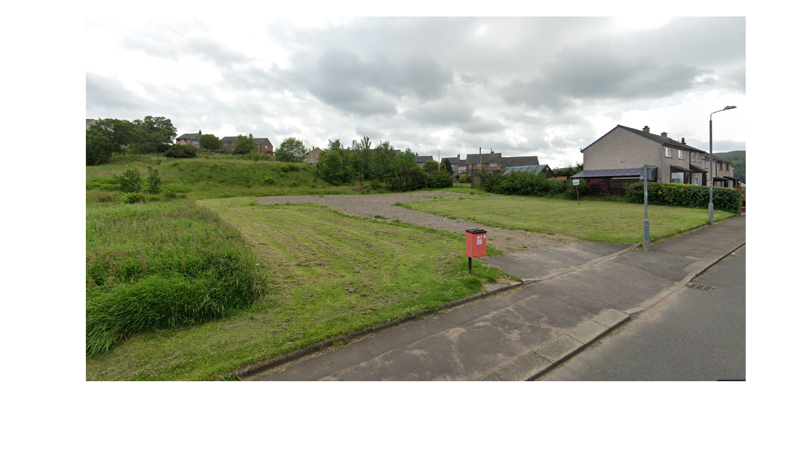

* RESIDENTIAL LOCATION
* SUITABLE FOR RESIDENTIAL USE SUBJECT TO PLANNING APPROVALS
* SITE EXTENDING TO 0.108 HECTARES OR THEREBY
* OFFERS FOR SALE INVITED

|  |
| --- |
| The above Particulars are believed to be correct, but are supplied for information only and no reliance should be placed thereon. They are not deemed to form any contract or part of contract which may be entered into. Inverclyde Council does not bind itself to accept the highest rent or offer and in supplying these Particulars is not issuing instructions and will not therefore, bear liability for Agent’s or other fees. |
|  |
| Property Asset Team  Inverclyde Council, Municipal Buildings, Greenock PA15 1LY  Telephone 01475 712102 Email: property@inverclyde.gov.uk |

**LOCATION**

The site is situated on a level plot of land in a local authority residential location in the Fancy Farm district of Greenock.

There are good public transport links to the town centre which lies some 2.25 miles to the northeast. The site benefits from easy access to all local facilities including the Inverclyde Royal Hospital which is within walking distance.

**DESCRIPTION**

The subjects comprise the site of a former purpose built Community Hall, now demolished, extending to 0.108 Hectares or thereby.

It is up to potential purchasers to satisfy themselves as to the suitability of the subjects for any potential use, including the availability, condition and capacity of all service provisions.

**PLANNING**

The site lies within the administrative area of Inverclyde Council and is consideredsuitable for residential development. Inverclyde Council planning service has indicated that the site would be suitable for a four terraced residential development or two semi-detached blocks, however, any specific proposals should be referred to the Planning Service utilising the contact details on the contacts page. Please note a change of use may be required.

**ROADS GUIDANCE**

All development proposals would be required to comply with the Council’s Roads Development Guidelines, including the requirement to provide off street car parking. Prospective developers are advised to contact the Council’s Roads Department on telephone number 01475 714800 to discuss all proposals.

**RATING**

The subjects are currently assessed as ‘Ground’ and will require to be re-assessed on completion and occupation of any development.

**ENTRY**

Immediate entry on completion of legal formalities can be offered.

**VIEWING**

The site is open for viewing at any time.

**INTEREST**

All interested parties must register their interest with the Property Asset Team either by telephone on 01475 712102, or via the Inverclyde Council website or online at [property@inverclyde.gov.uk](mailto:property@inverclyde.gov.uk) in order to receive the offer package which is required, prior to submitting an offer once a closing date has been announced.

**OFFERS**

Offers are invited for a purchase. The offer should include full details of any proposed development.

**CLOSING DATE**

Please note a **closing date for offers** has been set at 12 noon, Friday 25th November 2022. It is essential to register should you wish to make an offer.

All offers should be submitted by the notified time to;

Head of Legal & Democratic Services

Inverclyde Council

Municipal Buildings

Greenock PA15 1LY

Any offer submitted must strictly comply with the terms and conditions as set out in the attached conditions of sale. These will be forwarded to all parties who register an interest, and will include an address label which must be affixed to the front of all envelopes containing offers.