

e-Learning Guidelines

# August 2021

# Contents

## Introduction 3

## Who can use e-Learning? 4

## When can you use e-Learning? 4

## What happens next? 5

## Getting started! 6

# Introduction

We want our staff to be skilled, motivated and driven to deliver excellent customer services to the residents of Inverclyde, which means that your continual learning and development is important to us.

This is why we offer **e-Learning** through a platform called Brightwave, which allows you to access over 300 courses on a range of topics for your own personal development. We also offer face to face training via the CourseBooker section on ICON.

Not only are you able to access these **e-Learning** courses from a computer desk at work, you can access these courses from the comfort of your own home from your laptop, tablet or smart phone. This booklet will give you a step by step guide on how you can do this.

One of the most important areas where you will see

**e-Learning** being used is in conjunction with your Performance Appraisal. By reviewing your personal objectives and training needs with your line manager/supervisor, you will be able to work through the courses you need via Brightwave. As the Performance Appraisal process is designed around the Council’s Core Competencies, a guide has been created to assist with identifying relevant **e-Learning** topics to support each competency. This guide can be found on the *Learning and Development* page on ICON.

If you have any particular questions, please contact the Organisational Development Team on ext. 2740.

# Who can use e-Learning?

Everyone can. If you do not have access to a PC at work, then you can log in at home using the link on Page 6. Otherwise, arrangements can be made for you to use the training suite

at Princess House at Port Glasgow, local libraries and/or St Stephen’s Enterprise Centre, when it is most convenient for you to use a PC to develop your skills.

# When can you use e-Learning?

Bite size **e-Learning** courses (15 mins) are accessible during the working day but longer courses (90 mins) must be approved by your line manager. All courses are also accessible from your home computer using your unique employee number.

All training will be linked to your Performance Appraisal objectives which your line manager/supervisor will cover with you.

# What happens next?

Ask your line manager if you may access **e-Learning** at a time that suits your workload.

Some courses incorporate audio and video clips, therefore you need to use earphones to undertake these courses. If you have a comfortable pair of earphones for your personal phone, iPod or mp3 player, then these can be utilised for e-Learning.

Once you complete an e-Learning course, it is logged against your employee number as your personal training record, and will be monitored to confirm completion against your Performance Appraisal objectives.

If you are undertaking a course and decide to withdraw from it before completing, when you go back to it the system will remember where you left off, and provide you with the opportunity to start from there or go back to the beginning. In some instances though, if too much time has lapsed then you may not get this option, and you will have to restart the course from the beginning.

Some courses have certificates awarded on completion.

# Getting started!

## Registration

## Step 1

## Logging in at Work

Go to the Council’s ICON computer screen. Click on the ‘Learning & Development’ heading on the right hand side of the page.

Here you can choose between undertaking a face to face corporate training course by booking through **Course Booker**, or undertaking an **e-Learning** course of your choice at your desk, or from your computer at home.

## Logging in at Home

If you are trying to access from home the link is as follows:

[**http://tracking.brightwave.co.uk/LNT/Inverclyde/Login.aspx**](http://tracking.brightwave.co.uk/LNT/Inverclyde/Login.aspx)

For this purpose, please click on **e-Learning** and you will be taken to the registration screen below.

Once you have opened up the e-Learning link, you will be taken to the registration screen below. If you are a first time user, there are a few steps you will need to go through.

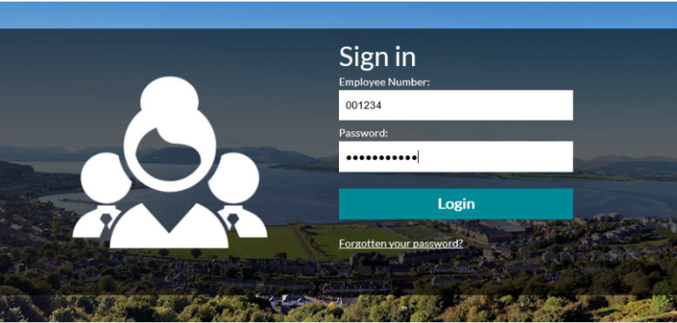

1. Firstly, type in your employee number. This is on your payslip and Council ID card.
2. Your employee number must be six digits, so make sure you add any necessary zero’s to the beginning of the number, as in the example above.
3. Your password for your first log in is your last name. Make sure you use any appropriate capital letters,

i.e. Smith or McLean.

## Step 2

You now need to register as a new user and change your password to something you will remember.

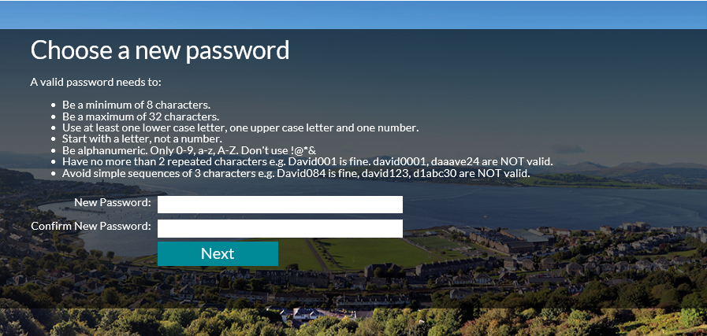

## Step 3

Once you have registered your password, you will be asked to provide an answer to a memorable question. This is for security purposes and will help you reset the password should you forget it.

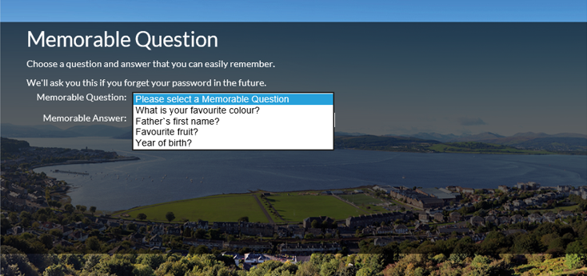

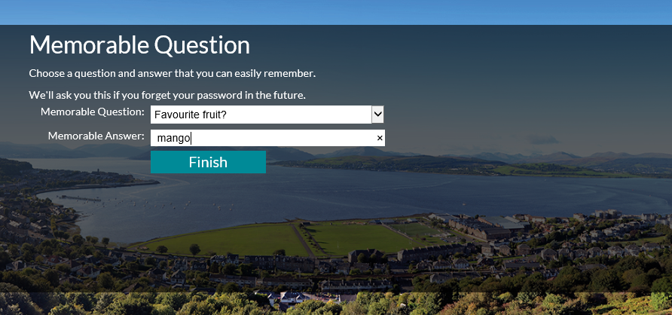

Select ‘finish’ and that is the registration process complete. Before you get started on your new course you need to turn off your popup blocker. The next section explains how to do this.

# Popup Blocker

Before you get started you may need to turn off your popup blocker. If you don’t do this, your courses may not work properly and the following message may appear.



## Steps

1. To disable the popup blocker in Internet Explorer, click on **tools**
2. Then click on **Internet Options**
3. Then **untick** **the** **turn on popup blocker box**
4. Select **Apply**

Once you have done this, you will be able to start your courses. See the next page for screenshots of the above steps.

Clicking on tools in the top right hand corner of Internet Explorer shows the internet options button.


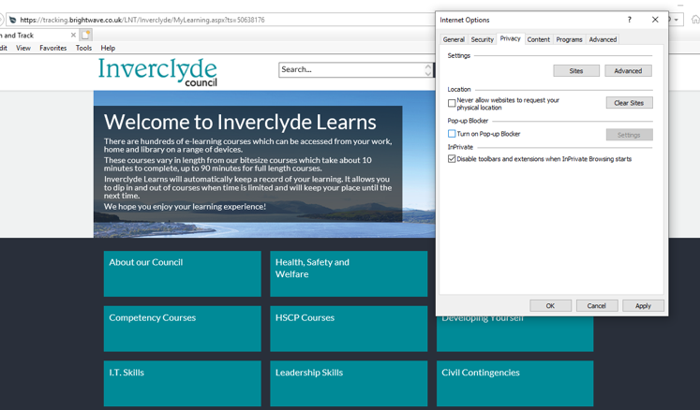

# Audio Settings

Please note some courses contain audio. **If you are not able to hear the audio using the Internet Explorer web browser, please try the following options:**

## Option 1 (*see screenshots on the next page)

1. Select **'Tools'** in the top right hand corner of the web browser in Internet Explorer.
2. Then select **'Internet Options.'**
3. Then select **'Advanced.'**
4. Scroll down until you find **'Multimedia'** and select **'play sounds in webpage.'**
5. Select **apply**, then **okay**.
6. **Close the course and reload**. The audio should now work.
7. Please note that these settings will not be saved, so next time you log in you will need to apply the above settings again.

**OR**

## Option 2

Open the course using the Edge or Google Chrome web browsers.

## *Screenshots for Audio Settings, Option 1

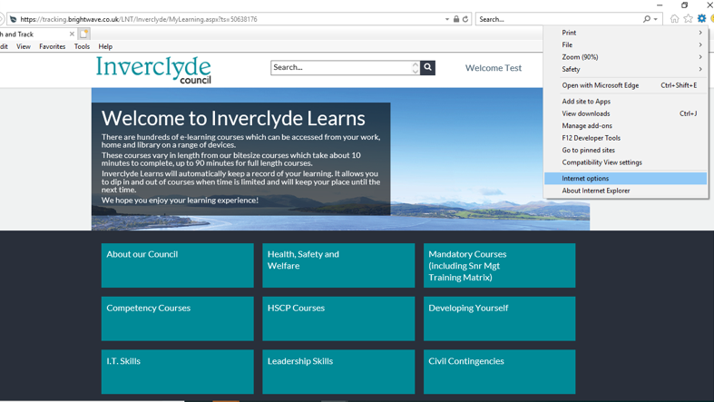

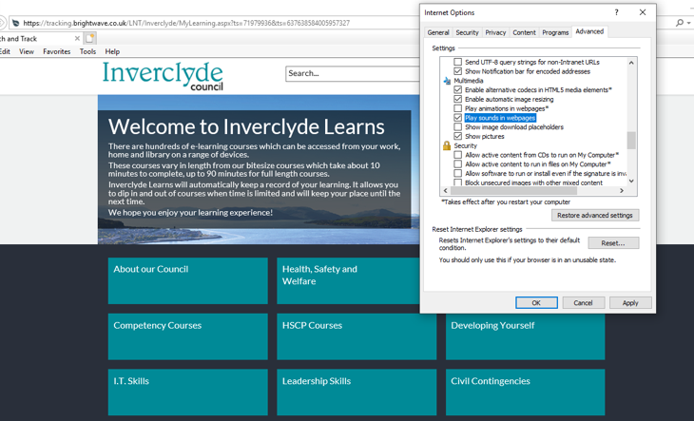

# Using e-Learning

## Step 1

This is the **e-Learning** home page.

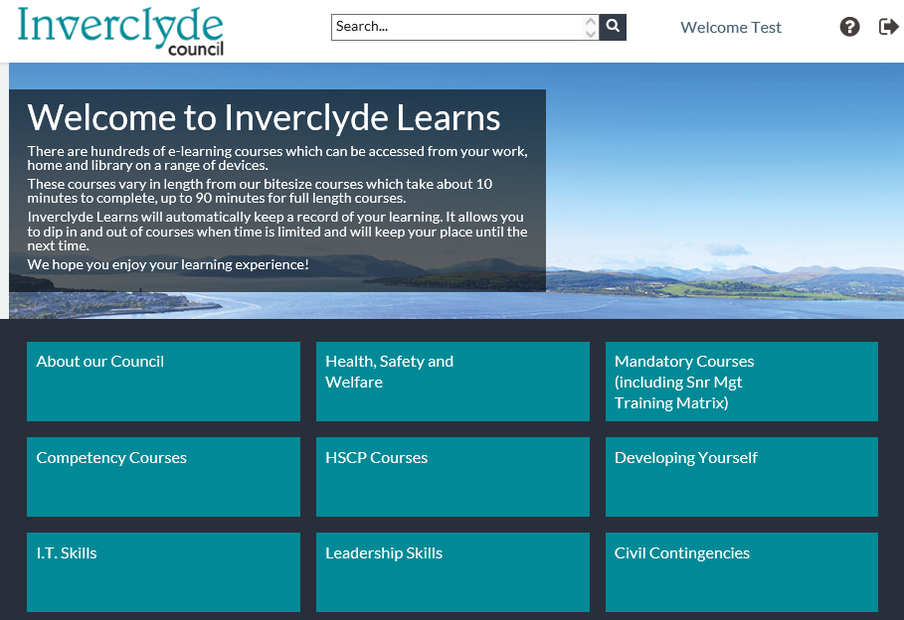

## Step 2



Click on the box to open up a category

Each box on the home page represents a category of courses.

## Step 3

Here we have opened up the **Developing Yourself** category. At the top, you will see a brief description of the types of courses in this category.

Below this, you will see a range of sub categories called **Programmes**.

After clicking a category, you will see the programmes within each category.

The home icon is highlighted at the top of the screen.

To go back a page, click **the home icon**.

***Do not*** use the Exit button at top right hand of page. The button looks like an arrow.button as this will take you out to the password screen.

Click on the arrow to

see a list of all the courses available in this **programme**.

## Step 4

Here we have opened up the **Time Management** programme.

You can now see all the courses which relate to managing your time.

To find out more information about a course, click the “**I”** button.

## All courses under the Time Management programme are shown. The 'i' screen is used to find out more, the clock button used to view course history, and a completion bar shows how much of a course you have completed.

To view your history for each course, click on the **clock** button.

This bar will tell you if you have completed the course or not.

## Step 5

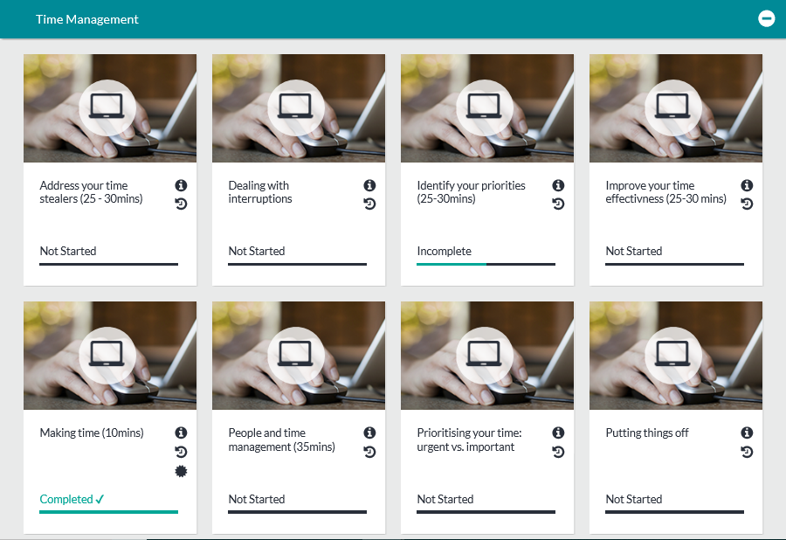

Some courses have certificates which you can print out for your training records. These courses are identified by the star button.

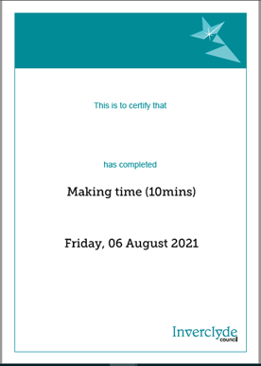

**Joe Bloggs**

## Technical support contacts

ICT Servicedesk ext. 2345 [servicedesk@inverclyde.gov.uk](mailto:servicedesk@inverclyde.gov.uk)

Organisational Development & HR Team ext. 2740 [human.resources@inverclyde.gov.uk](mailto:human.resources@inverclyde.gov.uk) or coursebooker@inverclyde.gov.uk

If you require further assistance, please contact your CHRIS21 administrator within your service who may be able to assist.

If you are unsure who this is, please see the list of contacts on the Learning and Development page on ICON: <http://icon/hr/employee-development/learning-development/>.

If they are unable to help, please contact ICT or HR.

We hope you enjoy these on-line learning opportunities.

More courses will continue to be developed through our joint working partnership with the Clyde Valley Training Consortium, to update and compliment the catalogue of courses provided.

# Get in touch

**Job ref 3775 e-Learning** Designed by Corporate Communications

**Phone:** 01475 712740

**Email:** [human.resources@inverclyde.gov.uk](mailto:human.resources@inverclyde.gov.uk)

**Write to:** Organisational Development,

Policy & Communications Inverclyde Council

Municipal Buildings Greenock Inverclyde PA15 1LX

[**www.inverclyde.gov.uk**](http://www.inverclyde.gov.uk/)