|  |
| --- |
| **Coronavirus (Covid-19) – briefing** |



Issued 29 April 2020

|  |
| --- |
| **Below is the latest briefing on the activity in managing the response to coronavirus (Covid-19).**  **Local updates, council service changes and links to trusted sources of health guidance are published at *www.inverclyde.gov.uk/coronavirus*** |

**Deaths involving covid-19**

National Records of Scotland has published the latest statistics showing deaths involving covid-19.

Their statement reads:

As at 26 April, 2,272 deaths have been registered in Scotland where COVID-19 was mentioned in the death certificate.

Between 20 April to 26 April, 656 deaths relating to COVID-19 have been registered, an increase of four from the previous week, 13th April to 19th April.

To place these statistics in context, the total number of deaths registered in Scotland from 20th April to 26th April was 1,830 – 68% more than the average number of deaths registered in the same week over the last five years, 1,087. Of these 743 excess deaths, 85% were deaths where COVID-19 was the underlying cause of death.

Over a third of all registered deaths involving COVID-19 occurred in care homes, 39%. 52% of registered deaths were in hospitals and 9% were at home or non-institutional settings.

Almost three quarters of registered deaths involving COVID-19 to date were people aged 75 or over. Of all deaths to date involving COVID-19, 53% were male and 47% were female.

The Inverclyde data included in the information includes a breakdown of the location people died of covid-19:

|  |  |  |  |
| --- | --- | --- | --- |
| Deaths where covid-19 was mentioned on the death certificate | Inverclyde | Greater Glasgow and Clyde | Scotland |
| Care Home | 27 | 282 | 886 |
| Home / Non-institution | 11 | 44 | 197 |
| Hospital | 55 | 415 | 1,188 |
| Other  institution | 0 | 0 | 1 |
| All locations | 93 | 741 | 2,272 |

The full report is available at: <https://www.nrscotland.gov.uk/news/2020/deaths-involving-covid-19-week-17-20th-to-26th-april>

**New helpline launched**

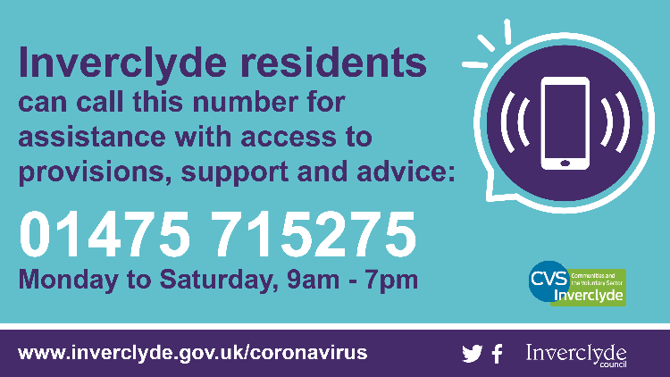The council and CVS Inverclyde have launched a new helpline to support residents in need across Inverclyde:

Below is the launch press release:

Inverclyde Council and CVS Inverclyde have joined forces to create a new single point of contact for residents in need during the coronavirus outbreak.

The new phone line aims to help people access provisions, support and advice.

Residents can call 01475 715275 to find out how to access food, how to get a prescription and how to get assistance with shopping and other services for people who are not on the 'shielding' list.

The helpline will be staffed by Inverclyde Council’s Community Learning and Development (CLD) staff and CVS Inverclyde between 9am-7pm Monday-Saturday.

The aim is to give people assistance through a one-stop helpline that will direct them to the correct support they need within their communities.

The team will also be able to link with the existing arrangements for the national helpline for those without access to support networks and for the very vulnerable people on the shielding arrangements.

Inverclyde Council leader, Councillor Stephen McCabe, said: “There has been a great deal of work behind the scenes to support very vulnerable people in the 'shielding' category and those with health issues but with no support network

"The aim of this service is to provide a rapid response to make sure that there is no-one who falls between the gaps and that help is there from the council and our partners at CVS Inverclyde

"If you need help and support and we can provide it, our CLD staff and the team from CVS will be there for you.

"If you need help accessing other services, our teams know the local area and what’s available and they will be able to point you in the right direction.”

Charlene Elliott, Chief Executive Officer of CVS Inverclyde, said: “We have been working closely with colleagues at Inverclyde Council, CLD and Health & Social Care Partnership (HSCP) services, to keep ahead of the rapidly changing landscape over the past six weeks.

"Paramount has been ensuring people get the help they need, as quickly as possible, to ensure that 'shielding' services and the necessary social-distancing measures are protected.

“As well as the telephone support service we are operating for our colleagues across the local third sector, we are delighted to be working alongside the council in delivering this helpline for local residents.”

The helpline number is 01475 715275.

**Brown bin collections and permits**

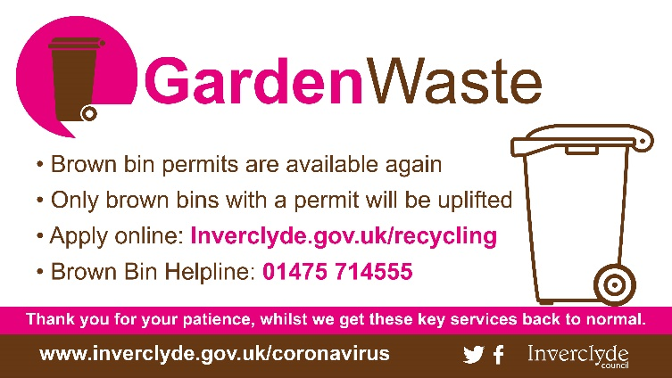The sale of garden waste permits has resumed in Inverclyde with brown bin collections now back to normal across Inverclyde.

The service was disrupted due to reduced staffing levels and other constraints caused by the coronavirus outbreak.

Brown garden waste bins continue to be emptied as normal on regular fortnightly collection days for those who have purchased a permit.

Bins without a permit will not be uplifted.

The sale of permits had to be temporarily suspended due to the coronavirus response but they are available to buy once again from the Inverclyde Council website.

During the disruption to garden waste collections, brown bins of existing permit holders were still being emptied but the contents were being taken away in a general refuse lorry. Brown bin contents will now be collected by a dedicated garden waste vehicle and recycled once again.

The council is continuing to work with its recycling contractor to reinstate fortnightly blue bin uplifts as soon as possible.

Food waste (green bin) collections will resume at a later date.

In the meantime, black/grey bins for general household waste will continue to be emptied every week until all waste collections return to normal.

To purchase a garden waste permit, visit **www.inverclyde.gov.uk/recycling** where there is also a frequently asked questions (FAQs) section and further information about Inverclyde’s waste and collection services. Residents are asked to note that due to the current circumstances, it may take up to two weeks to print the personalised permit and post it customers’ homes.

For advice about the brown bin service, including what to do if a permit is lost or stolen, phone 01475 714555.