|  |
| --- |
| **Coronavirus (Covid-19) – briefing** |

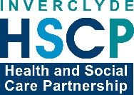

Issued 27 April 2020

|  |
| --- |
| **Below is the latest briefing on the activity in managing the response to coronavirus (Covid-19).**  **Local updates, council service changes and links to trusted sources of health guidance are published at *www.inverclyde.gov.uk/coronavirus*** |

**International worker’s Memorial Day – 28 April**

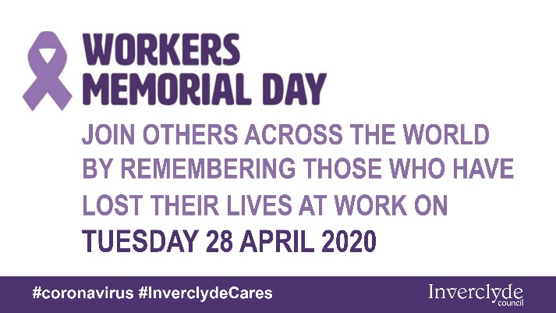Tomorrow (Tuesday 28 April 2020) marks International Worker’s Memorial Day.

A wreath laying ceremony and minute’s silence would normally be held at the Clyde Square in Greenock to mark this annual commemoration.

Because of the coronavirus (covid-19) social distancing rules, employees, residents and businesses are encouraged to join the national; minute’s silence at 11am tomorrow (Tuesday 28 April 2020) from their workplace or home individually to avoid congregating in large groups and maintaining essential social and physical distancing.

A short video will be published on the council’s social media with contributions from provost Brennan and Robin Taggart from Unison highlighting the significance of workers memorial day at this time.

**Extending PPE to all social care providers**

Supplies of personal protective equipment (PPE) are to be given to unpaid and family carers and personal assistants.

In a joint Scottish Government and COSLA statement it was announced that everyone who provides social care will have access to appropriate PPE.

From today (Monday 27 April 2020), local hubs will distribute PPE supplies to the whole of the social care sector where normal supply routes have not been successful. These hubs will extend their provision to include all social care providers, and unpaid or family carers and personal assistants.

During the coronavirus (COVID-19) pandemic, global supply chains have been put under immense pressure and that is why the Scottish Government has set up supplies of PPE to support the social care sector from the national stock.

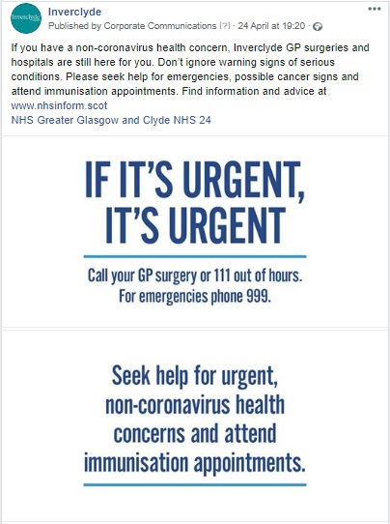**The NHS is open campaign**

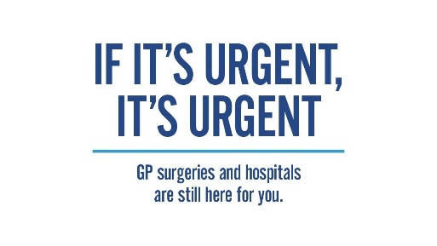A new campaign has been launched and is being supported locally to remind residents that the NHS is open for non-coronavirus health concerns.

Figures indicate patients are delaying going to the GP surgery or accident and emergency during the pandemic, that there has been a drop in urgent suspected cancer referrals, and a reduction in families bringing children for immunisation.

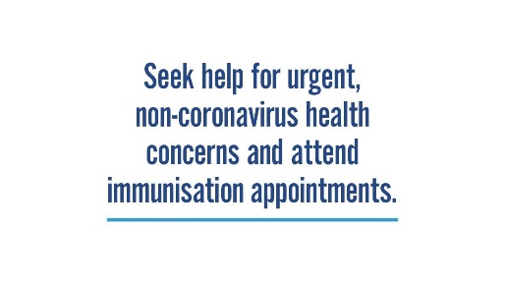Reasons may include wishing to reduce the strain on the NHS, or concerns over becoming infected with COVID-19, as well as the misconception that doctors do not want to see patients.

The will run throughout Scotland across TV, radio, digital and social media.

The message is that GP surgeries and hospitals are still there for you - whether you have a non-coronavirus health concern, are showing possible cancer signs or have an immunisation appointment.

**Junior doctors start early in fight against covid-19**

121 junior doctors across Greater Glasgow and Clyde have started their medical careers early as they join NHS Greater Glasgow and Clyde clinical staff in the fight against COVID-19.

All have volunteered to join the frontline and will be supported immensely by their colleagues, supervisors, mentors and a peer buddy system.

They will work in surgery, medicine and care of the elderly and will likely be treating patients with suspected and confirmed COVID-19.

These junior doctors will be placed across our hospitals: Glasgow Royal Infirmary, Queen Elizabeth University Hospital, Royal Alexandra Hospital and Inverclyde Royal Hospital.

A new post was created (foundation intermediate year) for these individuals to start months earlier, as this group was supposed to be starting work in August. The majority of these doctors have completed their studies with the University of Glasgow.